國立臺東高中104學年度第一學期高三B組英文科期末考試卷

適用班級303 304 307 308 (英文代碼08)
第壹部分：單選題（占70分） (答案卡+答案卷)
一、詞彙（占15分）
說明︰第1題至第15題，每題4個選項，其中只有一個是最適當的答案，畫記在答案卡之「選擇題答案區」。各題答對得1分；未作答、答錯、或畫記多於一個選項者，該題以零分計算。

1 We were forced to _____ our plan for the weekend picnic because of the bad weather.
(A) maintain (B) cancel (C) propose (D) record
2. If you _____ a traffic law, such as drinking and driving, you may not drive for some time.
(A) destroy (B) attack (C) violate (D) invade
3. Applying to college means sending in applications, writing study plans, and so on. It’s a long _____, and it makes students nervous.
(A) errand (B) operation (C) display (D) process
4 Dr. Chu’s speech on the new energy source attracted great _____ from the audience at the conference.
(A) influence (B) fortune (C) solution (D) attention
5. When I open a book, I look first at the table of to get a general idea of the book and to see which chapters I might be interested in reading.
(A) contracts (B) contests (C) contents (D) contacts
6. Mr. Lin is a very ________ writer; he publishes at least five novels every year.
(A) productive (B) temporary (C) moderate (D) reluctant
7 The government is doing its best to ____ the cultures of the tribal people for fear that they may soon die out.
(A) overthrow (B) frustrate (C) hesitate (D) preserve
8. Those college students work at the orphanage on a _____ basis, helping the children with their studies without receiving any pay.
(A) competitive (B) voluntary (C) sorrowful (D) realistic
9. John has been scolded by his boss for over ten minutes now. _____, she is not happy about his being late again.
(A) Expressively (B) Immediately (C) Apparently (D) Originally
10. Typhoon Morakot claimed more than six hundred lives in early August of 2009, making it the most serious natural _____ in Taiwan in recent decades.
(A) collapse (B) barrier (C) anxiety (D) disaster
11. Everyone in the office must attend the meeting tomorrow. There are no _____ allowed.
(A) exceptions (B) additions (C) divisions (D) measures
12. To make fresh lemonade, cut the lemon in half, ______ the juice into a bowl, and then add as much water and sugar as you like.
(A) decrease (B) squeeze (C) freeze (D) cease
13. Using a heating pad or taking warm baths can sometimes help to ______ pain in the lower back.
(A) polish (B) relieve (C) switch (D) maintain
14. Due to ______, prices for daily necessities have gone up and we have to pay more for the same items now.
(A) inflation (B) solution (C) objection (D) condition
15. I could not ______ the sweet smell from the bakery, so I walked in and bought a fresh loaf of bread.
(A) insist (B) resist (C) obtain (D) contain

二、綜合測驗（占15分）
說明︰第16題至第30題，每題一個空格，請依文意選出最適當的一個答案，畫記在答案卡之「選擇題答案區」。各題答對得1分；未作答、答錯、或畫記多於一個選項者，該題以零分計算。

When it comes to Egypt, people think of pyramids and mummies, both of which are closely related to Egyptian religious beliefs. The ancient Egyptians believed firmly in life 16 death. When a person died, his or her soul was thought to travel to an underworld, where it 17 a series of judgments before it could progress to a better life in the next world. For the soul to travel smoothly, the body had to 18 unharmed. Thus, they learned how to preserve the body by drying it out, oiling and then 19 the body in linen, before placing it in the coffin. Egyptians also built pyramids as 20 for their kings, or pharaohs. The pyramid housed the pharaoh’s body together with priceless treasure, which would accompany him into the next world.
16. (A) for (B) after (C) by (D) into
17. (A) went through (B) made up (C) turned out (D) changed into
18. (A) remind (B) remain (C) repair (D) replace
19. (A) wrapped (B) to wrap (C) wrapping (D) being wrapped
20. (A) galleries (B) landmarks (C) tombs (D) companies
Anita was shopping with her mother and enjoying it. Interestingly, both of them 21 buying the same pair of jeans.
According to a recent marketing study, young adults influence 88% of household clothing purchases. More often than not, those in their early twenties are the more 22 consumers. There isn’t a brand or a trend that these young people are not aware of. That is why mothers who want to keep abreast of trends usually 23 the experts－their daughters. This tells the retailers of the world that if you want to get into a mother’s 24 , you’ve got to win her daughter over first.
With a DJ playing various kinds of music rather than just rap, and a mix of clothing labels designed more for taste and fashion than for a precise age, department stores have managed to appeal to successful middle-aged women 25 losing their younger customers. They have created a shopping environment where the needs of both mother and daughter are satisfied.
21. (A) gave up (B) used to (C) took to (D) ended up
22. (A) informational (B) informative (C) informal (D) informed
23. (A) deal with (B) turn to (C) head for (D) look into
24. (A) textbook (B) notebook (C) pocketbook (D) workbook
25. (A) without (B) while (C) after (D) in
Miyazaki’s films 26 also because his characters reflect reality. The characters of Miyazaki’s films, 27 those of most typical Hollywood animated films, are neither completely righteous nor completely wicked. The characters are true to life and make his films 28 . As the story 29 , villains reveal certain positive traits, as well as their violence, evil, and hatred. Good and bad 30 together, and the tension between them gives richness and complexity to Miyazaki’s stories.
26. (A) stand up (B) stand out (C) sit in (D) sit down
27. (A) dislike (B) likely (C) unlike (D) unlikely
28. (A) take back (B) long term (C) point of view (D) one of a kind
29. (A) develops (B) folds (C) hides (D) walks
30. (A) amuse (B) produce (C) refuse (D) fuse
三、文意選填（占20分）
說明：第31題至第50題，每題一個空格，請依文意在文章後所提供的 (A) 到 (AE) 選項中分別選出最適當者，並將其英文字母代號畫記在答案卡之「選擇題答案區」。各題答對得1分；未作答、答錯、或畫記多於一個選項者，該題以零分計算。
Popcorn is one of the snacks that rarely fail to make watching a movie more fun. However, the modern way of preparing this 31 snack may carry an unhappy secret. Research by the U.S. government now reports that microwave popcorn may contain substances that can cause health 32 .
Researchers found that commercial popcorn companies often coat their microwave popcorn bags with a 33 called perfluorooctanoic acid (PFOA) which has been found to cause both cancer and lung disease in laboratory animals. Making matters worse, the artificial butter substitute that generally 34 with microwavable popcorn contains a common food-flavoring substance. This substance, according to health scientists, is 35 for some serious lung diseases.
For an easy and 36 alternative, nutritionists suggest that we pop our own popcorn. All that is 37 is a large, high pot, about four tablespoons of vegetable oil and a small handful of organic popcorn kernels. When the kernels start 38 , shake the pot to let the steam escape and to let the unpopped kernels fall to the bottom. As soon as the popping slows down, 39 the pot from the stove. Then pour the popcorn into a bowl and season with a small 40 of real butter or olive oil and natural salt. And the healthy and fun snack is ready to serve.
(A) chemical (B) amount (C) popping (D) popular (E) comes
(AB) healthy (BC) needed (CD) responsible (DE) remove (AE) problems

Verbal abuse 41 when someone says something impolite or offensive, especially when that person is angry, and it can take many forms. Sometimes it is an active 42 , as when a boss tells an employee off by saying that he or she is an “idiot” for failing to meet a 43 , or when a student is mocked, taunted, or 44 by his or her classmates for being different. The family is probably the
45 place that most people expect verbal abuse to happen in, but it happens there as well when a parent insults or 46 a child regularly. Verbal abuse can also be passive, and this type of abuse takes place when a parent ignores a child or frequently discounts the child’s opinions.
For those who have been 47 verbal abuse, it is highly likely that they will have low 48 and may be plagued by emotional problems, such as anxiety or depression. At times, the scars are so deep that some victims begin to 49 post-traumatic stress disorder. Left depressed and without hope, these people run an increased risk of committing suicide. Additionally, victims of verbal abuse often wind up 50 this pain on other people. They do so mainly because this is the only means of expression that they know. In other cases, the cycle of abuse continues because a victim may unconsciously want to regain power, and becoming an abuser is one way to do this.

(A) deadline (B) last (C) inflicting (D) suffer from (E) harassed
(AB) assault (BC) exposed to (CD) self-esteem (DE) occurs (AE) scolds
四、閱讀測驗（占20分）
說明︰第51題至第60題，每題4個選項，請分別根據各篇文章之文意選出最適當的一個答案，畫記在答案卡之「選擇題答案區」。各題答對得2分；未作答、答錯、或畫記多於一個選項者，該題以零分計算。

51-54為題組
Redwood trees are the tallest plants on the earth, reaching heights of up to 100 meters. They are also known for their longevity, typically 500 to 1000 years, but sometimes more than 2000 years. A hundred million years ago, in the age of dinosaurs, redwoods were common in the forests of a much more moist and tropical North America. As the climate became drier and colder, they retreated to a narrow strip along the Pacific coast of Northern California.
The trunk of redwood trees is very stout and usually forms a single straight column. It is covered with a beautiful soft, spongy bark. This bark can be pretty thick, well over two feet in the more mature trees. It gives the older trees a certain kind of protection from insects, but the main benefit is that it keeps the center of the tree intact from moderate forest fires because of its thickness. This fire resistant quality explains why the giant redwood grows to live that long. While most other types of trees are destroyed by forest fires, the giant redwood actually prospers because of them. Moderate fires will clear the ground of competing plant life, and the rising heat dries and opens the ripe cones of the redwood, releasing many thousands of seeds onto the ground below.
New trees are often produced from sprouts, little baby trees, which form at the base of the trunk. These sprouts grow slowly, nourished by the root system of the “mother” tree. When the main tree dies, the sprouts are then free to grow as full trees, forming a “fairy ring” of trees around the initial tree. These trees, in turn, may give rise to more sprouts, and the cycle continues.

51. Why were redwood trees more prominent in the forests of North America millions of years ago?
(A) The trees were taller and stronger.
(B) The climate was warmer and more humid.
(C) The soil was softer for seeds to sprout.
(D) The temperature was lower along the Pacific coast.
52. What does a “fairy ring” in the last paragraph refer to?
(A) Circled tree trunks.
(B) Connected root systems.
(C) Young trees surrounding a mature tree.
(D) Insect holes around an old tree.
53. Which of the following is a function of the tree bark as mentioned in the passage?
(A) It allows redwood trees to bear seeds.
(B) It makes redwood trees more beautiful and appealing.
(C) It helps redwood trees absorb moisture in the air.
(D) It prevents redwood trees from attack by insects
54. Why do redwood trees grow to live that long according to the passage?
(A) They are more resistant to fire damage than other trees.
(B) They are properly watered and nourished.
(C) They have heavy and straight tree trunks.
(D) They produce many young trees to sustain their life cycle.

55-57 為題組
On the island of New Zealand, there is a grasshopper-like species of insect that is found nowhere else on earth. New Zealanders have given it the nickname weta, which is a native Maori word meaning “god of bad looks.” It’s easy to see why anyone would call this insect a bad-looking bug. Most people feel disgusted at the sight of these bulky, slow-moving creatures.
Wetas are nocturnal creatures; they come out of their caves and holes only after dark. A giant weta can grow to over three inches long and weigh as much as 1.5 ounces. Giant wetas can hop up to two feet at a time. Some of them live in trees, and others live in caves. They are very long-lived for insects, and some adult wetas can live as long as two years. Just like their cousins grasshoppers and crickets, wetas are able to “sing” by rubbing their leg parts together, or against their lower bodies.
Most people probably don’t feel sympathy for these endangered creatures, but they do need protecting. The slow and clumsy wetas have been around on the island since the times of the dinosaurs, and have evolved and survived in an environment where they had no enemies until rats came to the island with European immigrants. Since rats love to hunt and eat wetas, the rat population on the island has grown into a real problem for many of the native species that are unaccustomed to its presence, and poses a serious threat to the native weta population.

55. From which of the following is the passage LEAST likely to be taken?
(A) A science magazine. (B) A travel guide
(C) A business journal. (D) A biology textbook.

56. According to the passage, which of the following statements is true?
(A) The Maoris nicknamed themselves “Wetas.”
(B) The weta is a newly discovered insect species.
(C) Wetas are unpleasant to the eye.
(D) The Europeans brought wetas to New Zealand.
57. Which of the following descriptions of wetas is accurate?
(A) They are decreasing in number.
(B) They are very active in the daytime.
(C) They are quick in movement.
(D) They have a short lifespan for insects.
58-60 為題組
The high school prom is the first formal social event for most American teenagers. It has also been a rite of passage for young Americans for nearly a century.
The word “prom” was first used in the 1890s, referring to formal dances in which the guests of a party would display their fashions and dancing skills during the evening’s grand march. In the United States, parents and educators have come to regard the prom as an important lesson in social skills. Therefore, proms have been held every year in high schools for students to learn proper social behavior.
The first high school proms were held in the 1920s in America. By the 1930s, proms were common across the country. For many older Americans, the prom was a modest, home-grown affair in the school gymnasium. Prom-goers were well dressed but not fancily dressed up for the occasion: boys wore jackets and ties and girls their Sunday dresses. Couples danced to music provided by a local amateur band or a record player. After the 1960s, and especially since the 1980s, the high school prom in many areas has become a serious exercise in excessive consumption, with boys renting expensive tuxedos and girls wearing designer gowns. Stretch limousines were hired to drive the prom-goers to expensive restaurants or discos for an all-night extravaganza.
Whether simple or lavish, proms have always been more or less traumatic events for adolescents who worry about self-image and fitting in with their peers. Prom night can be a dreadful experience for socially awkward teens or for those who do not secure dates. Since the 1990s, alternative proms have been organized in some areas to meet the needs of particular students. For example, proms organized by and for homeless youth were reported. There were also “couple-free” proms to which all students are welcome.
58. In what way are high school proms significant to American teenagers?
(A) They are part of the graduation ceremony.
(B) They are occasions for teens to show off their limousines.
(C) They are formal events in which teens share their traumatic experiences.
(D) They are important events for teenagers to learn social skills.
59. What is the main idea of the third paragraph?
(A) Proper social behavior must be observed by prom-goers.
(B) The prom has changed from a modest event to a glamorous party over the years.
(C) Proms are regarded as important because everyone dresses up for the occasion.
(D) Proms held in earlier times gave less pressure to teenagers.
60. According to the passage, what gave rise to alternative proms?
(A) Not all students behaved well at the proms.
(B) Proms were too serious for young prom-goers.
(C) Students with special needs did not enjoy conventional proms.
(D) Teenagers wanted to attend proms with their dates.
第貳部分：加分題（佔20分）
英翻中/中翻英
1. procrastination (請翻中文) | 2. 承認 (v.) a…..t (請寫英文)
3. method (請翻中文) | 4. 系統體系(n.) s…..m (請寫英文)
5. adequate (請翻中文) | 6. 居住棲息 (v.) i…t (請寫英文)
7. epidemic (請翻中文) | 8. 謠言 (n.) r…r (請寫英文)
9. accommodation (請翻中文) | 10. 突然消失不見 (v.) v…h (請寫英文)

第參部分：非選擇題（共30分）
一、翻譯題（佔10分）
說明：1.請將1.2題英文片語寫至答案卷上，每格1分，每題2分，共4分。
2.第3.4題請依序作答，並標明題號。每題3分，共6分。

1. When Miyakazi was little, he had to m (編) stories to entertain his younger brothers. (2 分)
2. The history of tea-drinking can d (追溯) to Shang dynasty in China, in the third century A.D. (2分)
3. 雖然他沒有很多錢，他還是請我們吃一餐。(答案可寫早餐午餐晚餐均可給分
;並請用過去式寫作) (3分)
4. 因為下雨，棒球賽被延期了。(請用過去式寫作) (3分)

二、英文作文（佔20分）
說明︰1.依提示在「答案卷」上寫一篇英文作文。
2.文長至少120個單詞(words)。

提示：請仔細觀察以下三幅連環圖片的內容，並想像第四幅圖片可能的發展，寫出一個涵蓋連環圖片內容並有完整結局的故事。
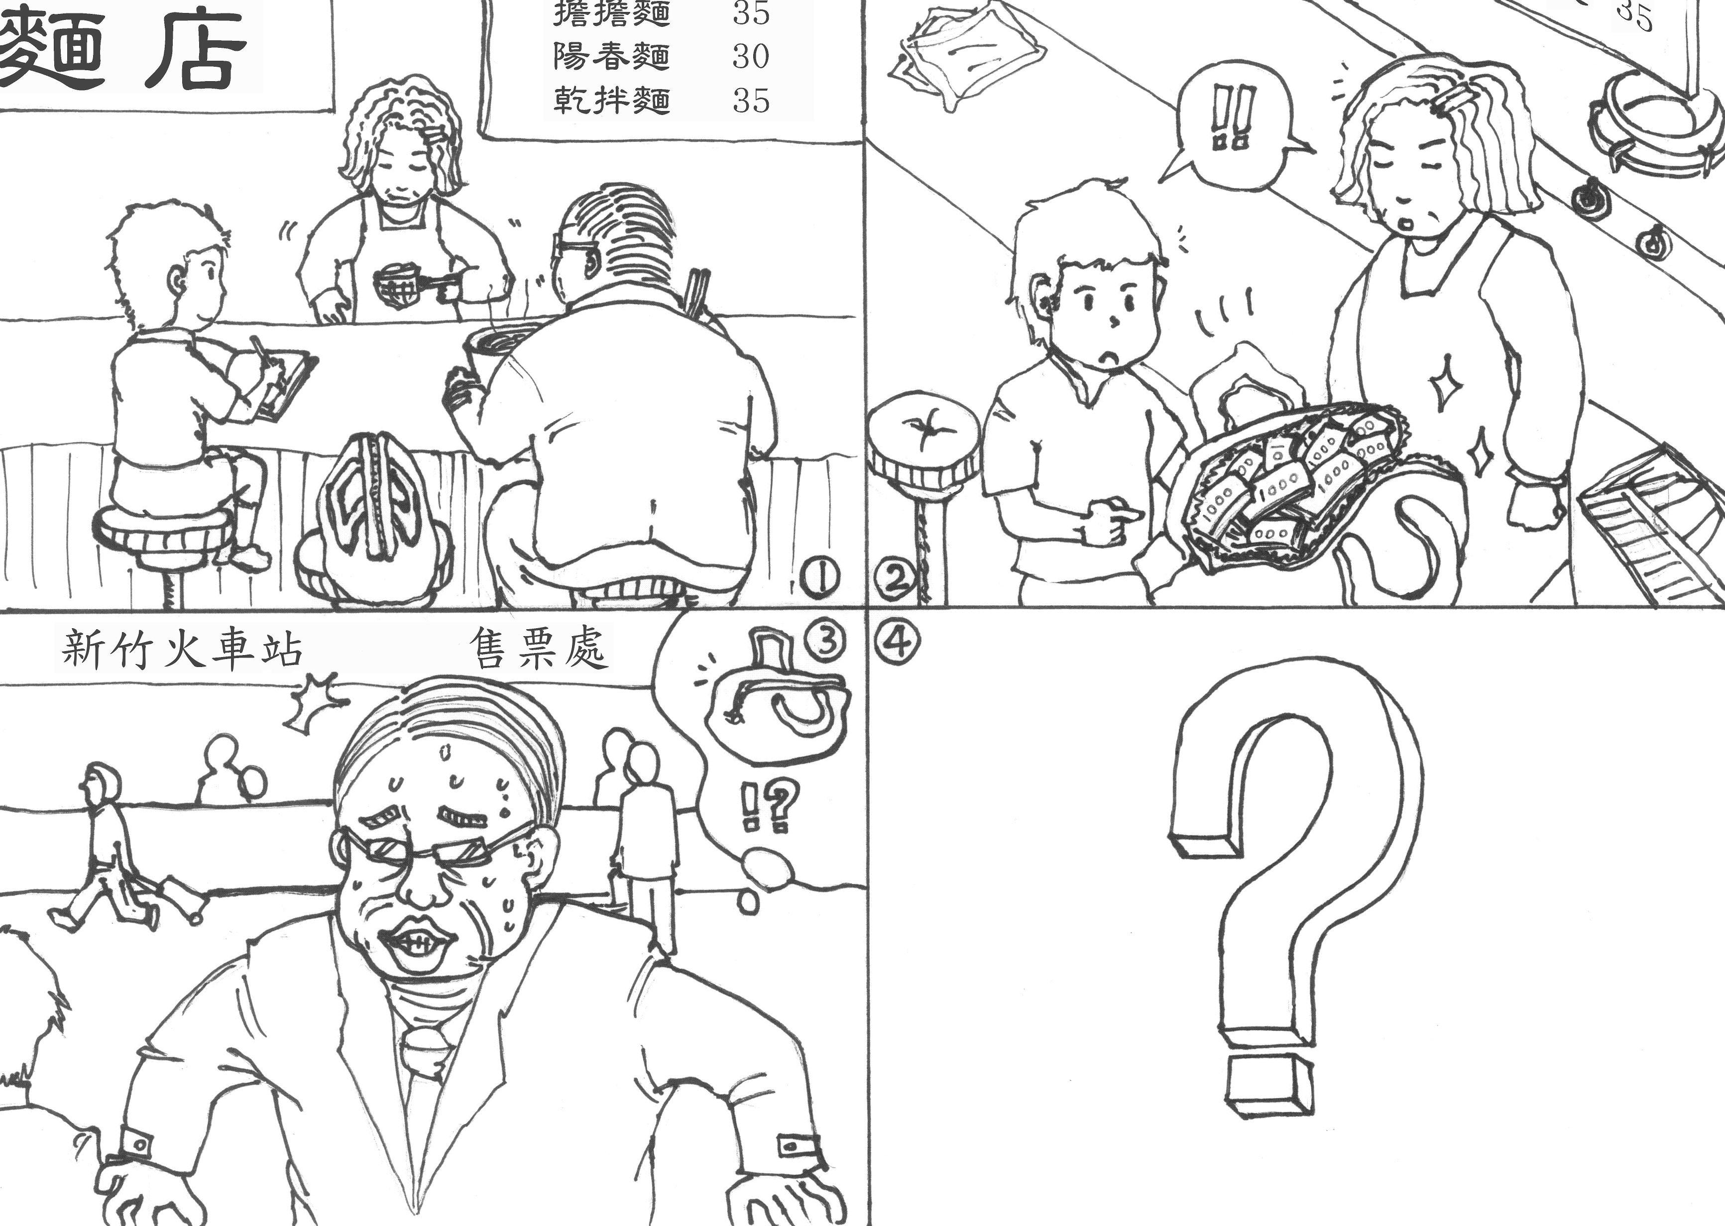

國立臺東高中104學年第一學期高三英文科期末考B組答案卷

適用班級303 304 307 308
班級: 姓名: 座號:
第貳部分：加分題（共20分）
英翻中/中翻英
1. | 2.
3. | 4.
5. | 6.
7. | 8.
9. | 10.

第參部分：非選擇題（共30分）
一、翻譯題（佔10分）
說明：1.請將1.2題英文片語寫至答案卷上，每格1分，共4分。
2.第3.4題請依序作答。每題3分，共6分。

1. When Miyakazi was little, he had to m (編) stories to entertain his younger brothers. (2 分)
2. The history of tea-drinking can d (追溯) to Shang dynasty in China, in the third century A.D. (2分)
3. 雖然他沒有很多錢，他還是請我們吃一餐。(答案可寫早餐午餐晚餐均可給分
;並請用過去式寫作) (3分)
3.

4. 因為下雨，棒球賽被延期了。(請用過去式寫作) (3分)
4.

二、英文作文（佔20分）
說明︰1.依提示在「答案卷」上寫一篇英文作文。
2.文長至少120個單詞(words)。

