台東高中104學年度第一學期第一次期中考高一
英文聽力測驗 適用班級:101-111 (請劃卡於答案卡上)

Part 1: Picture Questions (25%)
Look at each picture and answer the question.
1. | 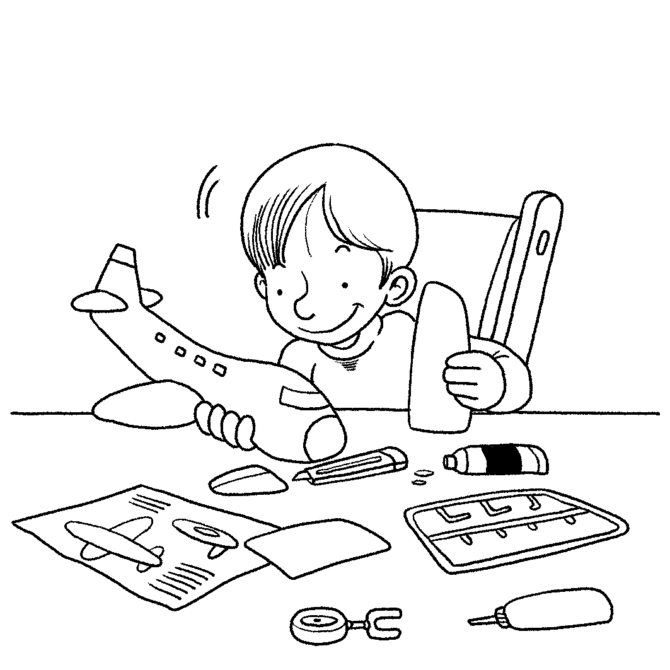 | 2. | 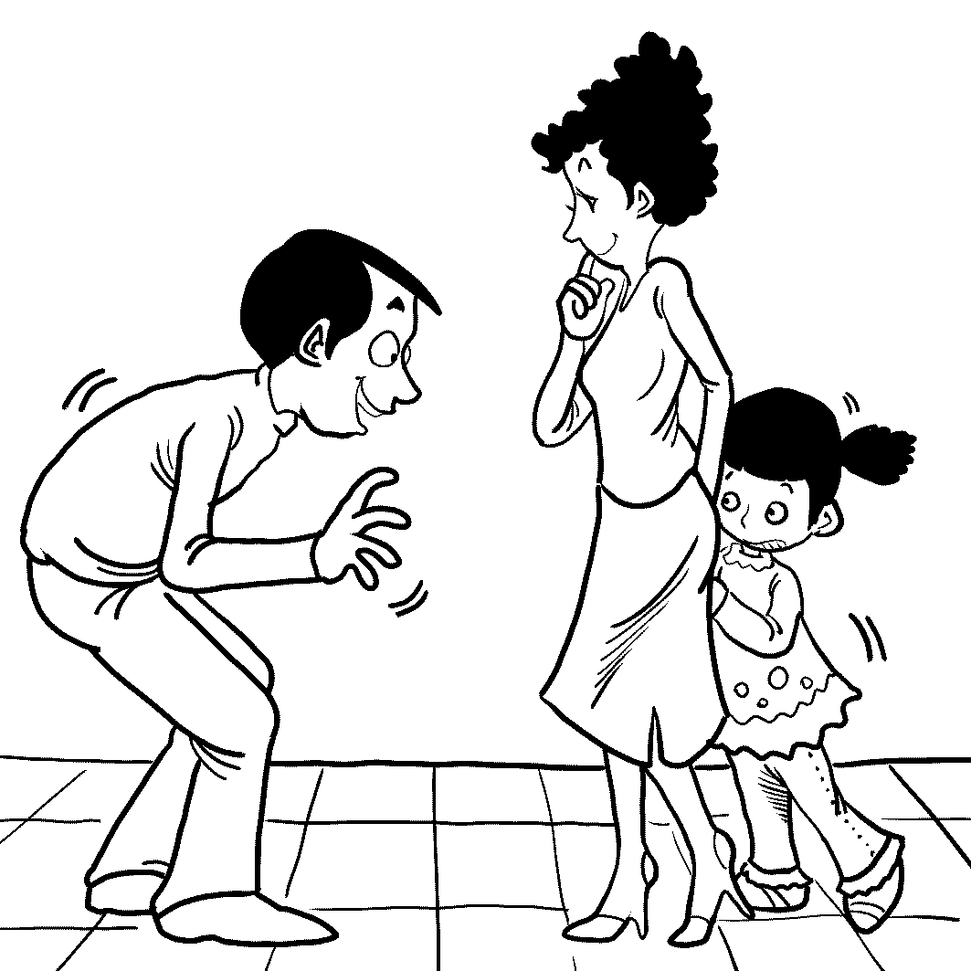
3. | 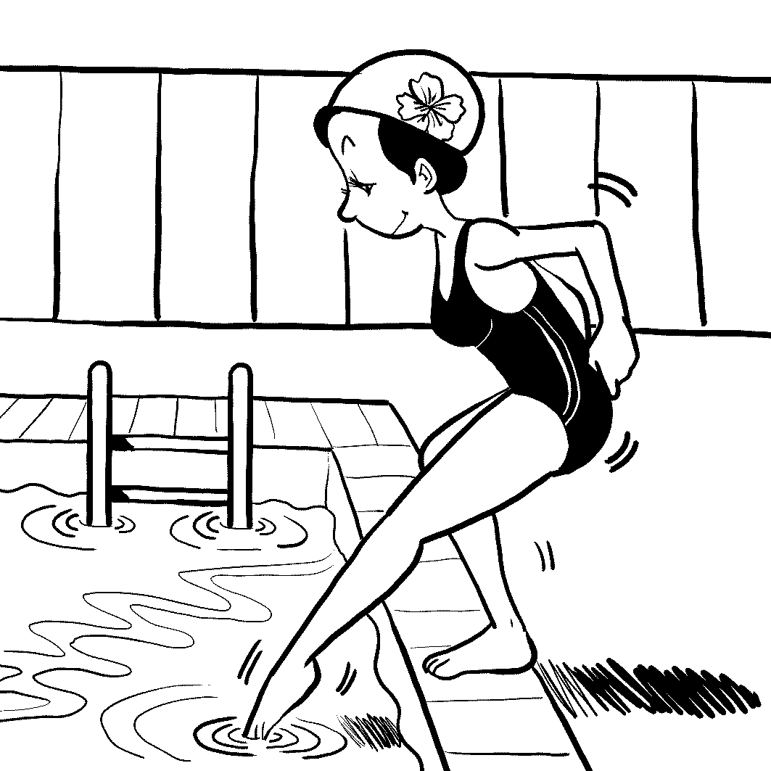 | 4. | 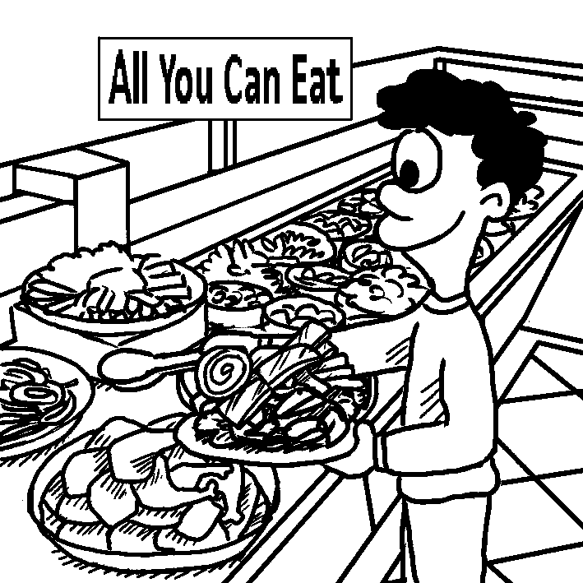
5. | 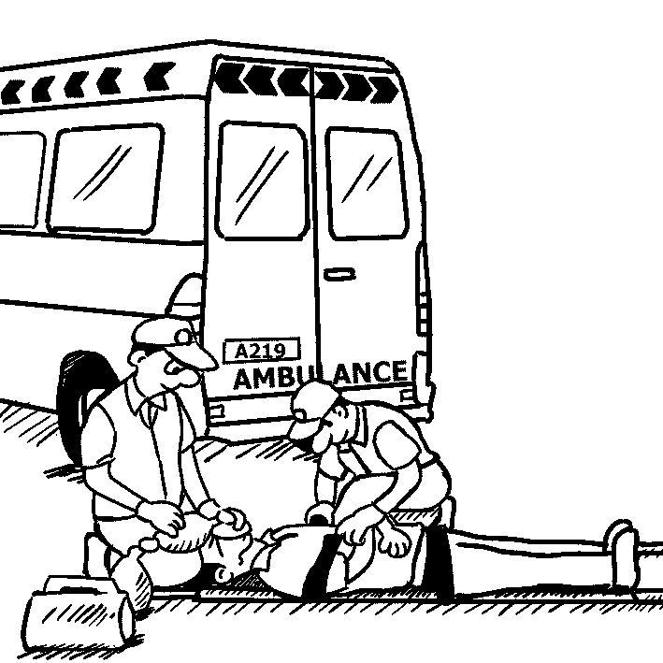 | 6. | 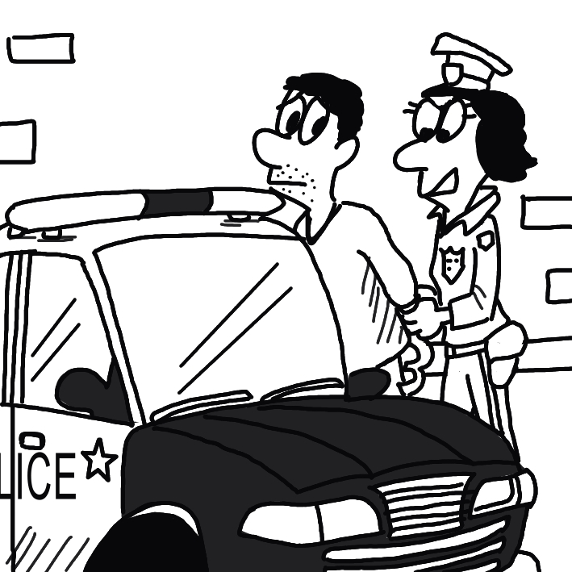
7. | 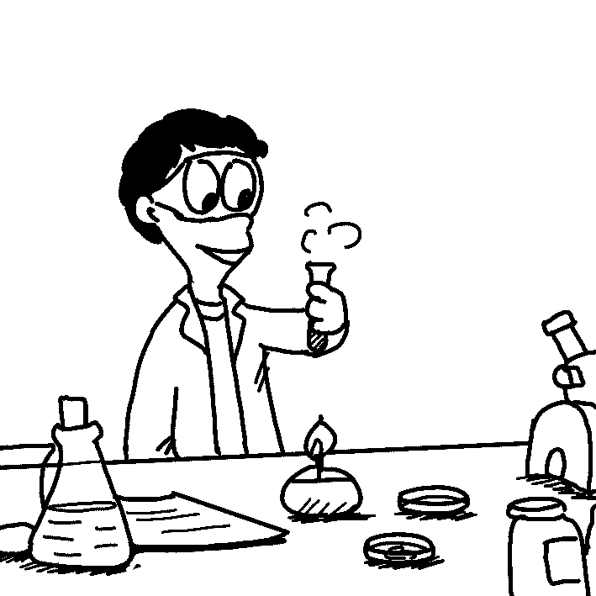 | 8. | 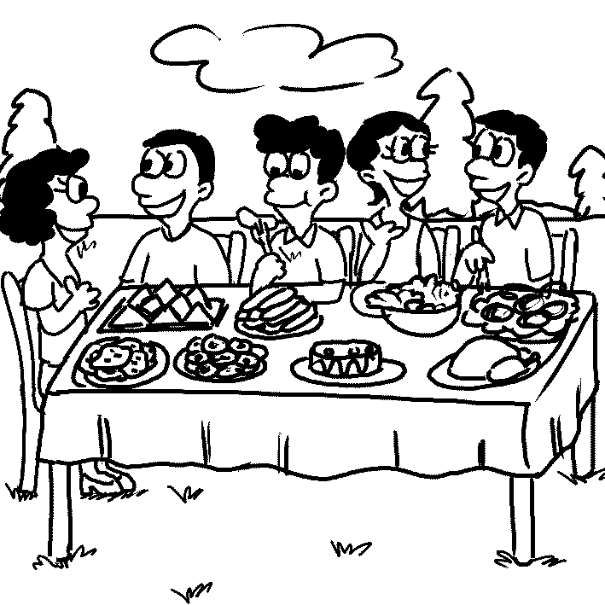
9. | 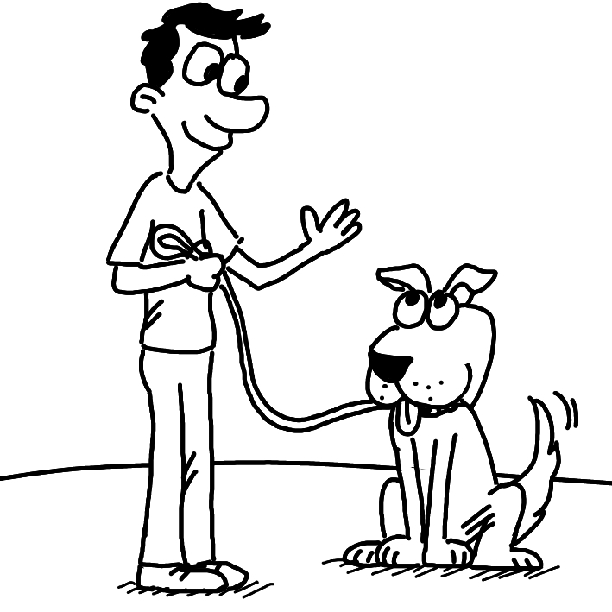 | 10. | 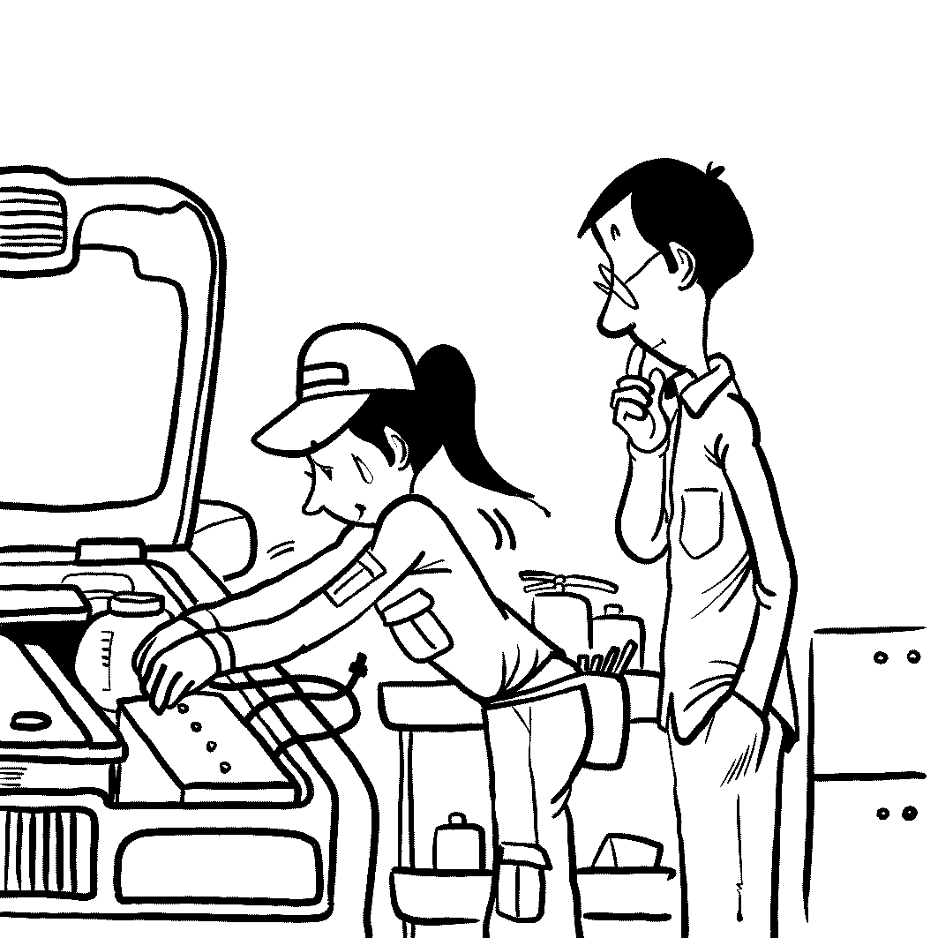

Part 2: Best Response Questions (25%)
Listen to the question or statement and choose the best response.

( ) 11. (A) Yes. I’ll eat anything.
(B) No. It has to be chocolate.
(C) Yeah. I like all flavors.
(D) I do. I only like vanilla.

( ) 12. (A) Of course. He’ll never lie again.
(B) Yes. No one would ever trust him.
(C) I know. We all forgot about it.
(D) That’s right. He is an honest man.

( ) 13. (A) Right. He was angry at both of them.
(B) No, he didn’t want to talk to Serena.
(C) He always gets those two mixed up.
(D) That’s true. He punished both of them.

( ) 14. (A) I know. It won’t do you any good.
(B) I agree. It can help you in the future.
(C) No. There aren’t many students in my class.
(D) That’s right. There are a lot of tests.

( ) 15. (A) I agree. She gives them whatever they want.
(B) I know. I wish she wouldn’t shout so much.
(C) Well, I’m sure she’ll have children one day.
(D) I agree. She never helps them with anything.

( ) 16. (A) Yes. He’s too lazy to start looking.
(B) Right. He is planning to go on a trip.
(C) Yeah. He started a new job last week.
(D) I know. He’s been searching online.

( ) 17. (A) No. You should not miss the class.
(B) That’s great. We can talk in class.
(C) All right. How about we meet for lunch?
(D) Let me know what class you want to take.

( ) 18. (A) Yes. You need to have experience in it.
(B) Right. It only lasts one year.
(C) True. You don’t need any experience.
(D) I know. You have to travel a lot.

( ) 19. (A) Yes. She is a very quiet girl.
(B) I agree. She’ll trust anyone.
(C) I know. She works too hard.
(D) Yeah. She’ll just cut you off.

( ) 20. (A) Really? You had better get it fixed.
(B) See? All you needed was some new tires.
(C) Oh? What kind of noise is it making?
(D) If you can smell that, it’s a bad sign.

Part 3: Conversation Questions (25%)
Listen to each conversation and answer the question.

( ) 21. (A) He has a good teacher.
(B) He can remember many things.
(C) He likes studying.
(D) He does well in school.

( ) 22. (A) It’s a gift from a good friend.
(B) It has special meaning to him.
(C) It’s made of strong material.
(D) It matches his clothes well.

( ) 23. (A) It’s too small. (B) It’s too hard.
(C) It’s about to break. (D) It’s used by other people.

( ) 24. (A) To order a meal. (B) To keep a table.
(C) To ask them to deliver food. (D) To find out where it is.

( ) 25. (A) They hate each other.
(B) Paul is not a nice man.
(C) She has a boyfriend already.
(D) They don’t share the same interests.

( ) 26. (A) He can’t hear very well. (B) He is unhappy.
(C) He has a sore throat. (D) He’s busy listening to music.

( ) 27. (A) She doesn’t have much money. (B) She can’t go home too late.
(C) She isn’t very hungry. (D) She doesn’t feel very well.

( ) 28. (A) He’s doing something important.
(B) He’s always late to things.
(C) He’s still coming today.
(D) He’s difficult to understand.

( ) 29. (A) If the woman has learned a lot from them.
(B) If the woman has taken them before.
(C) If the woman is glad to take them.
(D) If the woman knows a lot about them.

( ) 30. (A) Talk to Jim if he’s poor.
(B) Say Jim’s clothes are dirty.
(C) Tell people Jim’s secret.
(D) Judge Jim by his looks.

Part 4: Short Talk Questions (25%)
Listen to the following paragraph and answer the questions.

Paragraph A
( ) 31. (A) Her teacher. (B) A stranger.
(C) Her classmate. (D) A famous person.

( ) 32. (A) She knew some friends from there.
(B) She had studied the country before.
(C) She liked how the word sounded.
(D) She really wanted to travel there.

( ) 33. (A) Making art. (B) Going shopping.
(C) Playing sports. (D) Watching TV.

( ) 34. (A) Their age. (B) Their family wealth.
(C) Their hobbies. (D) Their personality.

( ) 35. (A) Write a book. (B) Attend college.
(C) Star in a movie. (D) Start a family.

Paragraph B
( ) 36. (A) The bones. (B) The eyes.
(C) The heart. (D) The head.

( ) 37. (A) You have more energy.
(B) You are able to learn more.
(C) You need less sleep.
(D) You don’t feel hungry as often.

( ) 38. (A) Apples. (B) Cherries.
(C) Grapes. (D) Strawberries.

( ) 39. (A) It slows down how fast you age.
(B) It helps your stomach process food.
(C) It cleans your blood.
(D) It makes you stronger.

( ) 40. (A) Bottled tea. (B) Chinese tea.
(C) Fresh tea. (D) Iced tea.

