台東高中104學年度第一學期第一次段考高一 Live英聽測驗

Part 1: Picture Questions (25%)
Look at each picture and answer the question.

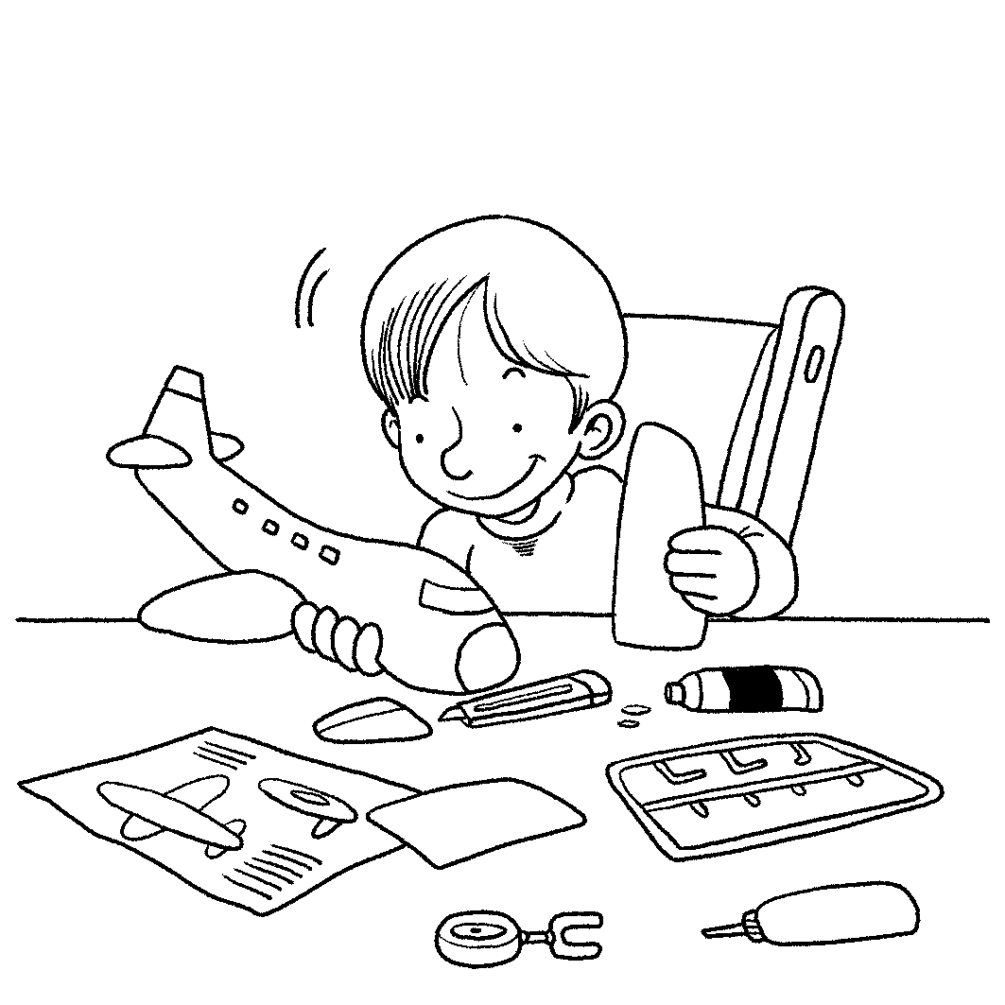
(B) 1. What is the boy doing? (9-p. 11-1)
(A) He is playing with blocks.
(B) He is building a model.
(C) He is using a flashlight.
(D) He is reading a text.

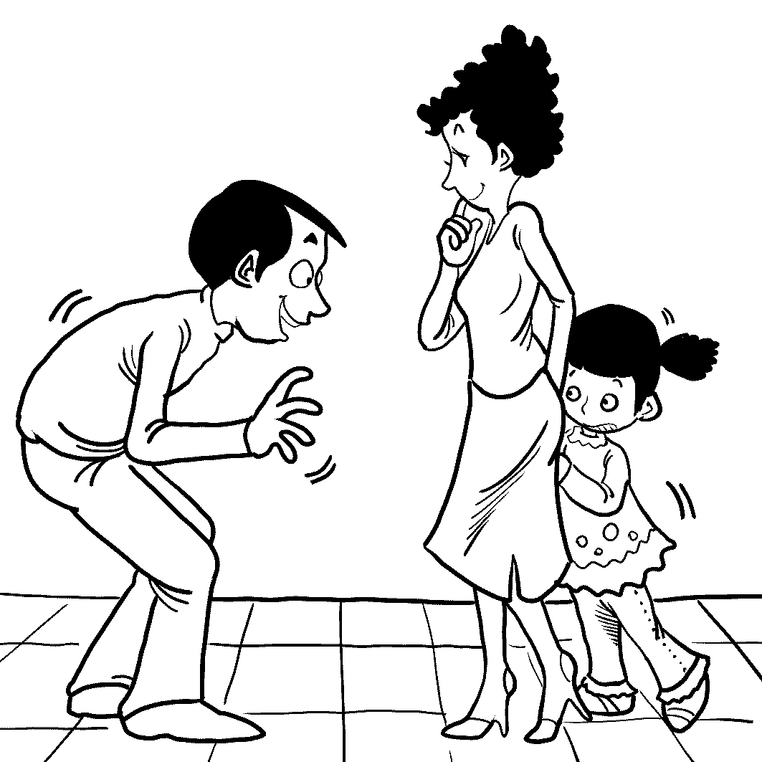
(D) 2. What do we know about the little girl? (9-p. 17-4)
(A) She looks happy to see the man.
(B) She is walking back and forth.
(C) She has a bad memory.
(D) She is avoiding the man.

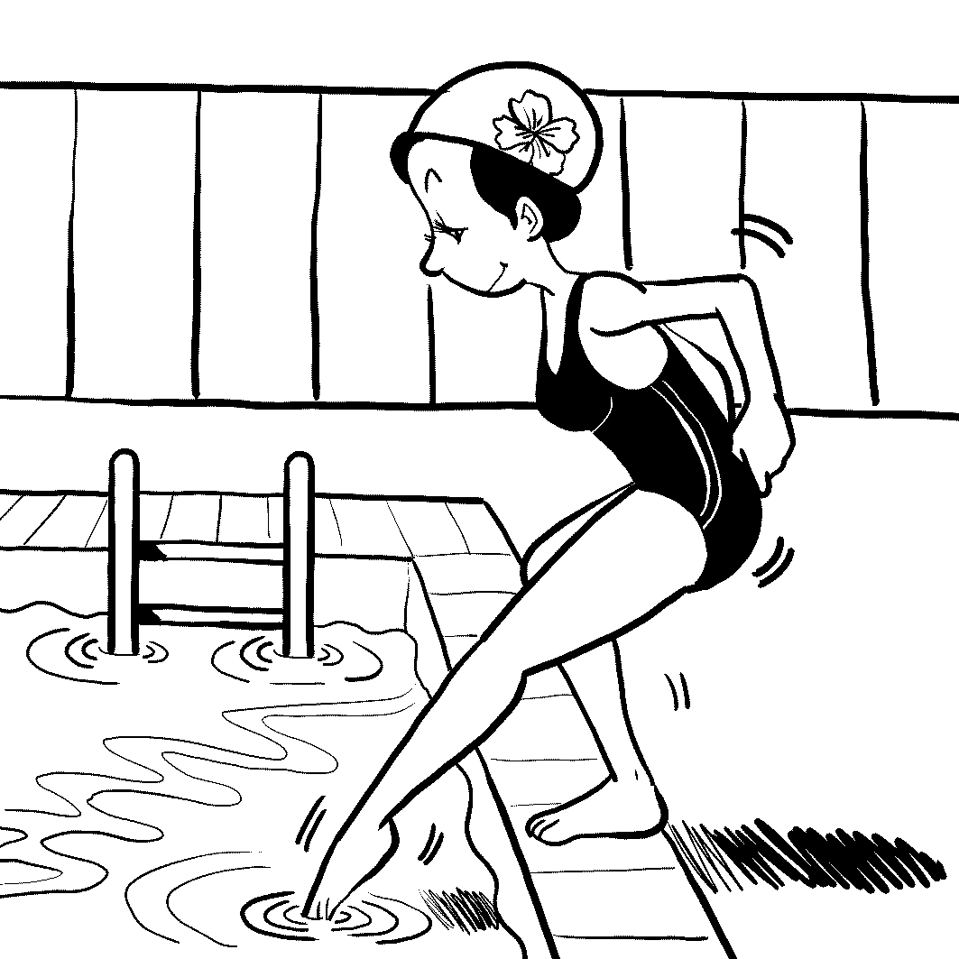
(B) 3. What is the woman doing? (9-p. 19-5)
(A) Taking a regular nap.
(B) Dipping her toes in the water.
(C) Responding to an e-mail.
(D) Showing a magical trick.

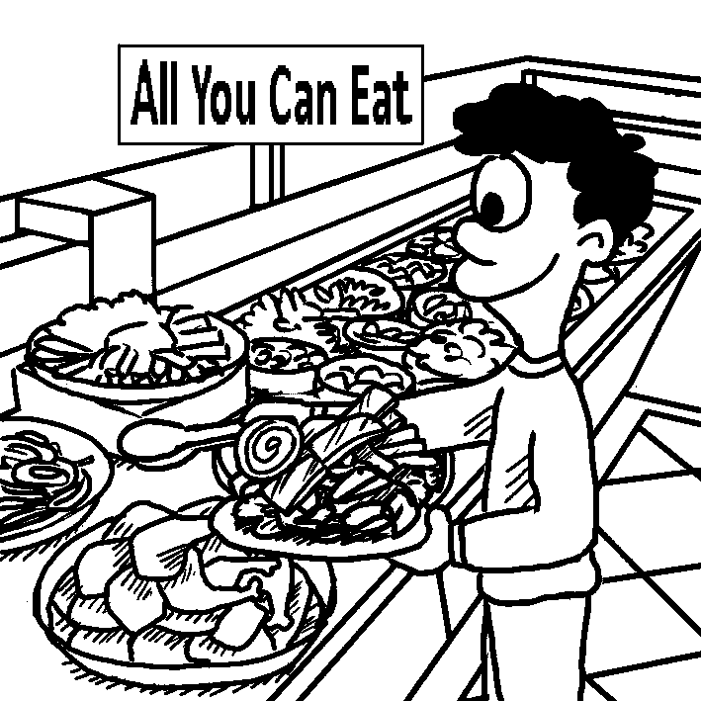
(B) 4. What do we know about the man? (9-p. 24-7)
(A) He can’t help but laugh loudly.
(B) He is at a buffet restaurant.
(C) He is trying to reserve a table.
(D) He is squeezing some juice.

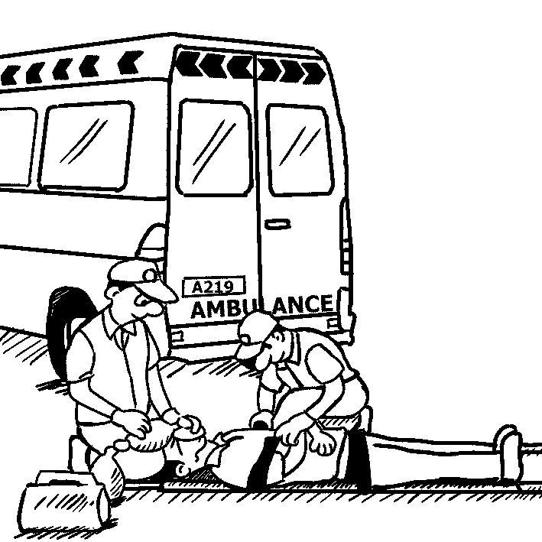
(D) 5. What can we see in the picture? (9-p. 29-9)
(A) A close friendship.
(B) A group of pals.
(C) An available seat.
(D) An emergency.

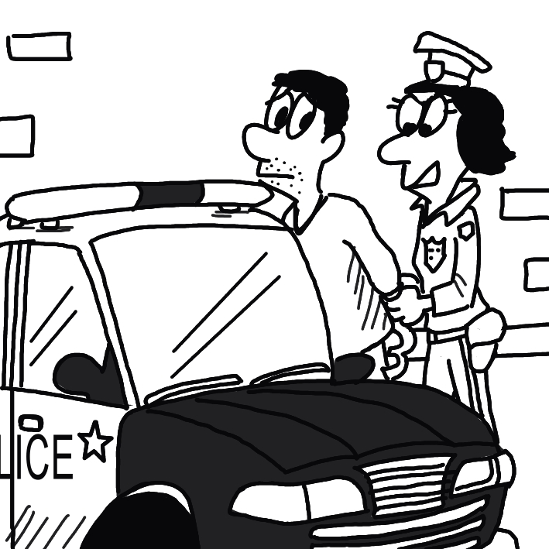
(B) 6. What happened to the man? (9-p. 31-10)
(A) He just quit his job.
(B) He has been arrested.
(C) He won a scholarship.
(D) He helped the woman secretly.

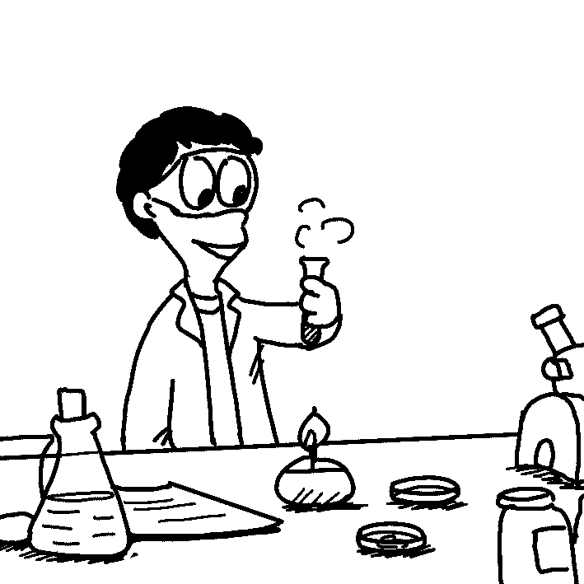
(C) 7. What do we know about the man? (9-p. 39-14)
(A) He designs swimwear.
(B) He exercises regularly.
(C) He is doing an experiment.
(D) He is buying an item that is on sale.

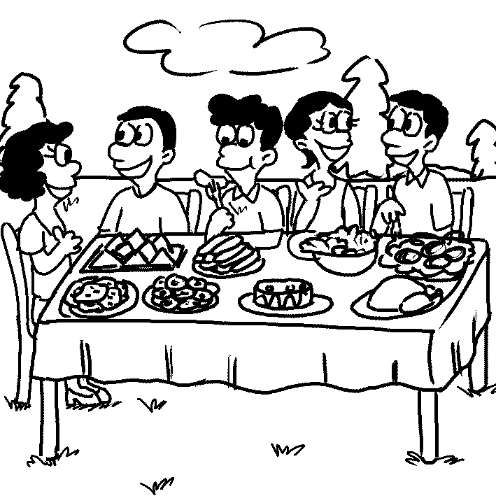
(B) 8. What is true about the people? (9-p. 42-15)
(A) They are losing their appetites.
(B) They are having an enjoyable meal.
(C) They are spoiling their children.
(D) They are making salty dishes.


(A) 9. What do we know about the dog? (9-p. 48-17)
(A) It is with its owner.
(B) It looks sick and weak.
(C) It is revealing its teeth.
(D) It needs to be rescued.

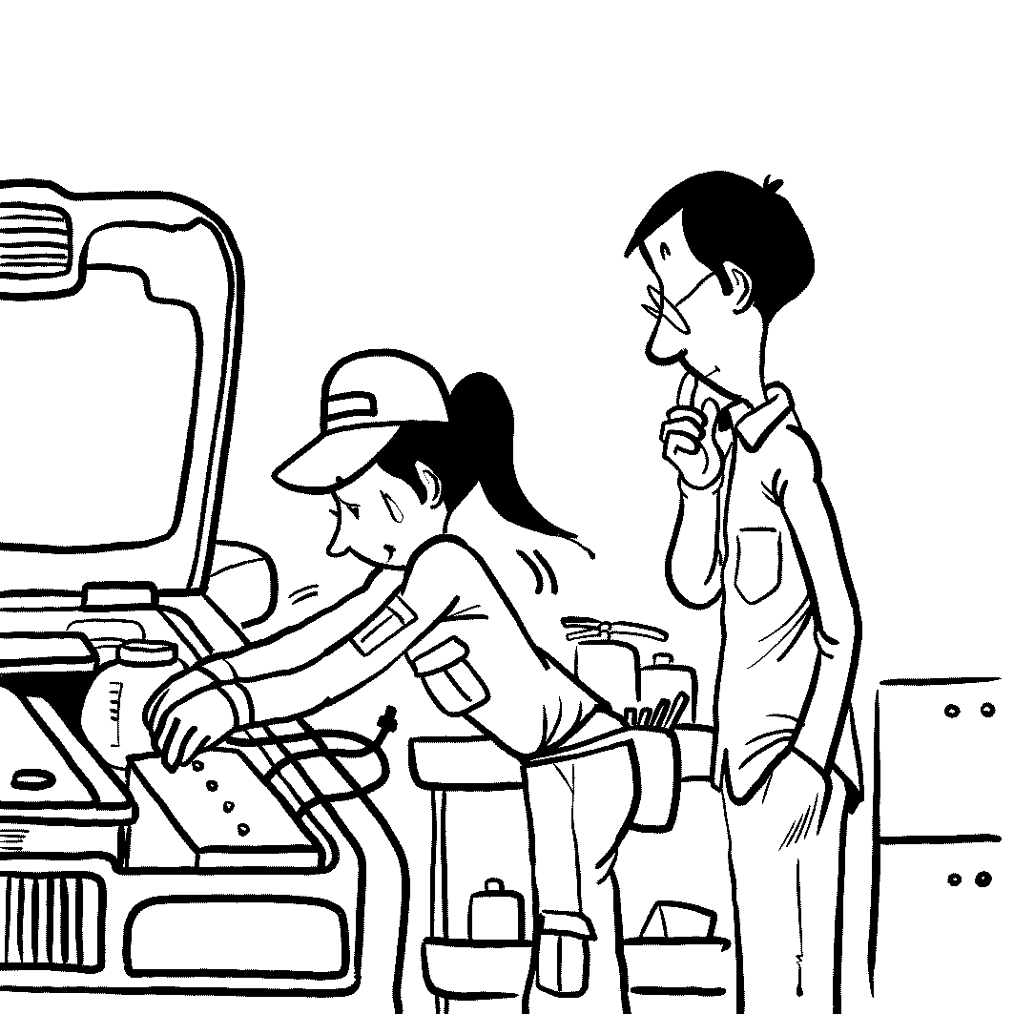
(D) 10. What is the woman doing? (9-p. 55-18)
(A) Grabbing the man’s arm.
(B) Interrupting the man.
(C) Hitting the man’s palm.
(D) Repairing the man’s car.

Part 2: Best Response Questions (25%)
Listen to the question or statement and choose the best response.

(D) 11. Do you have a specific flavor you like? (9-p. 13-2)
(A) Yes. I’ll eat anything.
(B) No. It has to be chocolate.
(C) Yeah. I like all flavors.
(D) I do. I only like vanilla.

(B) 12. After the accident, Larry was labeled a liar. (9-p. 17-4)
(A) Of course. He’ll never lie again.
(B) Yes. No one would ever trust him.
(C) I know. We all forgot about it.
(D) That’s right. He is an honest man.

(C) 13. Mr. Lee mistook Serena for her sister Sarah. (9-p. 21-6)
(A) Right. He was angry at both of them.
(B) No, he didn’t want to talk to Serena.
(C) He always gets those two mixed up.
(D) That’s true. He punished both of them.

(B) 14. There are many advantages of learning English. (9-p. 33-11)
(A) I know. It won’t do you any good.
(B) I agree. It can help you in the future.
(C) No. There aren’t many students in my class.
(D) That’s right. There are a lot of tests.

(A) 15. I can’t stand the way Mrs. Johnson spoils her children. (9-p. 35-12)
(A) I agree. She gives them whatever they want.
(B) I know. I wish she wouldn’t shout so much.
(C) Well, I’m sure she’ll have children one day.
(D) I agree. She never helps them with anything.

(D) 16. George is in the process of finding a job. (9-p. 39-14)
(A) Yes. He’s too lazy to start looking.
(B) Right. He is planning to go on a trip.
(C) Yeah. He started a new job last week.
(D) I know. He’s been searching online.

(C) 17. I have class before noon, but I can meet you afterward. (9-p. 42-15)
(A) No. You should not miss the class.
(B) That’s great. We can talk in class.
(C) All right. How about we meet for lunch?
(D) Let me know what class you want to take.

(A) 18. The job requires one year of experience. (9-p. 47-17)
(A) Yes. You need to have experience in it.
(B) Right. It only lasts one year.
(C) True. You don’t need any experience.
(D) I know. You have to travel a lot.

(D) 19. Angela has a bad habit of interrupting people. (9-p. 49-18)
(A) Yes. She is a very quiet girl.
(B) I agree. She’ll trust anyone.
(C) I know. She works too hard.
(D) Yeah. She’ll just cut you off.

(B) 20. My car runs much more smoothly than before. (9-p. 57-20)
(A) Really? You had better get it fixed.
(B) See? All you needed was some new tires.
(C) Oh? What kind of noise is it making?
(D) If you can smell that, it’s a bad sign.

Part 3: Conversation Questions (25%)
Listen to each conversation and answer the question.

(B) 21. F: What’s Alan’s favorite subject? (9-p. 13-2)
M: Geography.
F: That makes sense.
M: Yeah, he has a good memory.
Q: What does the man say about Alan?
(A) He has a good teacher.
(B) He can remember many things.
(C) He likes studying.
(D) He does well in school.

(B) 22. F: I like your necklace. (9-p. 17-4)
M: Thanks. I love it, too.
F: Do you always wear it?
M: Yeah. It represents strength.
Q: What is the man saying about his necklace?
(A) It’s a gift from a good friend.
(B) It has special meaning to him.
(C) It’s made of strong material.
(D) It matches his clothes well.

(B) 23. M: I can’t sit in this chair for long. (9-p. 19-5)
F: What’s the matter with it?
M: It isn’t soft enough for me.
F: You can go get another one.
Q: What do we know about the chair?
(A) It’s too small.
(B) It’s too hard.
(C) It’s about to break.
(D) It’s used by other people.

(B) 24. M: Let’s eat at that new Italian restaurant tonight. (9-p. 24-7)
F: Sounds great, but I heard it is always busy.
M: Can you call them to reserve a table for us?
F: Sure, no problem!
Q: Why does the woman call the restaurant?
(A) To order a meal.
(B) To keep a table.
(C) To ask them to deliver food.
(D) To find out where it is.

(D) 25. M: I heard that you are dating Paul. (9-p. 27-8)
F: That’s not true. He’s the last person I’d go out with.
M: Come on, is he that bad?
F: No, just we have nothing in common.
Q: Why doesn’t the woman date Paul?
(A) They hate each other.
(B) Paul is not a nice man.
(C) She has a boyfriend already.
(D) They don’t share the same interests.

(B) 26. M: Brian won’t talk to me. (9-p. 31-10)
F: I know. He’s not talking to anyone.
M: Did something happen to him?
F: He’s just in a bad mood.
Q: What does the woman say about Brian?
(A) He can’t hear very well.
(B) He is unhappy.
(C) He has a sore throat.
(D) He’s busy listening to music.

(C) 27. M: That movie was pretty funny. (9-p. 42-15)
F: Yeah. I liked it a lot.
M: So, should we get some dinner?
F: I don’t have a big appetite right now.
Q: What does the woman mean?
(A) She doesn’t have much money.
(B) She can’t go home too late.
(C) She isn’t very hungry.
(D) She doesn’t feel very well.

(D) 28. M: I thought Mike was coming today. (9-p. 47-17)
F: He was, but then he changed his mind.
M: Why does he always do that?
F: Who knows? He’s a complex person.
Q: What is the woman saying about Mike?
(A) He’s doing something important.
(B) He’s always late to things.
(C) He’s still coming today.
(D) He’s difficult to understand.

(C) 29. M: Have your music classes started? (9-p. 48-18)
F: Not until next week.
M: Are you looking forward to them?
F: Not really. My parents are making me go.
Q: What does the man ask about the classes?
(A) If the woman has learned a lot from them.
(B) If the woman has taken them before.
(C) If the woman is glad to take them.
(D) If the woman knows a lot about them.

(D) 30. F: I think Jim is poor. (9-p. 55-19)
M: Why do you say that?
F: Because his clothes are always dirty.
M: Don’t judge him by his appearance.
Q: What is the man telling the woman not to do?
(A) Talk to Jim if he’s poor.
(B) Say Jim’s clothes are dirty.
(C) Tell people Jim’s secret.
(D) Judge Jim by his looks.

Part 4: Short Talk Questions (25%)
Listen to the following paragraph and answer the questions.

Paragraph A
In 1997, Caitlin Alifirenka’s seventh grade teacher told her to write to someone in another country. She chose Zimbabwe because the sound of the word appealed to her. Caitlin and her pen pal, Martin Gamba, had some things in common, like playing soccer or listening to the Spice Girls. However, there were also differences. Martin lived in poverty; his family shared a single room with another family, and the kids slept on the floor. Caitlin secretly sent him money, and with her help, Martin was able to finish school and earn two degrees on a scholarship in America. This year, they published a book together about their friendship, called I Will Always Write Back.
(9-p. 26-29)

(B) 31. Who did Caitlin write to?
(A) Her teacher.
(B) A stranger.
(C) Her classmate.
(D) A famous person.

(C) 32. Why did Caitlin choose Zimbabwe?
(A) She knew some friends from there.
(B) She had studied the country before.
(C) She liked how the word sounded.
(D) She really wanted to travel there.

(C) 33. What do both Caitlin and Martin enjoy doing?
(A) Making art.
(B) Going shopping.
(C) Playing sports.
(D) Watching TV.

(B) 34. What difference between Caitlin and Martin is mentioned in the passage?
(A) Their age.
(B) Their family wealth.
(C) Their hobbies.
(D) Their personality.

(A) 35. What did Caitlin and Martin do together this year?
(A) Write a book.
(B) Attend college.
(C) Star in a movie.
(D) Start a family.

Paragraph B
To do better in school and at work, we should eat foods that promote brain health. Berries are well-known brain foods. Studies show that blueberries can improve learning capacity and reduce depression symptoms. Strawberries and blueberries have been shown to lower the risk of age-related diseases like Alzheimer’s. Doctors recommend one cup of berries per day. Eating fish is also good for your brain. Salmon contain omega-3 fatty acids which can slow down the aging process. In fact, certain brain cells live longer in fish-eaters than in those with a fishless diet. Finally, tea is a super brain food that helps memory and concentration. However, it must be freshly brewed, not bottled. (9-p. 36-39)

(D) 36. What part of the body is the focus of the passage?
(A) The bones.
(B) The eyes.
(C) The heart.
(D) The head.

(B) 37. How can eating berries improve your health?
(A) You have more energy.
(B) You are able to learn more.
(C) You need less sleep.
(D) You don’t feel hungry as often.

(D) 38. According to the passage, what should you eat to fight Alzheimer’s?
(A) Apples.
(B) Cherries.
(C) Grapes.
(D) Strawberries.

(A) 39. What can eating salmon do for your health?
(A) It slows down how fast you age.
(B) It helps your stomach process food.
(C) It cleans your blood.
(D) It makes you stronger.

(C) 40. What kind of tea is best when it comes to promoting brain health?
(A) Bottled tea.
(B) Chinese tea.
(C) Fresh tea.
(D) Iced tea.

