台東高中104學年度第一學期第一次期中考高三
英文聽力測驗 適用班級:301-311 (請劃卡於答案卡上)
一 、 看 圖 辨 義 ： 第 一 部 分 （ 單 選 題 ）
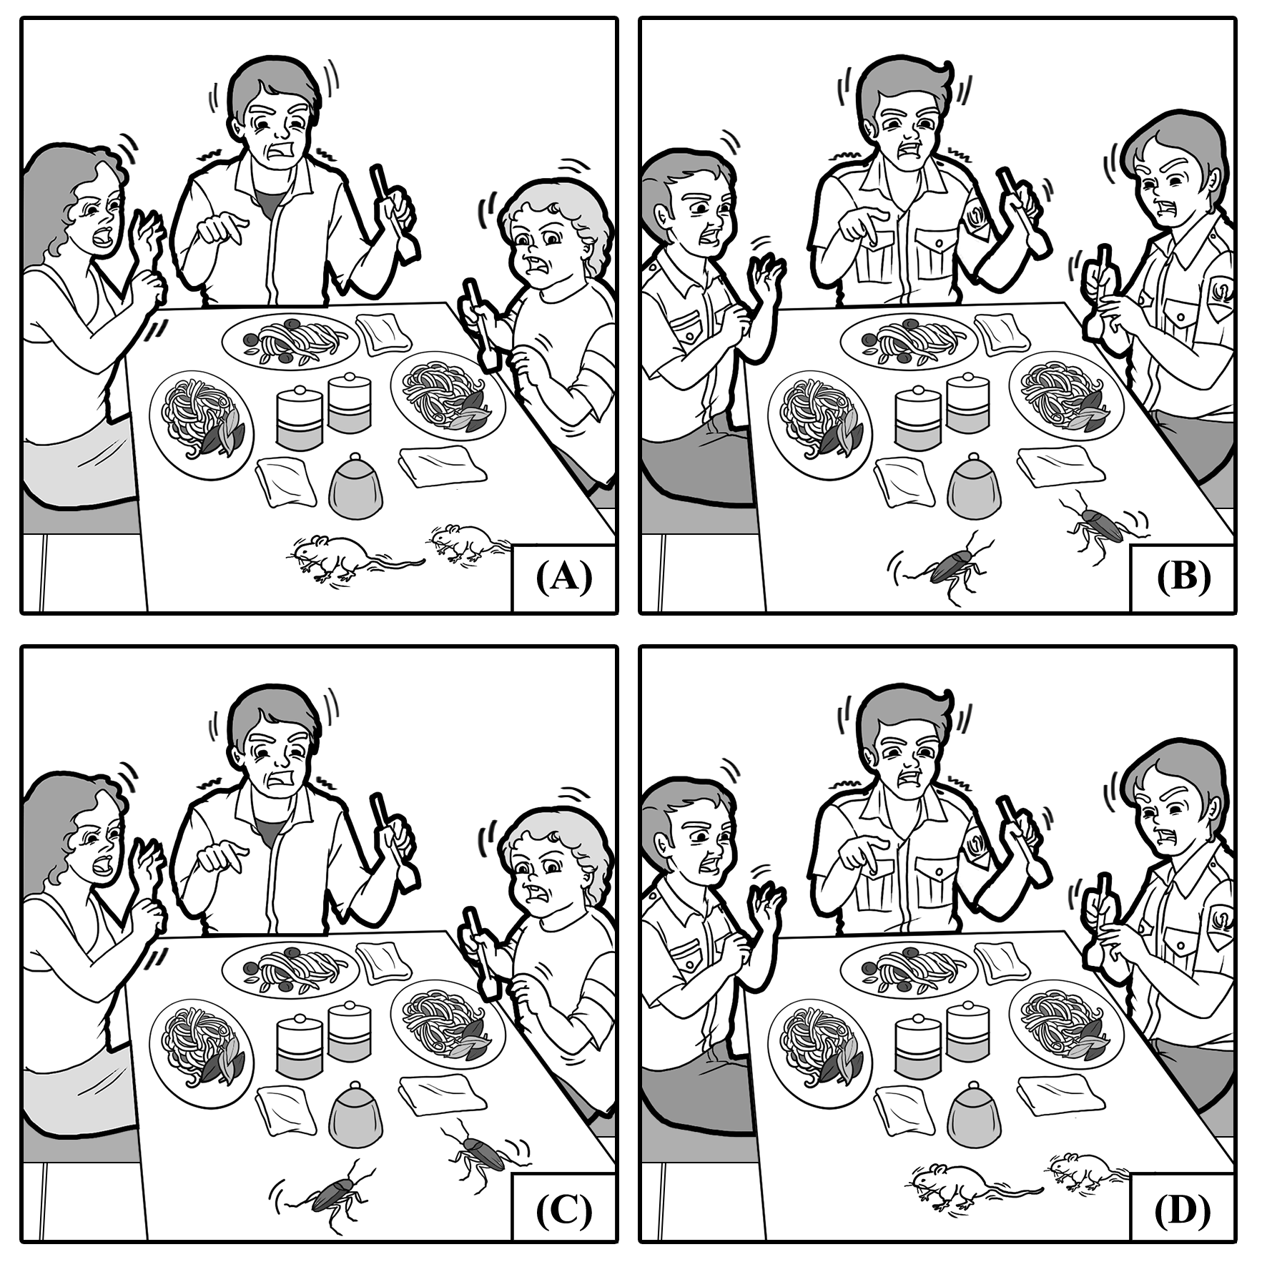說明︰第1題至第4題，每題有四幅圖畫。請仔細觀察各圖畫，並聆聽語音播出的試題，根據試題內容選出最符合題意的圖畫選項，並將答案畫記在答案卡之「選擇題答案區」，每題播放一次。

1. ( )
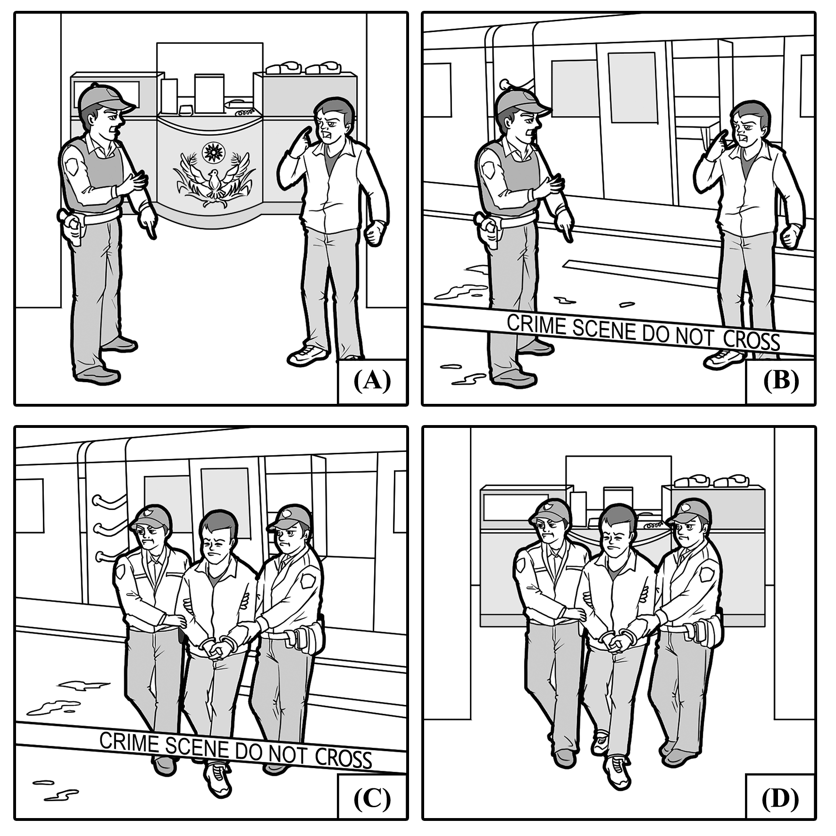

2. ( )

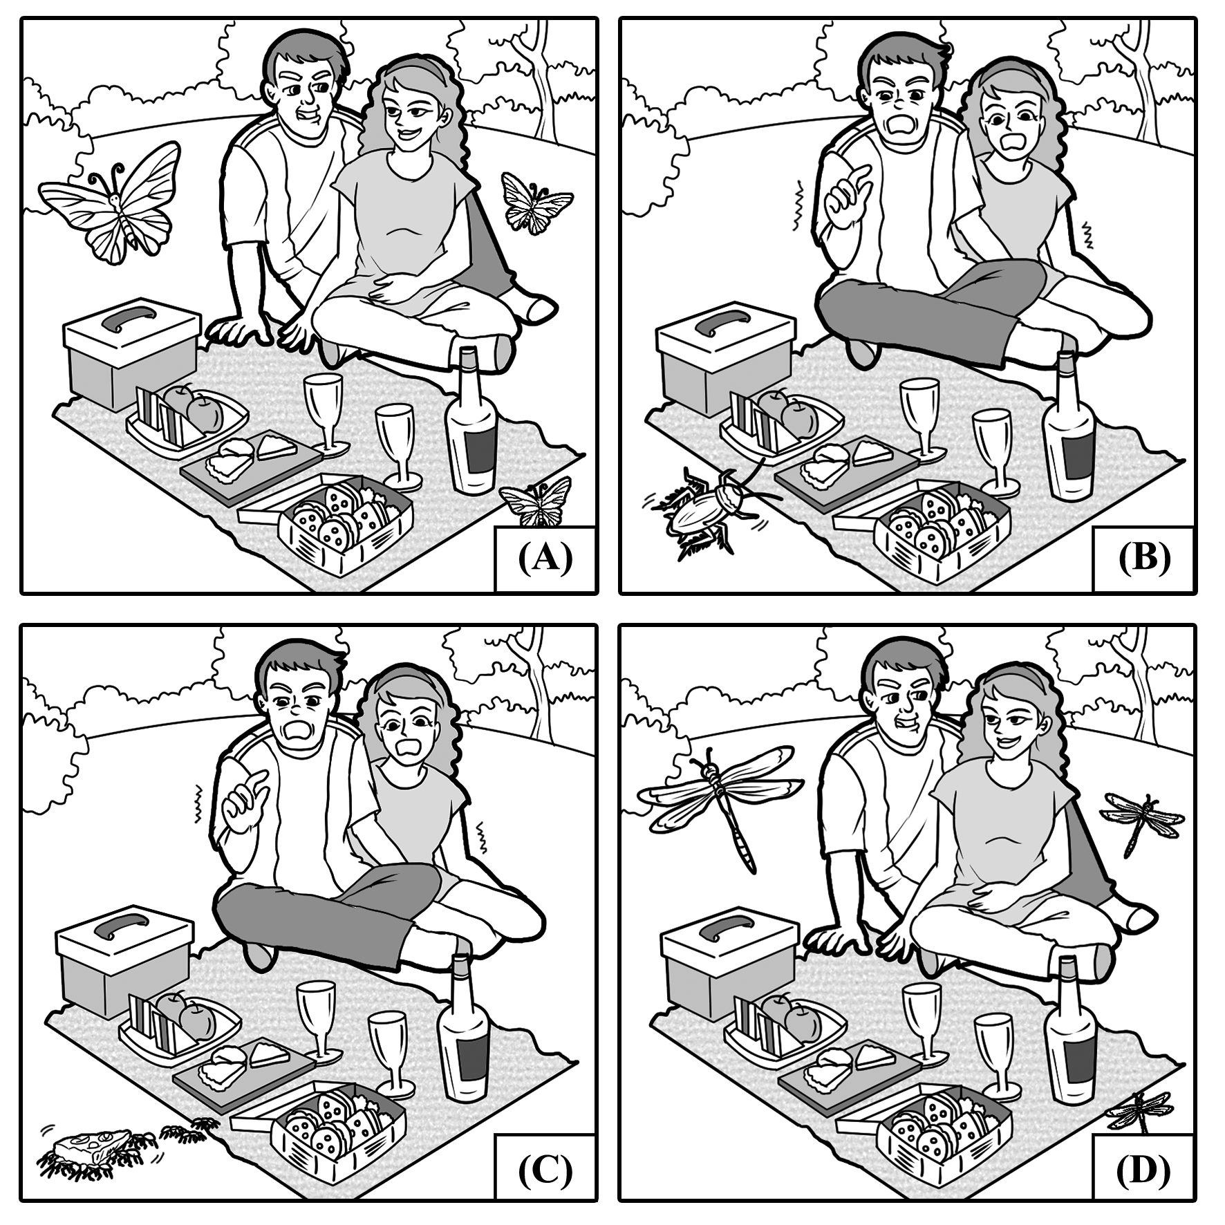

3. ( )
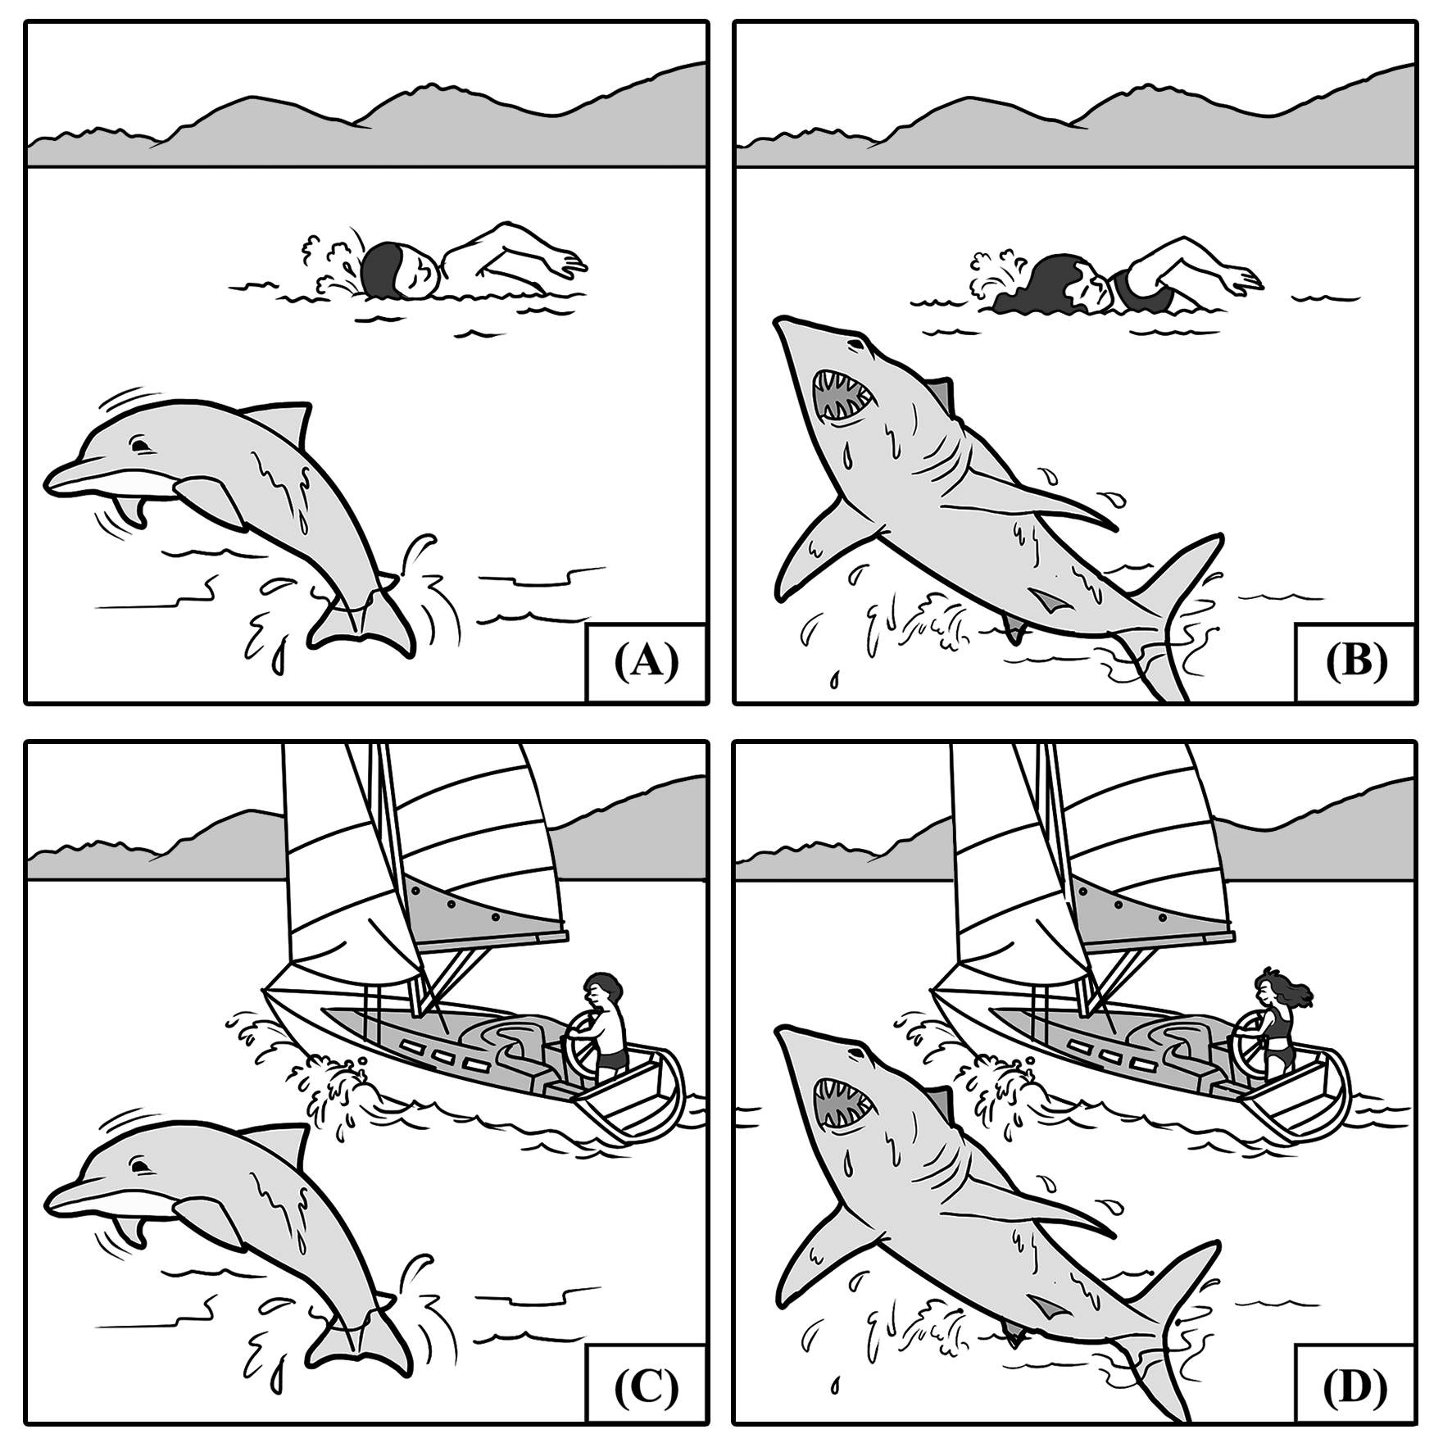

4. ( )
一 、 看 圖 辨 義 ： 第 二 部 分 （ 多 選 題 ）
說明︰第5題至第10題為多選題，每題配有一幅圖畫，請仔細觀察圖畫並聆聽試題，從聽到的4個選項中選出最符合圖意的2個答案，並將答案畫記在答案卡之「選擇題答案區」，每題播放一次。各題之選項獨立判定，所有選項均答對者，得該題題分；答錯1個選項者，得該題一半題分；答錯多於1個選項或所有選項均未作答者，該題以零分計算。

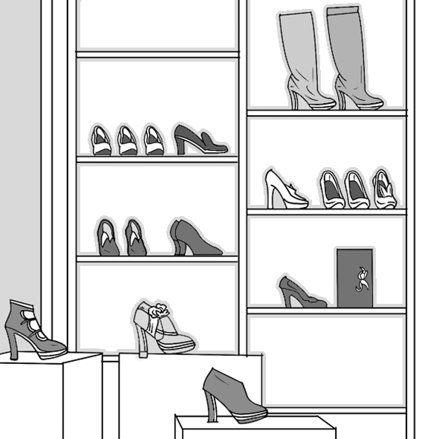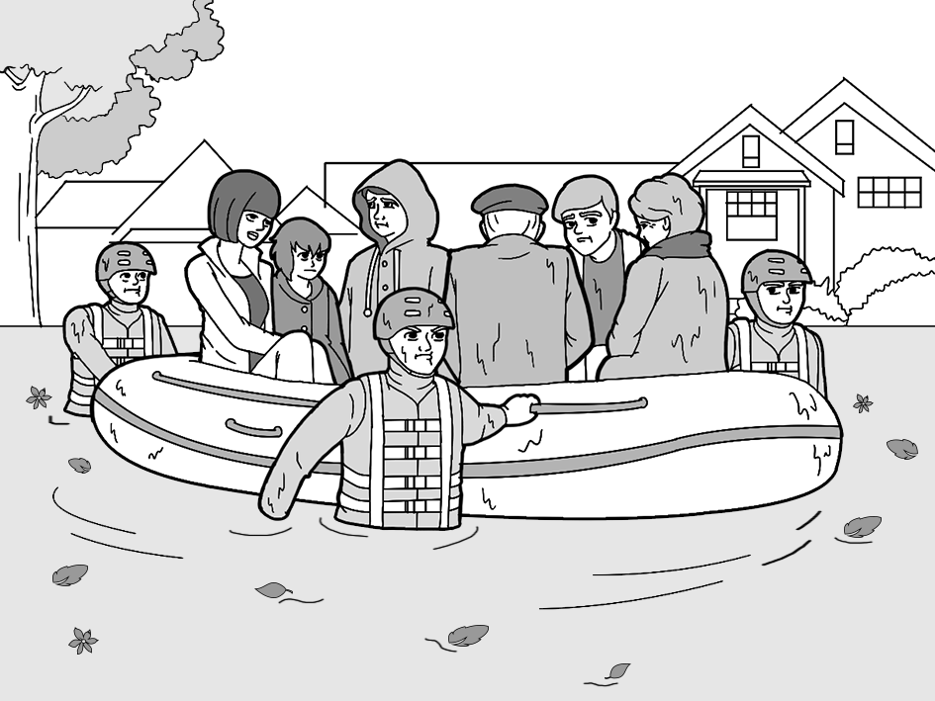
B
A

5. ( ) ( ) 6. ( ) ( )
D
C
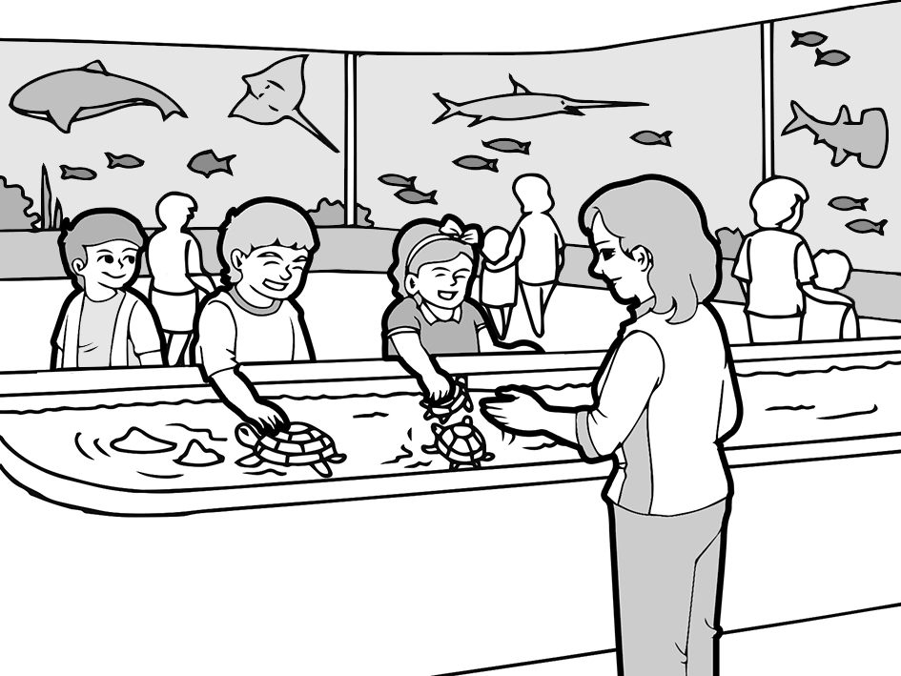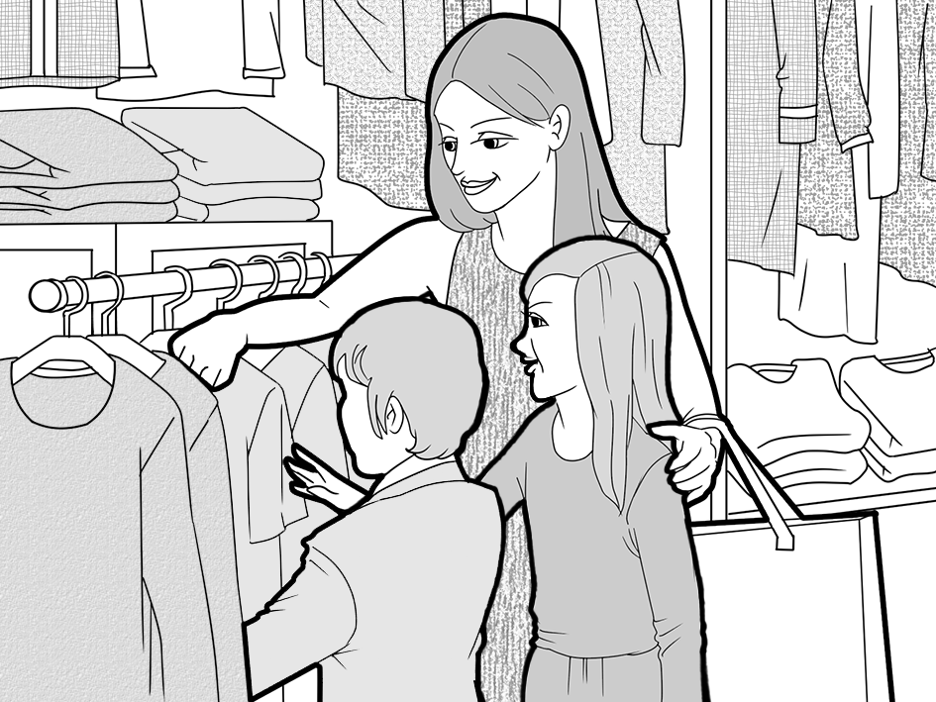

7. ( ) ( ) 8. ( ) ( )
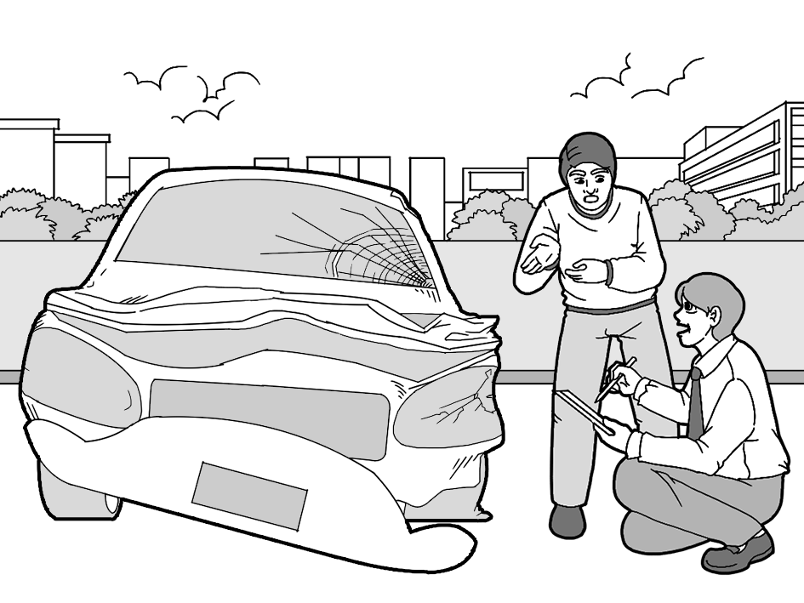
F
E
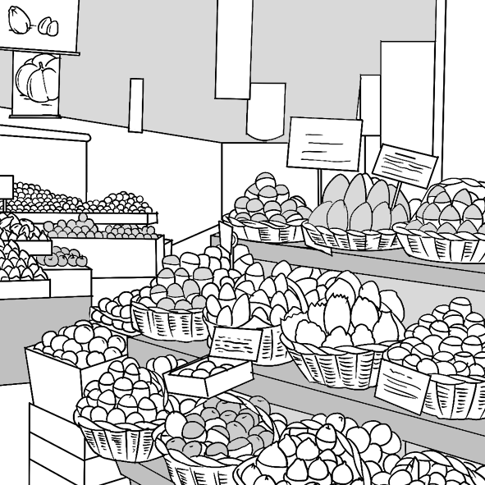

9. ( ) ( ) 10. ( ) ( )
二 、 對 答
說明：第11題至第20題，共10題，皆為單題。請聽語音播出的一個問句或直述句後，依試題本所列的選項，選出一個最適當的回應選項，並將答案畫記在答案卡之「選擇題答案區」，每題播放一次。

11. (A) I don't like going to see the doctor because I hate needles.
(B) Yes, I slept like a baby last night.
(C) That's scary. I'll try to sleep more to avoid poor health.
(D) You overslept for the second time this week.

12. (A) The meeting went poorly because you weren't there.
(B) Even though I fell, I didn't get hurt.
(C) I miss the summer, too. I dislike this cold weather.
(D) It was great! I did well in my classes.

13. (A) No, I was told she wouldn't do the dishes.
(B) I heard she forgot to turn off the stove.
(C) Yes, she is dreaming of becoming a chef.
(D) She does not know how to properly set a table.

14. (A) No, I haven't started the essay, either.
(B) Yes, you should take the course because the professor is fantastic.
(C) I can show you the steps, but not the answer. You need to do the work.
(D) You should work on your business proposal on your own.

15. (A) She was nervous about her first time hosting the awards show.
(B) How do you know? Was she not speaking to him?
(C) She told me she wants to go out for dinner tonight.
(D) Do you know what happened to the car?

16. (A) He must have felt disappointed when he realized it wasn't real.
(B) His lifelong dream finally came true.
(C) His birthday celebration keeps getting better every year.
(D) He always has a difficult time waking up early.

17. (A) Keep up the excellent work attitude.
(B) Please, stop talking during the lecture. It is quite rude.
(C) Yes, we do need to talk about the homework.
(D) But Dad, I was trying to defend my friend from a bully.

18. (A) It's too warm in here. Can you please turn on the air conditioner?
(B) Sure. I'm planning to go skiing this winter.
(C) In my opinion, I would recommend you to buy a used car as your first car.
(D) You're welcome! I'm glad that this is for a good cause.

19. (A) I've got five alarms set and prepared everything I will need.
(B) Thanks for reminding me about the exam.
(C) OK, I'll remember to wake you up for work.
(D) The school is the best in the whole country. You should go.

20. (A) I can't find a good bakery in this city.
(B) That chef's recipe book is on sale.
(C) That's weird. She refused to even eat them before.
(D) Could you lend me a hand with baking?
三 、 簡 短 對 話
說明：第21題至第30題，共10題，含單題及題組。第21題至第24題，各為單題；第25題至第30題，每兩題為一題組。請聽語音播出一段對話和相關的問題，依試題本所列的選項，選出一個最適當的選項，並將答案畫記在答案卡之「選擇題答案區」，每題（組）播放一次。

21. (A) He doesn't think the professor is great at teaching.
(B) He needs the notes from last week's lecture.
(C) He wants to know what to expect since she has already taken it.
(D) He wants to ask the woman out on a date.

22. (A) He showed her what she did wrong in her homework.
(B) He told her to look in a handbook.
(C) He gave details about the furniture she wants to buy.
(D) He offered her a discount on the furniture.

23. (A) She believes they're a great invention.
(B) She thinks they are too expensive.
(C) She likes to collect antique cameras.
(D) She thinks professional photography needs the right tools.

24. (A) The man was going to talk about a custom in South Korea.
(B) Gossip in the Korean entertainment world.
(C) The man's birthday and where he was born.
(D) Where he placed his phone earlier.

第 25、26 題為題組

25. (A) He wants to break up with her.
(B) He needs the rent money from her.
(C) He can't sleep at night because her music is too loud.
(D) He wants her to join his band.

26. (A) She needs to buy new headphones.
(B) Her bed is not comfortable enough to sleep in.
(C) The walls are not as thick as she thought.
(D) The music she listens to is bad.

第 27、28 題為題組
27. (A) They took pictures with cameras.
(B) They caught a criminal.
(C) They hid cameras all over a room.
(D) They were acting in a film.

28. (A) They realized they were robbed.
(B) They wanted to catch a ghost.
(C) Their documents were stolen by a spy.
(D) Someone has been making a mess of their documents.

第 29、30 題為題組
29. (A) She couldn't hear him.
(B) He sees that she is very angry.
(C) He noticed her new earrings.
(D) Her ears were hurt.

30. (A) Her landlord threw out her possessions.
(B) She was upset about the neighbor's loud music.
(C) She had an argument with her landlord over the rent.
(D) She got a steam burn and had to treat it.

四 、 短 文 聽 解
說明：第31題至第40題，共10題，每兩題為一題組。請聽語音播出的一段訊息，從試題本中選出一個最適當的選項，並將答案畫記在答案卡之「選擇題答案區」，每題組播放一次。

第 31、32 題為題組 （請先閱讀試題）
31. What should people do when seeing a solar eclipse?
(A) Wear something that will protect their eyes.
(B) Try to record it on their phones.
(C) Explain why it's happening in an essay.
(D) Wear protective clothing.

32. Which of the following is NOT what many ancient cultures thought of eclipses?
(A) They thought it was an overwhelming event.
(B) They believed some creatures were eating the sun.
(C) They thought it was a sign of disaster.
(D) They believed it was a sign of good luck.

第 33、34 題為題組 （請先閱讀試題）

33. Which airport is the Jumbo Stay Hotel close to?
(A) The Oscar Dios Airport.
(B) The Stockholm Airport.
(C) The Arlanda International Airport.
(D) The Jumbo Stay Airport.

A 34. Why is the Jumbo Stay Hotel considered a hostel?
(A) It doesn't have as many services as a hotel.
(B) It has a nice café whereas hotels don't.
(C) It is close to the airport.
(D) It has more beds than a hotel does.

第 35、36 題為題組 （請先閱讀試題）

35. What event took place at the Burj Khalifa?
(A) A field trip for birds.
(B) A bird setting a world record.
(C) A sport involving birds.
(D) A man-made sculpture of a bird.

36. Why did the event take place?
(A) To make hunting for birds popular.
(B) To raise awareness for endangered birds.
(C) To test the birds on their flying skills.
(D) To teach birds how to fly from high places.

第 37、38 題為題組 （請先閱讀試題）

37. Which of the following make the word "Postcrossing"?
(A) Post office and crosswalk.
(B) Postcard and cross out.
(C) Poster and crossing.
(D) Postcard and crossing.

38. What must people do to send and receive postcards?
(A) They need to travel to Portugal.
(B) They must first register online.
(C) Write a letter to Paulo Magalhães.
(D) Take a test to see if they qualify.

第 39、40 題為題組 （請先閱讀試題）

39. Why is listening to music while bike riding not safe?
(A) You can't hear when your alarm goes off.
(B) You might miss people calling your name.
(C) You can't hear anything around you.
(D) You might miss some important phone calls.

40. What was Albert's big mistake?
(A) Being an angry driver.
(B) Going cycling in heavy rain while listening to music.
(C) Listening to music and looking at his phone while cycling.
(D) Not focusing on the good things in his life.

