台東高中104學年度第一學期第一次段考
班級: ____ 年 _____ 班
座號: ______________
姓名: ______________

高三英聽測驗解答
一 、 看 圖 辨 義 ： 第 一 部 分 （ 單 選 題 ）
說明︰第1題至第4題，每題有四幅圖畫。請仔細觀察各圖畫，並聆聽語音播出的試題，根據試題內容選出最符合題意的圖畫選項，並將答案畫記在答案卡之「選擇題答案區」，每題播放一次。

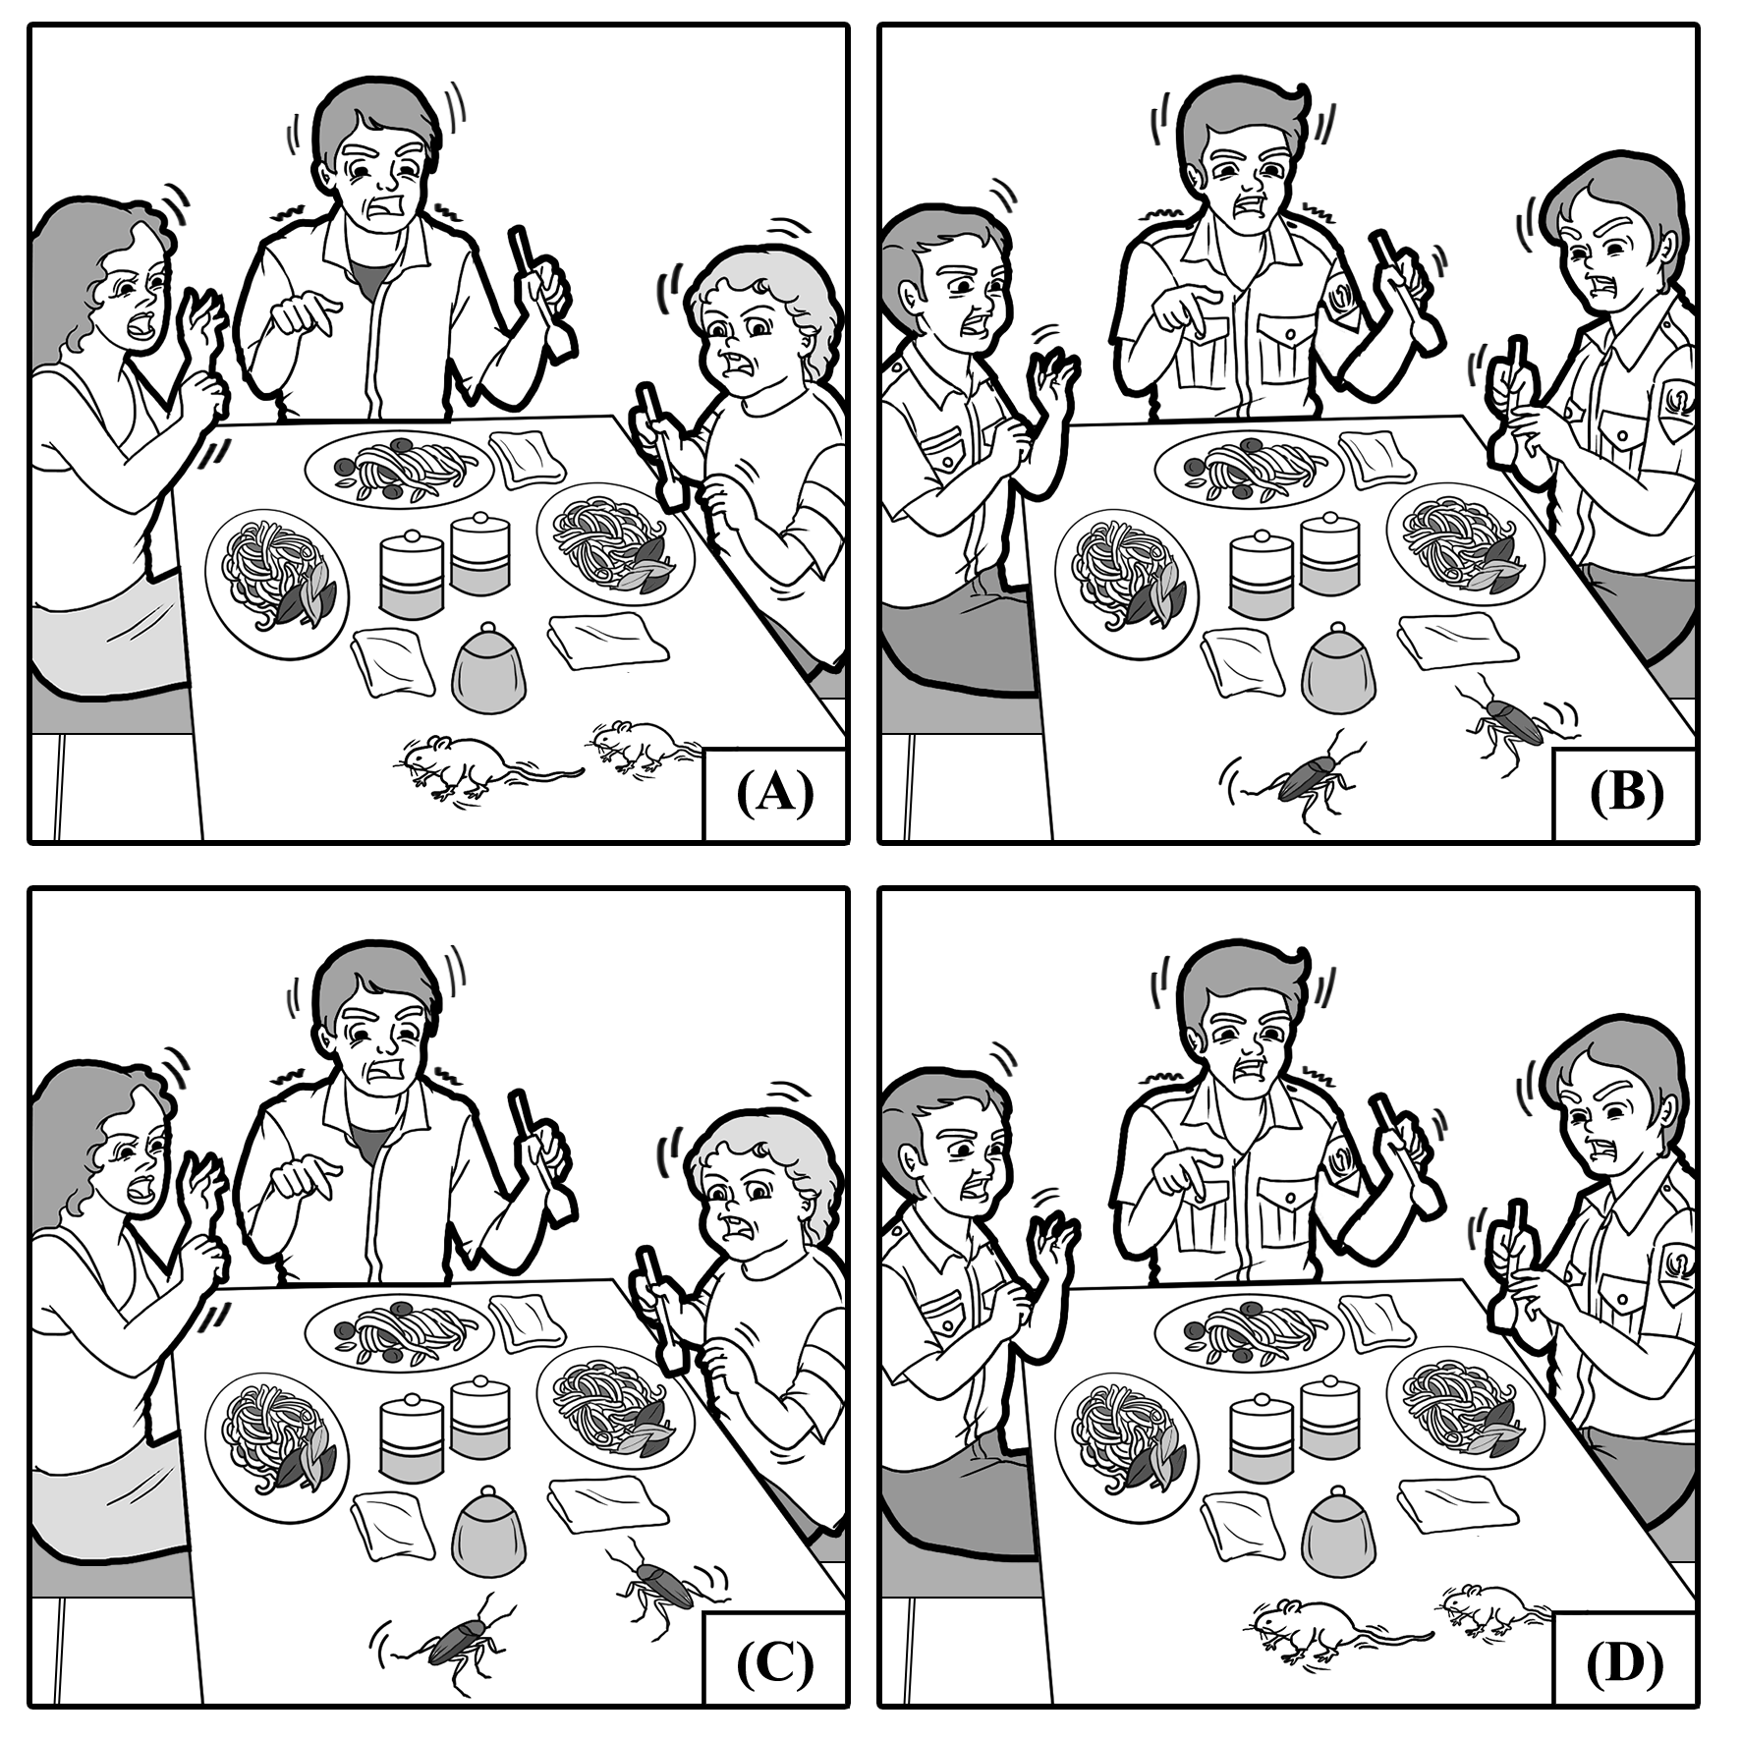

For question number 1, please look at the four pictures.
C Question number 1: A family eating dinner is scared of the approaching cockroaches.
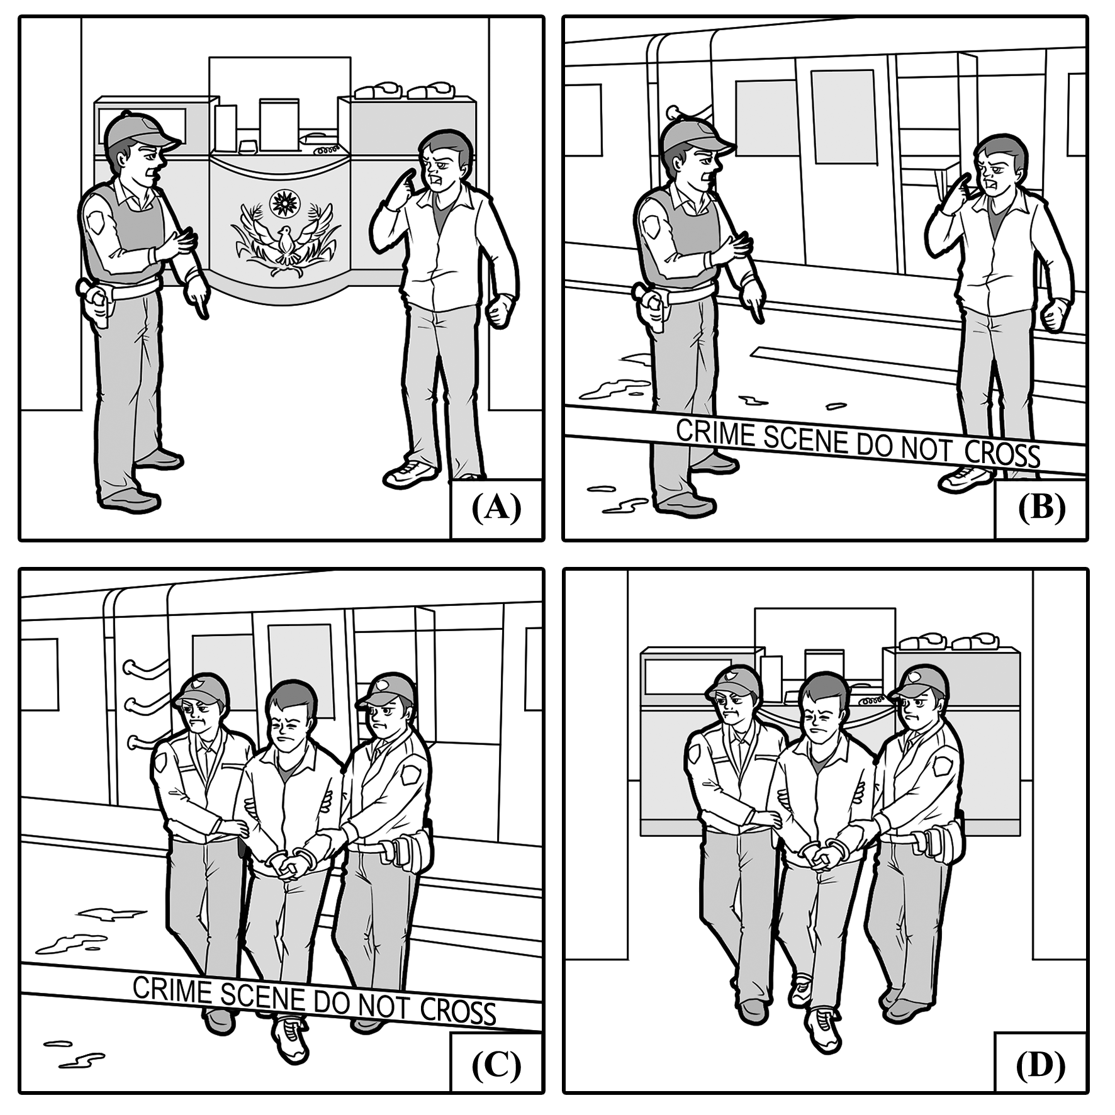

For question number 2, please look at the four pictures.
C Question number 2: A man is being led away in handcuffs from a crime scene at a train station.
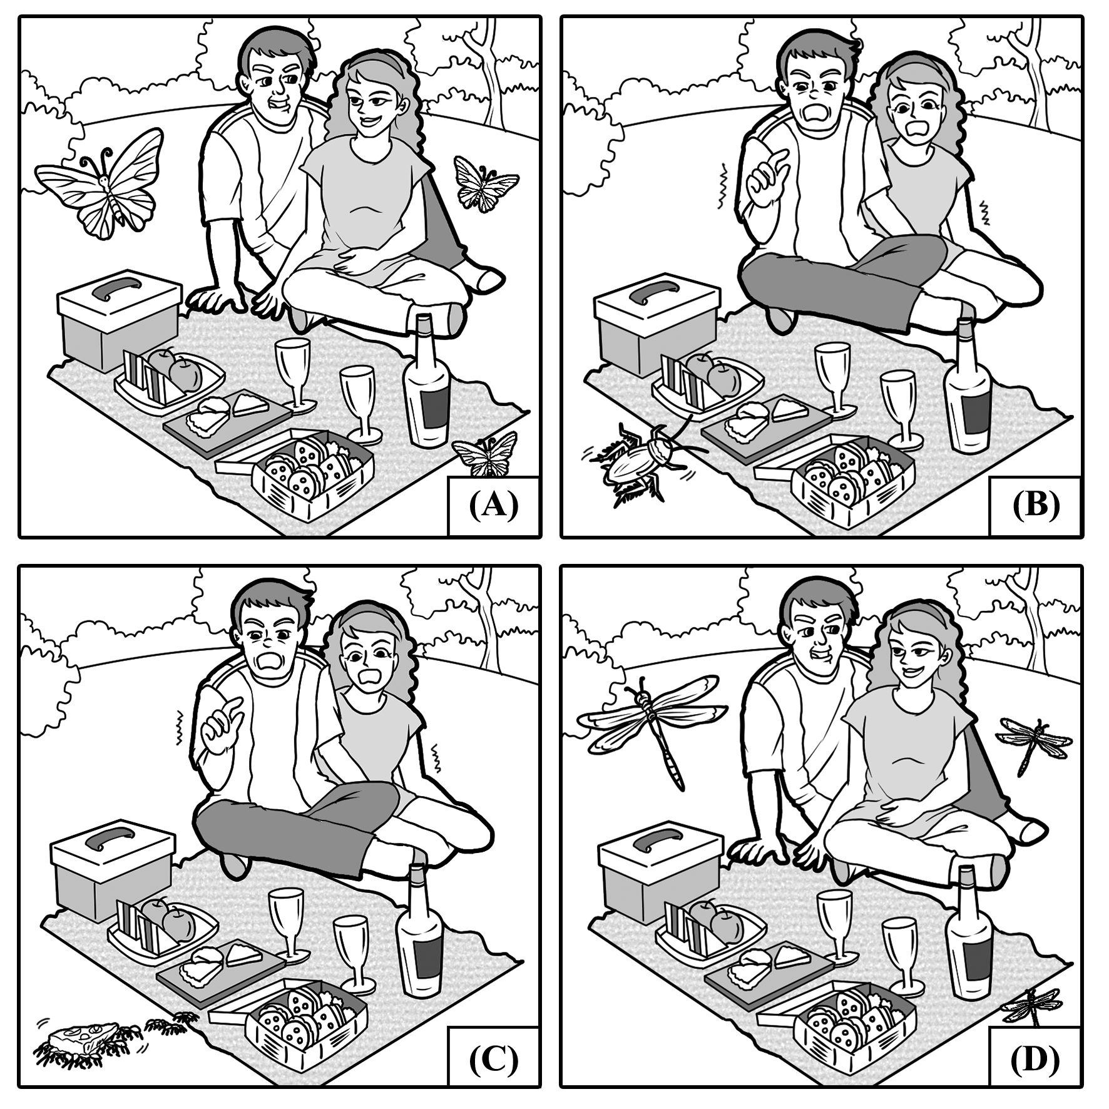

For question number 3, please look at the four pictures.
A Question number 3: A couple is having a nice picnic with butterflies flying around.
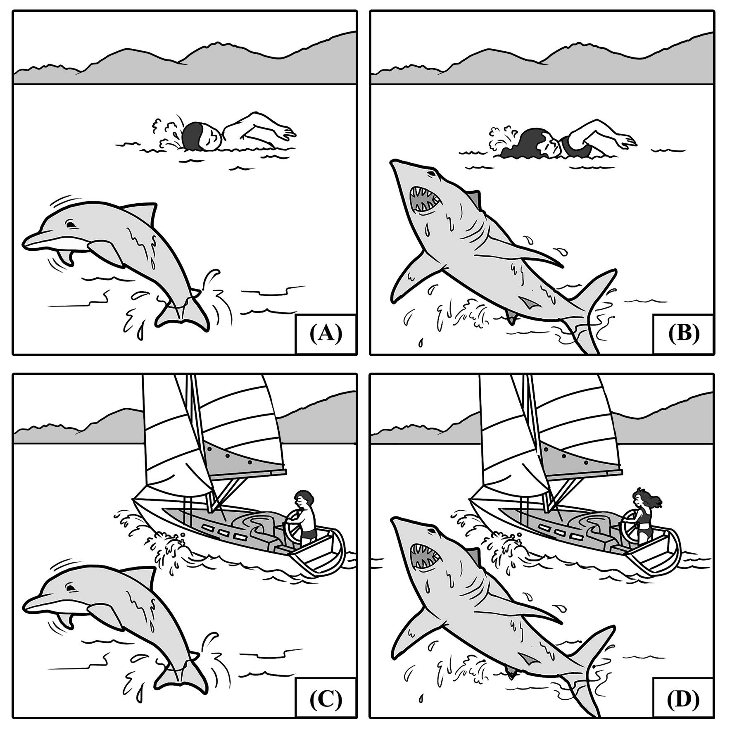

For question number 4, please look at the four pictures.
C Question number 4: A man is sailing in a boat while a dolphin is jumping out of the water.

一 、 看 圖 辨 義 ： 第 二 部 分 （ 多 選 題 ）
說明︰第5題至第10題為多選題，每題配有一幅圖畫，請仔細觀察圖畫並聆聽試題，從聽到的4個選項中選出最符合圖意的2個答案，並將答案畫記在答案卡之「選擇題答案區」，每題播放一次。各題之選項獨立判定，所有選項均答對者，得該題題分；答錯1個選項者，得該題一半題分；答錯多於1個選項或所有選項均未作答者，該題以零分計算。

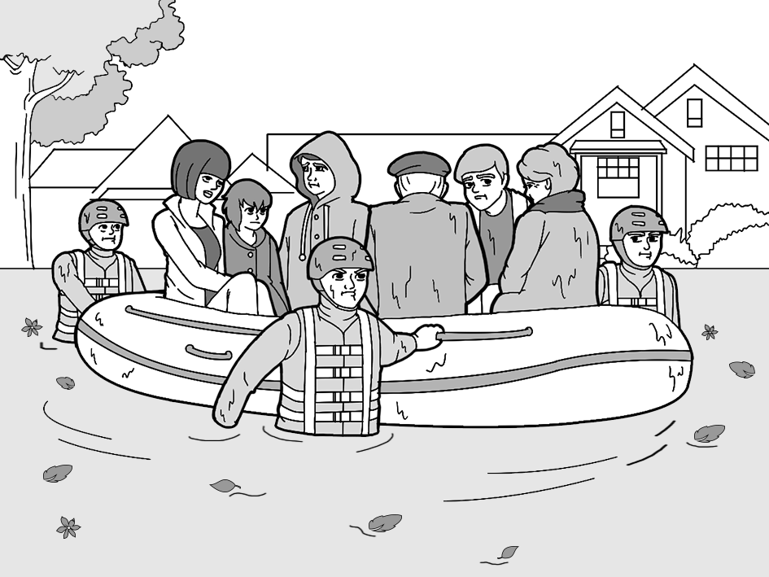
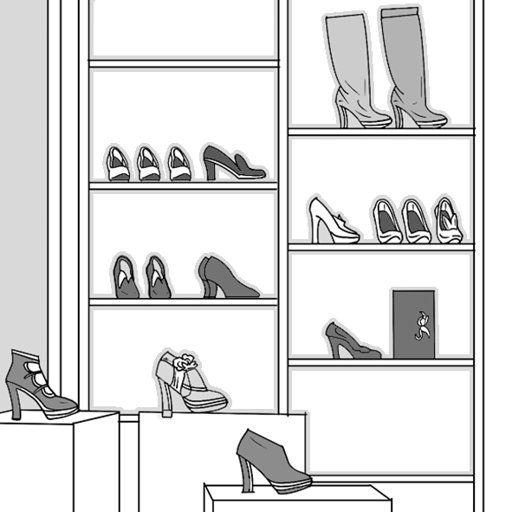
A
B

C
D

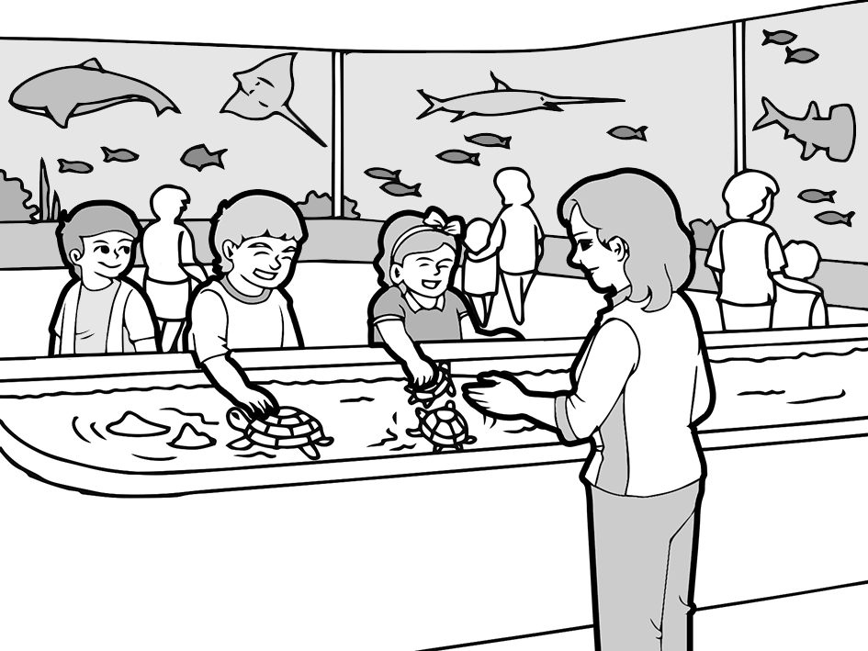

E
F
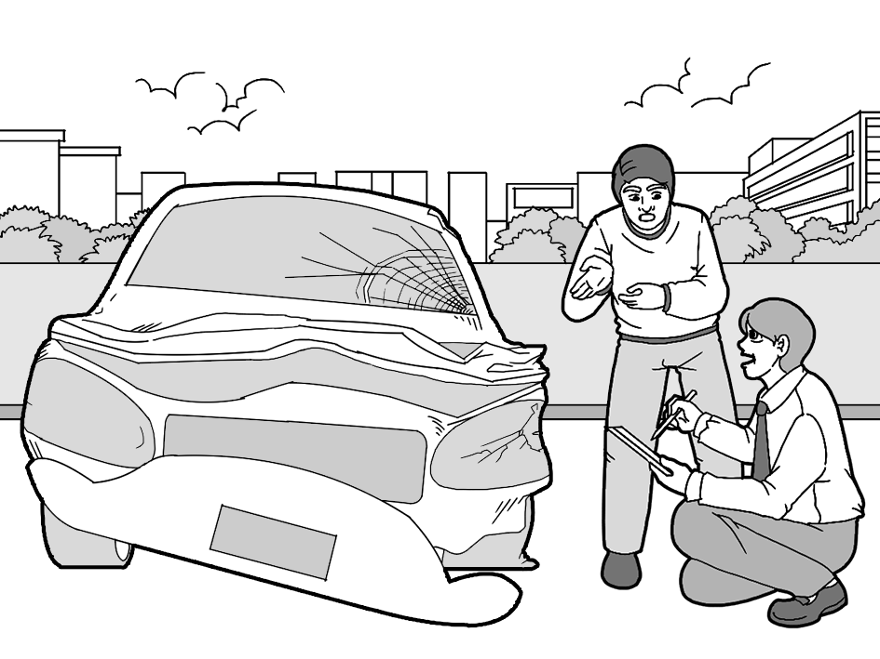


For question number 5, please look at picture A.
Question number 5: Where are the rescuers taking the people to?
AC (A) To a safe area.
(B) To prison.
(C) To a shelter.
(D) To the side of the pool.

For question number 6, please look at picture B.
Question number 6: Where would you find this place?
BD (A) At a place that sells fishing supplies.
(B) A store in a shopping mall.
(C) In a sports equipment shop.
(D) A shoe store which sells a variety of women's shoes.

For question number 7, please look at picture C.
Question number 7: Why are they in the store?
AC (A) They are clothes shopping.
(B) The kids need to buy some stationery.
(C) The children saw an interesting shirt.
(D) They need to do their laundry.

For question number 8, please look at picture D.
Question number 8: What is happening?
AD (A) The students are learning about turtles.
(B) The teacher is scolding the kids.
(C) The classmates are fighting over the turtles.
(D) The children are playing with the animals.

For question number 9, please look at picture E.
Question number 9: What could have happened to the man's car?
AC (A) Someone crashed into his car.
(B) It ran out of gasoline.
(C) He got into an accident.
(D) A person scratched his car with a key.

For question number 10, please look at picture F.
Question number 10: Where can this picture be found?
CD (A) In a clothing retailer.
(B) At a bakery
(C) At a supermarket.
(D) At a grocery store.

二 、 對 答
說明：第11題至第20題，共10題，皆為單題。請聽語音播出的一個問句或直述句後，依試題本所列的選項，選出一個最適當的回應選項，並將答案畫記在答案卡之「選擇題答案區」，每題播放一次。

C 11. If you don't get seven or more hours of sleep, it will lead to many health consequences. (9/2)
(A) I don't like going to see the doctor because I hate needles.
(B) Yes, I slept like a baby last night.
(C) That's scary. I'll try to sleep more to avoid poor health.
(D) You overslept for the second time this week.

D 12. I haven't seen you since the summer. How did your fall semester at college go? (9/3)
(A) The meeting went poorly because you weren't there.
(B) Even though I fell, I didn't get hurt.
(C) I miss the summer, too. I dislike this cold weather.
(D) It was great! I did well in my classes.

B 13. Laura was to blame for accidentally setting the kitchen on fire. (9/4)
(A) No, I was told she wouldn't do the dishes.
(B) I heard she forgot to turn off the stove.
(C) Yes, she is dreaming of becoming a chef.
(D) She does not know how to properly set a table.

C 14. Can you help me figure out how to solve this math problem? (9/5)
(A) No, I haven't started the essay, either.
(B) Yes, you should take the course because the professor is fantastic.
(C) I can show you the steps, but not the answer. You need to do the work.
(D) You should work on your business proposal on your own.

B 15. It is obvious that Carrie is mad at her husband even though she said she's not. (9/7)
(A) She was nervous about her first time hosting the awards show.
(B) How do you know? Was she not speaking to him?
(C) She told me she wants to go out for dinner tonight.
(D) Do you know what happened to the car?

A 16. Jerry was about to celebrate winning the lottery when he woke up from his dream. (9/8)
(A) He must have felt disappointed when he realized it wasn't real.
(B) His lifelong dream finally came true.
(C) His birthday celebration keeps getting better every year.
(D) He always has a difficult time waking up early.

D 17. We need to have a chat about your behavior at school today, Thomas. (9/9)
(A) Keep up the excellent work attitude.
(B) Please, stop talking during the lecture. It is quite rude.
(C) Yes, we do need to talk about the homework.
(D) But Dad, I was trying to defend my friend from a bully.

D 18. Thank you for donating your used coats! The homeless will be warm this winter. (9/10)
(A) It's too warm in here. Can you please turn on the air conditioner?
(B) Sure. I'm planning to go skiing this winter.
(C) In my opinion, I would recommend you to buy a used car as your first car.
(D) You're welcome! I'm glad that this is for a good cause.

A 19. Don't oversleep or else you'll miss out on the school field trip tomorrow. (9/11)
(A) I've got five alarms set and prepared everything I will need.
(B) Thanks for reminding me about the exam.
(C) OK, I'll remember to wake you up for work.
(D) The school is the best in the whole country. You should go.

C 20. Marcie discovered that she was rather fond of carrots after eating the carrot cake. (9/12)
(A) I can't find a good bakery in this city.
(B) That chef's recipe book is on sale.
(C) That's weird. She refused to even eat them before.
(D) Could you lend me a hand with baking?

三 、 簡 短 對 話
說明：第21題至第30題，共10題，含單題及題組。第21題至第24題，各為單題；第25題至第30題，每兩題為一題組。請聽語音播出一段對話和相關的問題，依試題本所列的選項，選出一個最適當的選項，並將答案畫記在答案卡之「選擇題答案區」，每題（組）播放一次。

C 21. M: Should I take this course? I remember that you've taken it before. (9/11)
W: Yes, you should take it. The professor is great and easygoing.
M: Can you give me a brief introduction to the course?
W: Sure, let me just go over the notes I took.
Q: Why is the man asking the woman about the class?
(A) He doesn't think the professor is great at teaching.
(B) He needs the notes from last week's lecture.
(C) He wants to know what to expect since she has already taken it.
(D) He wants to ask the woman out on a date.

B 22. W: Excuse me. I need help with something. (9/12)
M: What can I do for you today?
W: Do you know how to put this furniture together? I think I did something wrong.
M: You should refer to the manual that came along with your purchase.
W: I already did and I can't find a solution. Can you offer any more help?
Q: How does the man help the woman?
(A) He showed her what she did wrong in her homework.
(B) He told her to look in a handbook.
(C) He gave details about the furniture she wants to buy.
(D) He offered her a discount on the furniture.

D 23. M: I want to become a photojournalist. (9/14)
W: All right, but do you know what that means?
M: Of course. You take pictures and get money from them.
W: There's more to it than that. You need to tell a story with the photos.
M: Really? Well, I'll take out my phone and film what's happening instead.
W: You need professional equipment, not your camera phone.
M: This sounds like tougher work than I thought.
Q: What does the woman say about cameras?
(A) She believes they're a great invention.
(B) She thinks they are too expensive.
(C) She likes to collect antique cameras.
(D) She thinks professional photography needs the right tools.

A 24. M: Do you know what is interesting? (9/15)
W: Let me guess. To date, many people in South Korea have still believed in the custom.
M: Whoa, how did you know what I was going to say?
W: I saw you looking it up on the Internet.
Q: What did the woman know?
(A) The man was going to talk about a custom in South Korea.
(B) Gossip in the Korean entertainment world.
(C) The man's birthday and where he was born.
(D) Where he placed his phone earlier.

第 25、26 題為題組

Questions 25-26 are based on the following conversation.
M: Sally, we need to have a talk. (9/25)
W: All right, Cole, what is this about?
M: Please listen to music on your headphones at night. It is impossible for me to sleep.
W: OK, I will. I thought the walls were thicker.
C 25. Q: Why did Cole want to have a talk with Sally?
(A) He wants to break up with her.
(B) He needs the rent money from her.
(C) He can't sleep at night because her music is too loud.
(D) He wants her to join his band.

C 26. Q: What did Sally learn from the talk?
(A) She needs to buy new headphones.
(B) Her bed is not comfortable enough to sleep in.
(C) The walls are not as thick as she thought.
(D) The music she listens to is bad.

第 27、28 題為題組

Questions 27-28 are based on the following conversation.
W: Are you ready, John? (9/26)
M: Yes, Irene. The room has been set up with hidden cameras.
W: I hope we will catch the criminal in the act this time.
M: That's right! I'm confident that whoever has been messing up our documents will get
caught soon.
C 27. Q: What did Irene and John do?
(A) They took pictures with cameras.
(B) They caught a criminal.
(C) They hid cameras all over a room.
(D) They were acting in a film.

D 28. Q: What is the reason behind their action?
(A) They realized they were robbed.
(B) They wanted to catch a ghost.
(C) Their documents were stolen by a spy.
(D) Someone has been making a mess of their documents.

第 29、30 題為題組

Questions 29-30 are based on the following conversation.
M: Whoa, Casey, is steam coming out of your ears? (9/28)
W: Yes, Ezra. I am furious at my landlord.
M: Why? What happened?
W: He broke into my apartment and threw out all of my belongings.
B 29. Q: Why did Ezra ask Casey about her ears?
(A) She couldn't hear him.
(B) He sees that she is very angry.
(C) He noticed her new earrings.
(D) Her ears were hurt.

A 30. Q: What happened to Casey?
(A) Her landlord threw out her possessions.
(B) She was upset about the neighbor's loud music.
(C) She had an argument with her landlord over the rent.
(D) She got a steam burn and had to treat it.

四 、 短 文 聽 解
說明：第31題至第40題，共10題，每兩題為一題組。請聽語音播出的一段訊息，從試題本中選出一個最適當的選項，並將答案畫記在答案卡之「選擇題答案區」，每題組播放一次。

第 31、32 題為題組 （請先閱讀試題）

You've probably heard of a solar eclipse before. If you've seen one, then you might have worn protective eyewear to see it since it is damaging to the eyes. The fact is that the total solar eclipse has fascinated mankind since before recorded time. Though it occurs infrequently, the eclipse is an overwhelming event that many ancient civilizations attempted to explain with special myths. Many cultures thought that it was a sign of future disaster. Some thought it was simply a creature eating the sun. Nowadays, eclipse chasers from all over the world spend considerable time and money trying to experience total solar eclipses. It is advised that everyone should get the chance to see nature's most magnificent celestial show in his or her lifetimes. (9/8)

A 31. What should people do when seeing a solar eclipse?
(A) Wear something that will protect their eyes.
(B) Try to record it on their phones.
(C) Explain why it's happening in an essay.
(D) Wear protective clothing.

D 32. Which of the following is NOT what many ancient cultures thought of eclipses?
(A) They thought it was an overwhelming event.
(B) They believed some creatures were eating the sun.
(C) They thought it was a sign of disaster.
(D) They believed it was a sign of good luck.

第 33、34 題為題組 （請先閱讀試題）

Have you ever wondered what it would be like to stand on a jet's wing? How about sleeping comfortably on a plane without paying extra for first class? In Stockholm, Sweden, there is a hostel called Jumbo Stay Hotel that can help you answer those questions.
The Jumbo Stay Hotel is a repurposed airplane that is located near the Arlanda International Airport. It has 33 rooms with 80 beds to give travelers a place to stay. It opened in 2008 thanks to a businessman named Oscar Dios. Also, it's a hostel, not a hotel like its name suggests. This means it only has a limited amount of services, but it has a café where guests can have a coffee and a snack. (9/17)

C 33. Which airport is the Jumbo Stay Hotel close to?
(A) The Oscar Dios Airport.
(B) The Stockholm Airport.
(C) The Arlanda International Airport.
(D) The Jumbo Stay Airport.

A 34. Why is the Jumbo Stay Hotel considered a hostel?
(A) It doesn't have as many services as a hotel.
(B) It has a nice café whereas hotels don't.
(C) It is close to the airport.
(D) It has more beds than a hotel does.

第 35、36 題為題組 （請先閱讀試題）

A recent event took place at the Burj Khalifa, the world's tallest building in Dubai. It was done to raise awareness of the plight of endangered birds. The event was, in fact, a record-setting bird flight from the highest man-made structure by an eagle named Darshan. A camera was strapped to its back and the bird's-eye-view video was broadcast for the public to watch. An organization called Freedom was behind the event. The founders teach birds of prey how to hunt and fly, and they have an unconventional way of teaching them. They take them on skiing, kayaking, and paragliding trips in the French Alps. Given that the breeding facilities are located in a picturesque place on the French-Swiss border, it is no surprise that these trips take place there. (9/22)

B 35. What event took place at the Burj Khalifa?
(A) A field trip for birds.
(B) A bird setting a world record.
(C) A sport involving birds.
(D) A man-made sculpture of a bird.

B 36. Why did the event take place?
(A) To make hunting for birds popular.
(B) To raise awareness for endangered birds.
(C) To test the birds on their flying skills.
(D) To teach birds how to fly from high places.

第 37、38 題為題組 （請先閱讀試題）

In the age of digital media and instant messaging, postcards are a cherished relic. What is lost during this time is feeling delighted or surprised over intimate mail. There is an online project called Postcrossing that seeks to copy these emotions. The name is actually the words "postcard" and "crossing" combined. People must become registered members of the project online in order to randomly select people and start sending, as well as receiving, postcards. After launching in 2005 by Paulo Magalhães in Portugal, over 489,000 people from 212 countries have signed up. Postcrossing has also made efforts towards sustainability. It provides helpful tips to be greener on its website, like using recycled paper or writing during the day without electricity. (9/24)

D 37. Which of the following make the word "Postcrossing"?
(A) Post office and crosswalk.
(B) Postcard and cross out.
(C) Poster and crossing.
(D) Postcard and crossing.

B 38. What must people do to send and receive postcards?
(A) They need to travel to Portugal.
(B) They must first register online.
(C) Write a letter to Paulo Magalhães.
(D) Take a test to see if they qualify.

第 39、40 題為題組 （請先閱讀試題）

Some people enjoy listening to music while riding on their bikes. It isn't safe, though, since you can't hear what's going on around you. Albert experienced this the other day. After it rained for a long period of time, he decided to go cycling on a beautiful day. However, he was listening to music on his smartphone. Whenever the light turned red, he would check his phone for any new text messages. This turned out to be a big mistake for Albert as the light turned green. He couldn't hear all the honking. He only realized that the driver behind him was furious at him after he pulled up and shook his fist. Albert sincerely apologized and never did those things again. (9/28)

C 39. Why is listening to music while bike riding not safe?
(A) You can't hear when your alarm goes off.
(B) You might miss people calling your name.
(C) You can't hear anything around you.
(D) You might miss some important phone calls.

C 40. What was Albert's big mistake?
(A) Being an angry driver.
(B) Going cycling in heavy rain while listening to music.
(C) Listening to music and looking at his phone while cycling.
(D) Not focusing on the good things in his life.

