國立台東高中104學年度第一學期第一次期中考高二英文聽力測驗
適用班級: 201. 202. 205. 206. 209 (請劃卡於答案卡上)

Listening Test

I. Pictures看圖辨義
Listen to the questions. Then choose the best answer according to each picture.

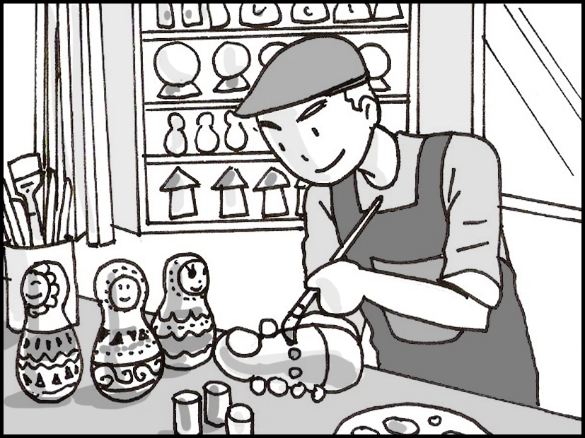

- _____

- _____

- _____

- _____

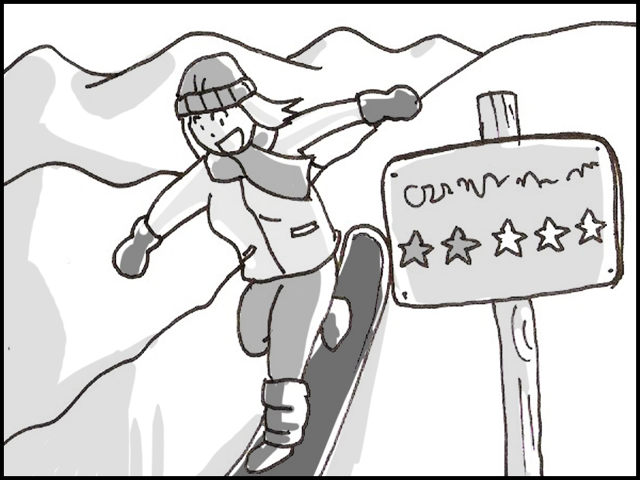

- _____

- _____

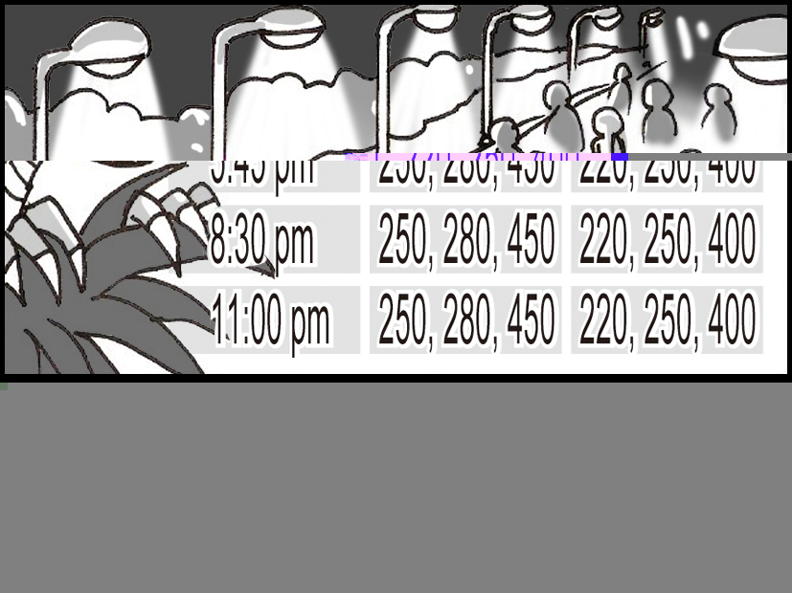
D.

- _____

- _____

E.
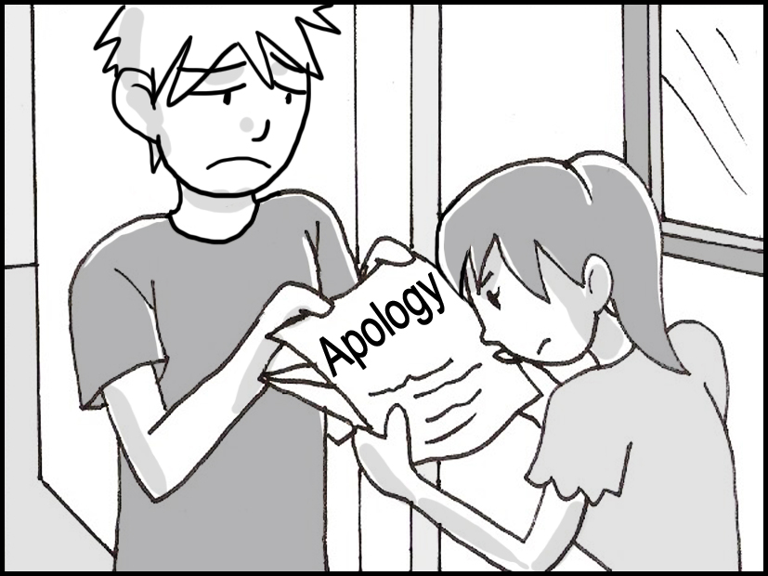

- _____

- _____

II. Best Response 最佳回應句
Choose the best response to each question or statement.

____11.
A. The freeway is one kilometer away.
B. I’ll get out of the car and guide you.
C. I think the supermarket is on the next corner.
D. It’s not easy to fly a plane in this kind of weather.

____12.
A. Were they really disappointed?
B. Did his mom agree with his decision?
C. His boss said he deserved a promotion.
D. I’m sure his bosses were happy to teach him.

____13.
A. Not yet. I’m waiting for my blood test results.
B. Yes, the doctor gave me medicine for about three days.
C. Yes, they said my symptoms include a runny nose and cough.
D. Not yet. The broken bone could be in my hand and not my wrist.

____14.
A. Yeah, I never made it to class on time.
B. Me, too. I gained another two kilograms.
C. Me, too. The professor was so interesting.
D. Oh, I made a lot of money from my business as well.

____15.
A. Yes, the project collaboration between departments is going well.
B. Yes, they seem to like her sense of humor.
C. Yes, everyone has co-operated with the police investigation.
D. Yes, the combination of singers has been received well by audiences.

____16.
A. I think so. I caught the fish early in the morning.
B. I don’t think so. Some of them had worms inside.
C. Yes, I managed to buy the bread fresh from the oven.
D. No, none of the vegetables I bought lasted longer than a day.

____17.
A. Oh, I didn’t know she owned an art gallery.
B. The audience really likes the play she wrote.
C. I heard she designed the building we’re standing in.
D. She’s very talented at making products by hand.

____18.
A. He’s very close with his family.
B. He’s always been a slow driver.
C. He’s very careful with his luggage.
D. He’s a great emergency room doctor.

____19.
A. Do you need me to help you buy some bandages for your wound?
B. How big do you want them to get before the weight lifting competition?
C. Well, that was a bad accident so you should do some physical therapy.
D. Stretch your muscles before and after your workout to reduce the pain.

____20.
A. No, he asked me to write it.
B. Yes, he saved it on his smartphone.
C. No, I’m still waiting for him to answer me.
D. Yes, he said he’d buy his own stamps.

III. Short Conversations 簡短會話
Listen to the conversations. Then answer the questions.

____21.
A. She thinks that she is too tired.
B. She thinks that it is too hot.
C. She is too busy at work.
D. She is not feeling well enough.

____22.
A. She wants to go and see Europe.
B. The man’s collection of new watches.
C. The man’s collection of old watches.
D. She wants to see the man’s photos from his travels.

____23.
A. She fell down, and she is in a dangerous condition.
B. She fell down, but it is not serious.
C. His mother will need to spend the next month in the hospital.
D. His mother got out of the hospital last night.

____24.
A. The race is held just after lunch.
B. The race is held on weekends.
C. The race is held in January.
D. The race is held just after sunset.

____.
A. The woman is always tired at work.
B. The woman isn’t working hard enough.
C. Her boss won’t listen to her.
D. Her boss keeps giving more work to her.

____26.
A. He lied to his wife.
B. He lied to his boss.
C. He was caught taking money from a customer.
D. He was caught taking money from the company.

____27.
A. He is talking about a story he is reading.
B. He is talking about a TV show he is watching.
C. He is talking about his family.
D. He is talking about his favorite food.

____28.
A. The woman said that her sister loves to help out other people.
B. The woman said that she will speak to her sister urgently.
C. The woman said that she can read French.
D. The woman said that her sister can speak French very well.

____29.
A. She thinks that peacocks fly beautifully.
B. She thinks that peacocks look beautiful.
C. The girl likes watching TV.
D. The girl likes feeding the boy.

____30.
A. They want to go camping in the mountains.
B. They want to live on the beach.
C. They want to live by the beach.
D. They want to stay in a house in the mountains.

IV. Short Talk 短文
Listen to the talk. Then choose the best answer to each question.

____31.
A. To introduce a special guest.
B. To introduce a famous company.
C. To explain how to help poor people.
D. To explain how to start your own business.

____32.
A. She likes to make lots of money.
B. She likes to help people in need.
C. She likes to learn about computers.
D. She likes to travel around the country.

____33.
A. To tell people how to keep a secret.
B. To explain how to enter an old house.
C. To introduce what will happen on the show.
D. To learn some Italian from a book.

____34.
A. A special map to hidden treasure.
B. A special box filled with broken glass.
C. A special room covered in beautiful plants.
D. A special book written in another language.

____35.
A. Someone who enjoyed drinking tea.
B. Someone who worked with bees.
C. Someone who entered a contest.
D. Someone who avoided eating honey.

____36.
A. Honey can cure any illness.
B. Honey can last a long time.
C. Honey should only be used in drinks.
D. Honey should be eaten within one year.

____37.
A. To provide details about an event.
B. To explain how to get to a certain place.
C. To persuade people to buy more books.
D. To encourage people to go to bed early.

____38.
A. Study quietly on the first floor.
B. Take a nap on the second floor.
C. Buy food and crafts on the third floor.
D. Dance with a librarian on the street outside.

____39.
A. In the car as they drive to work.
B. In the classroom while they take a test.
C. At the office during a meeting with their boss.
D. At the store while they are talking to the clerk.

____40.
A. The winner will get to watch the movie in a big city.
B. The winner will get to meet the actors from the movie.
C. The winner will get to watch the movie with a large group of people.
D. The winner will get to be one of the first people to watch the movie.

