
Name:
Class:
No:
台東高中
104學年度第一學期高二第一次英文聽力測驗
For Teacher’s Use Only

Listening Test

I. Pictures看圖辨義
Listen to the questions. Then choose the best answer according to each picture.

- (9/9,10)
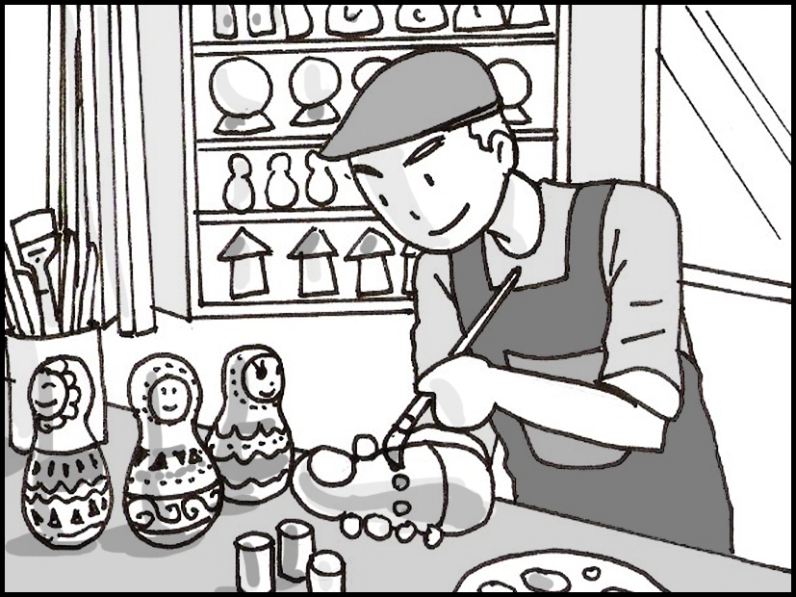

For questions number 1 and 2, please look at picture A.
1. What can you see in the picture?
A. A hard-working millet farmer.
B. An artist in his workshop.
C. A warm-hearted housewife.
D. An old warrior in costume.

2. What is on the table?
A. Some fascinating novels.
B. Some delicious mochi.
C. Some delicate handicrafts.
D. Some aboriginal weapons.

- (9/24,25)

For questions number 3 and 4, please look at picture B.
3. What can you see in this picture?
A. A gigantic monster.
B. A solitary man.
C. A thrilling car chase.
D. A brave superhero.

4. What information can you see in the picture?
A. Details about the sound system.
B. Express train ticket prices.
C. The names of the actors in the movie.
D. Times to watch the show on the big screen.

- (9/21-23)

For questions number 5 and 6, please look at picture C.
5. What is the girl doing?
A. She is spinning around in the snow.
B. She is balancing on a board.
C. She is blowing bubbles outdoors.
D. She is hiding in an icy cave.

6. What might the sign say?
A. Brake Ahead.
B. Plentiful Water Available.
C. Beginner-Intermediate Slope.
D. Terrifying Animals, Use Caution.

D. (9/5)


For questions number 7 and 8, please look at picture D.
7. What is true of the picture?
A. The sky at twilight is lovely.
B. The moon is high in the sky.
C. The streets are illuminated with candles.
D. The road is lined with bright streetlights.

8. Why have these people come here?
A. To run a marathon.
B. To make a soundtrack.
C. To drive their vehicles.
D. To audition for a band.

E. (9/1,2)

For questions number 9 and 10, please look at picture E.

9. What is true of the woman?
A. She is responding to a letter.
B. She is concentrating on a letter.
C. She is interrupting the man.
D. She is giving the man advice.

10. What might the man have written to the woman?
A. I’m sorry for the misunderstanding.
B. Thank you for suggesting that restaurant.
C. It is essential that you finish your degree.
D. My ears are sensitive. Turn off the music

II. Best Response 最佳回應句
Choose the best response to each question or statement.

11. I’m trying to navigate the car out of the mud. (9/3,4)
A. The freeway is one kilometer away.
B. I’ll get out of the car and guide you.
C. I think the supermarket is on the next corner.
D. It’s not easy to fly a plane in this kind of weather.

12. Barry told all his subordinates that he’s leaving his job in November. (9/11,12)
A. Were they really disappointed?
B. Did his mom agree with his decision?
C. His boss said he deserved a promotion.
D. I’m sure his bosses were happy to teach him.

13. Have doctors been able to pinpoint the origin of your fever? (9/17,18)
A. Not yet. I’m waiting for my blood test results.
B. Yes, the doctor gave me medicine for about three days.
C. Yes, they said my symptoms include a runny nose and cough.
D. Not yet. The broken bone could be in my hand and not my wrist.

14. I’ve profited a lot from my business class. (9/7,8)
A. Yeah, I never made it to class on time.
B. Me, too. I gained another two kilograms.
C. Me, too. The professor was so interesting.
D. Oh, I made a lot of money from my business as well.

15. Helen interacts well with her new coworkers and they all like her. (9/24,25)
A. Yes, the project collaboration between departments is going well.
B. Yes, they seem to like her sense of humor.
C. Yes, everyone has co-operated with the police investigation.
D. Yes, the combination of singers has been received well by audiences.

16. Are the peaches you bought and left in the refrigerator still edible? (9/24,25)
A. I think so. I caught the fish early in the morning.
B. I don’t think so. Some of them had worms inside.
C. Yes, I managed to buy the bread fresh from the oven.
D. No, none of the vegetables I bought lasted longer than a day.

17. Patricia has decided to open a store selling handicrafts. (9/9,10)
A. Oh, I didn’t know she owned an art gallery.
B. The audience really likes the play she wrote.
C. I heard she designed the building we’re standing in.
D. She’s very talented at making products by hand.

18. Terry left town abruptly when he heard his brother got into a car accident. (9/28-30)
A. He’s very close with his family.
B. He’s always been a slow driver.
C. He’s very careful with his luggage.
D. He’s a great emergency room doctor.

19. My muscles are sore after that intense workout. (9/14-16)
A. Do you need me to help you buy some bandages for your wound?
B. How big do you want them to get before the weight lifting competition?
C. Well, that was a bad accident so you should do some physical therapy.
D. Stretch your muscles before and after your workout to reduce the pain.

20. Did Harry respond to your email yet? (9/1,2)
A. No, he asked me to write it.
B. Yes, he saved it on his smartphone.
C. No, I’m still waiting for him to answer me.
D. Yes, he said he’d buy his own stamps.

III. Short Conversations 簡短會話
Listen to the conversations. Then answer the questions.

21. (9/21-23)
M: The weather is good today. Do you want to go out for a bicycle ride later on?
W: It’s too warm today. If I go for a ride, I’ll be covered in sweat.
M: So what do you want to do today then?
W: Let’s go see a movie.
Q: Why doesn’t the woman want to go for a bike ride?
A. She thinks that she is too tired.
B. She thinks that it is too hot.
C. She is too busy at work.
D. She is not feeling well enough.

22. (9/26)
M: I have many collectibles from my travels around the world. Would you like to see some of them?
W: What kinds of things do you collect?
M: I have an assortment of old watches from Europe.
W: How old are they?
M: Some of the older ones date back to the 1950s.
W: Wow, I’d love to see them.
Q: What does the woman want to see?
A. She wants to go and see Europe.
B. The man’s collection of new watches.
C. The man’s collection of old watches.
D. She wants to see the man’s photos from his travels.

23. (9/28-30)
M: My mother went to the hospital again last night.
W: I’m sorry to hear that. Is she OK?
M: Don’t worry, it’s not critical. She fell while she was walking.
W: How long does she need to stay in the hospital?
M: The doctor said that she should make a complete recovery and be out by next Tuesday.
Q: What happened to the man’s mother?
A. She fell down, and she is in a dangerous condition.
B. She fell down, but it is not serious.
C. His mother will need to spend the next month in the hospital.
D. His mother got out of the hospital last night.

24. (9/5)
W: I read about a race that is held at twilight.
M: That sounds fun.
W: It is held every year around Prague’s illuminated streets.
M: How many people run in the race?
W: There are up to 70,000 participants that race each year. I want to do it next year.
M: You’d better do some training first then.
Q: When is the race held?
A. The race is held just after lunch.
B. The race is held on weekends.
C. The race is held in January.
D. The race is held just after sunset.

25. (9/1,2)
W: I’m having trouble talking to my boss.
M: What’s the problem?
W: Every time I want to say something, she interrupts me.
M: That’s rude. I hope she will listen to you and let you finish talking.
Q: What problem does the woman have?
A. The woman is always tired at work.
B. The woman isn’t working hard enough.
C. Her boss won’t listen to her.
D. Her boss keeps giving more work to her.

26. (9/11,12)
M: One of my subordinates at work got into big trouble with the boss last week.
W: What happened?
M: He was caught taking a bribe from a customer in order to get a better deal for a work contract.
W: What happened to him?
M: He was fired from the company as soon as they found out.
Q: Why was the man fired from the company?
A. He lied to his wife.
B. He lied to his boss.
C. He was caught taking money from a customer.
D. He was caught taking money from the company.

27. (9/7,8)
M: I’m already up to chapter 9 in my book.
W: What is it about?
M: It’s about a woman who uses magic to become a queen in a strange land.
W: Sounds interesting.
Q: What is the man talking about?
A. He is talking about a story he is reading.
B. He is talking about a TV show he is watching.
C. He is talking about his family.
D. He is talking about his favorite food.

28. (9/17,18)
M: I need someone to help me translate an article for work. Do you know anyone who speaks French?
W: My sister can speak French fluently.
M: Great. Can you give me her phone number?
W: I’ll just call her myself and see if she has the time to help you.
M: That would be great, thanks.
Q: What did the woman say?
A. The woman said that her sister loves to help out other people.
B. The woman said that she will speak to her sister urgently.
C. The woman said that she can read French.
D. The woman said that her sister can speak French very well.

29. (9/3,4)
B: I love watching peacocks move around.
G: Me, too. They look so majestic when all of their feathers are up on display.
B: I’ve only ever seen them on TV.
G: I’ve seen them on TV and in real life at the zoo. I even fed one from my hand once.
B: I’m so jealous. I would love to do that.
Q: What can we know about the girl?
A. She thinks that peacocks fly beautifully.
B. She thinks that peacocks look beautiful.
C. The girl likes watching TV.
D. The girl likes feeding the boy.

30. (9/14-16)
W: I want to go somewhere different this summer. I’m tired of the beach.
M: How about renting a house in the mountains?
W: That’s a great idea.
M: I’ll see about booking a place online.
Q: What do the couple want to do for their summer holiday?
A. They want to go camping in the mountains.
B. They want to live on the beach.
C. They want to live by the beach.
D. They want to stay in a house in the mountains.

IV. Short Talk 短文
Listen to the talk. Then choose the best answer to each question.

Part A (9/9,10)
Today we will be meeting a fascinating woman who specializes in making handicrafts. Her name is Mary Collins. She began making handicrafts as a way to raise money to help poor people. Some people in her community doubted that a housewife could make a difference in the lives of the poor. They believed that it would be too difficult to help such a large number of people. But Mary didn’t give up. Instead, she launched an online e-shop to sell her handicrafts. People from around the country loved her designs and started ordering some of her handmade costumes. When people found out what the profits would be used for, they started buying even more of her handicrafts.

31. What is the main purpose of this talk?
A. To introduce a special guest.
B. To introduce a famous company.
C. To explain how to help poor people.
D. To explain how to start your own business.

32. What is true of Mary Collins?
A. She likes to make lots of money.
B. She likes to help people in need.
C. She likes to learn about computers.
D. She likes to travel around the country.

Part B (9/17,18)
Old houses hold secrets. On tonight’s episode of Beneath the Dust, we will be exploring the contents of a house that hasn’t been lived in for over 20 years. The doorway of the house is covered in ivy, so we will need to cut it off before we can go in. Aside from the usual dusty boxes and broken windows, we hope to find something of interest. Specifically, we are looking for a book with frayed edges that contains information about what happened in this house so many years ago. The people living here at that time were from Italy, so we have someone with us to translate the book if we find it.

33. Why is this talk being given?
A. To tell people how to keep a secret.
B. To explain how to enter an old house.
C. To introduce what will happen on the show.
D. To learn some Italian from a book.

34. What do they want to find in the house?
A. A special map to hidden treasure.
B. A special box filled with broken glass.
C. A special room covered in beautiful plants.
D. A special book written in another language.

Part C (9/14-16)
Congratulations! You have won 10 jars of our finest honey. This honey was harvested from our hives just last week. Ten jars might sound like a lot of honey, but don’t worry, honey never spoils. So you can store the extra jars of honey in your home, or give them away as gifts. Honey is also very easy to use. You can add it to your coffee or tea. You can even use it instead of sugar when you make cookies. If you have a sore throat, try adding some honey to your water or tea to relieve the pain. Enjoy your sweet prize!

35. Who is probably listening to this talk?
A. Someone who enjoyed drinking tea.
B. Someone who worked with bees.
C. Someone who entered a contest.
D. Someone who avoided eating honey.

36. According to the talk, what is true?
A. Honey can cure any illness.
B. Honey can last a long time.
C. Honey should only be used in drinks.
D. Honey should be eaten within one year.

Part D (9/5)
Next week marks the 50th anniversary of the Southern County Library. The library has been a key part of our community since its founding. To celebrate this important date, the library will host a 24-hour party beginning at twilight on September 5. Everyone is welcome to stop by and check out the fun, regardless of the time. If you start to feel tired, don’t worry. Visitors have the option of sleeping on the second floor, while the celebration continues below. In addition to activities inside the library, the illuminated streets outside will be crowded with people buying and selling food, crafts and, of course, books. Be sure to stop by for a great time!

37. What is the main purpose of this talk?
A. To provide details about an event.
B. To explain how to get to a certain place.
C. To persuade people to buy more books.
D. To encourage people to go to bed early.

38. What can someone do during the celebration?
A. Study quietly on the first floor.
B. Take a nap on the second floor.
C. Buy food and crafts on the third floor.
D. Dance with a librarian on the street outside.

Part E (9/24,25)
Attention! Radio station FM 104.5 is holding a contest to win movie tickets for the latest superhero movie, Revenge of Quasar. If you are the type of person that can’t restrain yourself from rushing to the theater when a new movie comes out, then you should join the contest. The grand-prize winner will enjoy the thrill of watching the movie with four of their friends in a gigantic theater. And the best part is, you will be watching the movie a full 24 hours before it is shown in any other theater! To enter the contest, simply call the radio station and tell them who your favorite superhero is!

39. Where might someone hear this talk?
A. In the car as they drive to work.
B. In the classroom while they take a test.
C. At the office during a meeting with their boss.
D. At the store while they are talking to the clerk.

40. What is special about the prize?
A. The winner will get to watch the movie in a big city.
B. The winner will get to meet the actors from the movie.
C. The winner will get to watch the movie with a large group of people.
D. The winner will get to be one of the first people to watch the movie.

