國立台東高中104學年度第一學期第一次英文期中考高二
聽力測驗 適用班級:203.204.207.208.210.211 (請劃卡)
Part 1
1.  2. | ( )  ( ) | 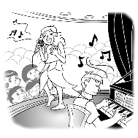 | 3. | ( ) | 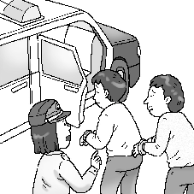
4. | ( ) | 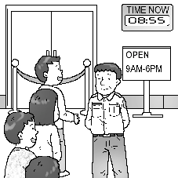 | 5. | ( ) | 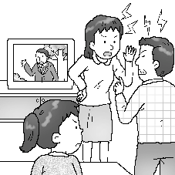
6. | ( ) | 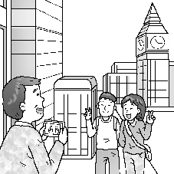 | 7. | ( ) | 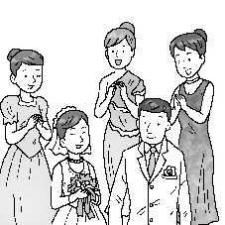
8. | ( ) | 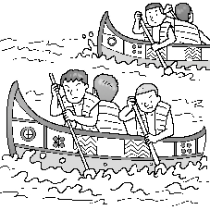 | 9.  10. | ( )  ( ) | 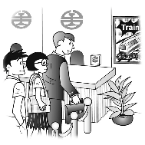

Part 2
( ) | 11. | (A) Try exercising regularly.
 |  | (B) One more cookie can’t hurt, right?
 |  | (C) I’ll give you a hand lifting it up.
 |  | (D) Why don’t you simplify the whole thing?
( ) | 12. | (A) A woman was murdered last night.
 |  | (B) I don’t know. The police are trying to find out his identity.
 |  | (C) He is in his room right now.
 |  | (D) I have not committed a crime.
( ) | 13. | (A) I’m a history major.
 |  | (B) I’ll be a teacher next year.
 |  | (C) I attend Chung Hsing University.
 |  | (D) I’ll enroll at the end of August.
( ) | 14. | (A) You didn’t have a chance.
 |  | (B) Do it out of habit.
 |  | (C) Try flipping a coin.
 |  | (D) I’m a changed man.
( ) | 15. | (A) Are you sure you used the right ingredients?
 |  | (B) There is a lemon tree in my garden.
 |  | (C) How much is the cake?
 |  | (D) I never had a birthday cake.
( ) | 16. | (A) I’m trying to find accommodation.
 |  | (B) I just passed him by.
 |  | (C) He handed me a note.
 |  | (D) I know! I was stunned.
( ) | 17. | (A) That should come as no surprise to people in Taiwan.
 |  | (B) I caught a cold last week.
 |  | (C) Yes, the fabric feels thick and soft.
 |  | (D) Sure! Those marketing experts were right.
( ) | 18. | (A) I guess so. He spent years in jail.
 |  | (B) I don’t know. We should try reaching out to him
 |  | (C) It’s not too much to ask for.
 |  | (D) Right. That’s what flashed through my mind too!
( ) | 19. | (A) It’s one of our regular services.
 |  | (B) Best of all, neither do mine.
 |  | (C) Without a doubt, it was a tough test.
 |  | (D) Sometimes it’s hard to motivate them to study.
( ) | 20. | (A) No one has ever been so nice to me in my whole life.
 |  | (B) Yes. They will vanish if you don’t watch them carefully!
 |  | (C) No. Bring all your possessions with you.
 |  | (D) OK, but promise me you’ll be honest from now on!
Part 3
( ) | 21. | (A) Her landlord is going to sell it.
 |  | (B) Her landlord wants to move back in.
 |  | (C) Her landlord’s nephew will live in it.
 |  | (D) Her landlord is going to raise the rent.
( ) | 22. | (A) Because they are unemployed.
 |  | (B) Because they are sick.
 |  | (C) Because they don’t have access to the Internet.
 |  | (D) Because they are not used to modern life.
( ) | 23. | (A) She feels very warm.
 |  | (B) People feel comfortable when being with her.
 |  | (C) She loves summers.
 |  | (D) People are impressed by her broad knowledge.
( ) | 24. | (A) She went to the airport to catch a plane.
 |  | (B) She went to use the telephone.
 |  | (C) She left without saying goodbye.
 |  | (D) She was in a business trip.
( ) | 25. | (A) She feels happy.
 |  | (B) She feels angry.
 |  | (C) She feels sad.
 |  | (D) She feels nervous.
( ) | 26. | (A) They do not have human intelligence.  (B) They do not have spaceships.  (C) They do not know where Earth is.  (D) They live too far away.
( ) | 27. | (A) Ants that act just like robots.
 |  | (B) Spaceships that can travel faster than light.
 |  | (C) A new kind of galaxy.
 |  | (D) A space telescope more advanced than Hubble.
( ) | 28. | (A) They will start eating dinner.
 |  | (B) They will eat dinner.
 |  | (C) They will relax and wait.
 |  | (D) They will go shop grocery.
( ) | 29. | (A) He dreams of going to Japan.
 |  | (B) He comes from Japan.
 |  | (C) He invites the woman to go to Japan with her.
 |  | (D) He considers Japanese very polite.
( ) | 30. | (A) The man is similar to the woman.
 |  | (B) The man is encouraging the woman.
 |  | (C) The man is reading a poem to the woman.
 |  | (D) The man is complaining about his sister.
Part 4
( ) | 31. | Why were the roads blocked in the mountains?
 |  | (A) Because mountain areas were closed during holidays.
 |  | (B) Because the government tried to protect people’s safety.
 |  | (C) Because protest against tourism continued.
 |  | (D) Because heavy rain caused landslides.
( ) | 32. | What happened after the sun and rainbow appeared?
 |  | (A) People greeted and smiled at strangers.
 |  | (B) People displayed umbrellas and raincoats.
 |  | (C) People started cleaning the mud in their houses.
 |  | (D) People stopped raging at each other.
( ) | 33. | What are Gill’s job duties?
 |  | (A) Putting new supplies into the shelves.
 |  | (B) Standing by the elevators and welcome each customer.
 |  | (C) Helping customers try out and find suitable makeup.
 |  | (D) Giving directions in the information desk.
( ) | 34. | What makes Gill a popular sales girl?
 |  | (A) Her trendy make-up.
 |  | (B) Good taste and excellent service.
 |  | (C) Her politeness.
 |  | (D) Obedience and high efficiency.
( ) | 35. | Why is James upset?
 |  | (A) He is involved in a quarrel.
 |  | (B) He and his friends will soon be in separate cities.
 |  | (C) He is unable to go hiking in Kenting.
 |  | (D) He is late for watching sunrise.
( ) | 36. | Which of the following is NOT on James and his friends’ to-do list?
 |  | (A) Throwing their own barbecue party.
 |  | (B) Watching the sunset on the shore.
 |  | (C) Visiting wonderful seafood restaurants.
 |  | (D) Camping on the Kenting beach.
( ) | 37. | Is the earth lifeless?
 |  | (A) Yes, the black and brown color suggests its death.
 |  | (B) Not at all, much tiny life inhabit there.
 |  | (C) Not really, only if we discover an earthworm.
 |  | (D) It depends on which garden we enter.
( ) | 38. | What role can those living organisms play to make the earth healthy?
 |  | (A) Natural fertilizer.
 |  | (B) Microscope.
 |  | (C) Pesticide.
 |  | (D) Gardener.
( ) | 39. | How can a part-time job help Ethan with his studies?
 |  | (A) He can apply his knowledge to real-world marketing.
 |  | (B) He can earn more credits during summer vacation.
 |  | (C) He can secure a place in any of the private companies.
 |  | (D) He can write essays based on real working experience.
( ) | 40. | According to the passage, what can an English major do for a part-time job?
 |  | (A) Being an assistant in departments of foreign affairs.
 |  | (B) Teaching in language schools.
 |  | (C) Working as a secretary in a trading company.
 |  | (D) Serving in fast food restaurants.

