常春藤解析英語雜誌社
聽力測驗 (10/16～11/15)
班級: ____ 年 _____ 班
座號: ______________
姓名: ______________

教師卷
Part A (%)
In Part A, you will hear four statements. For each statement, you will see four pictures. Choose the best picture for what you hear.

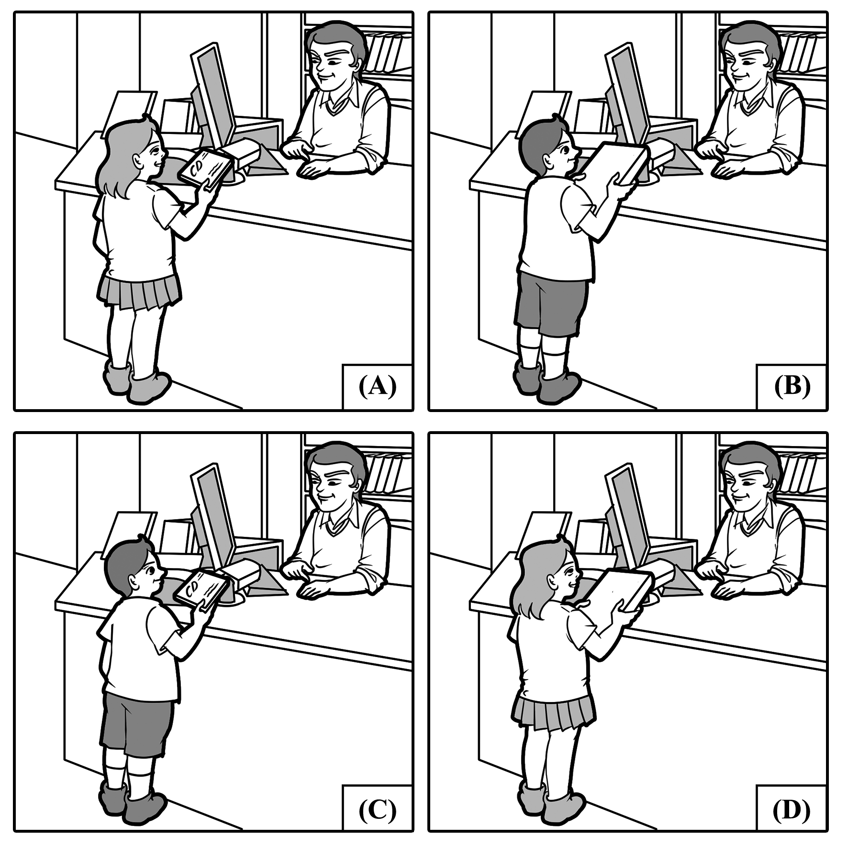

For question number 1, please look at the four pictures.
D Question number 1: The girl is returning a book she borrowed to the librarian.

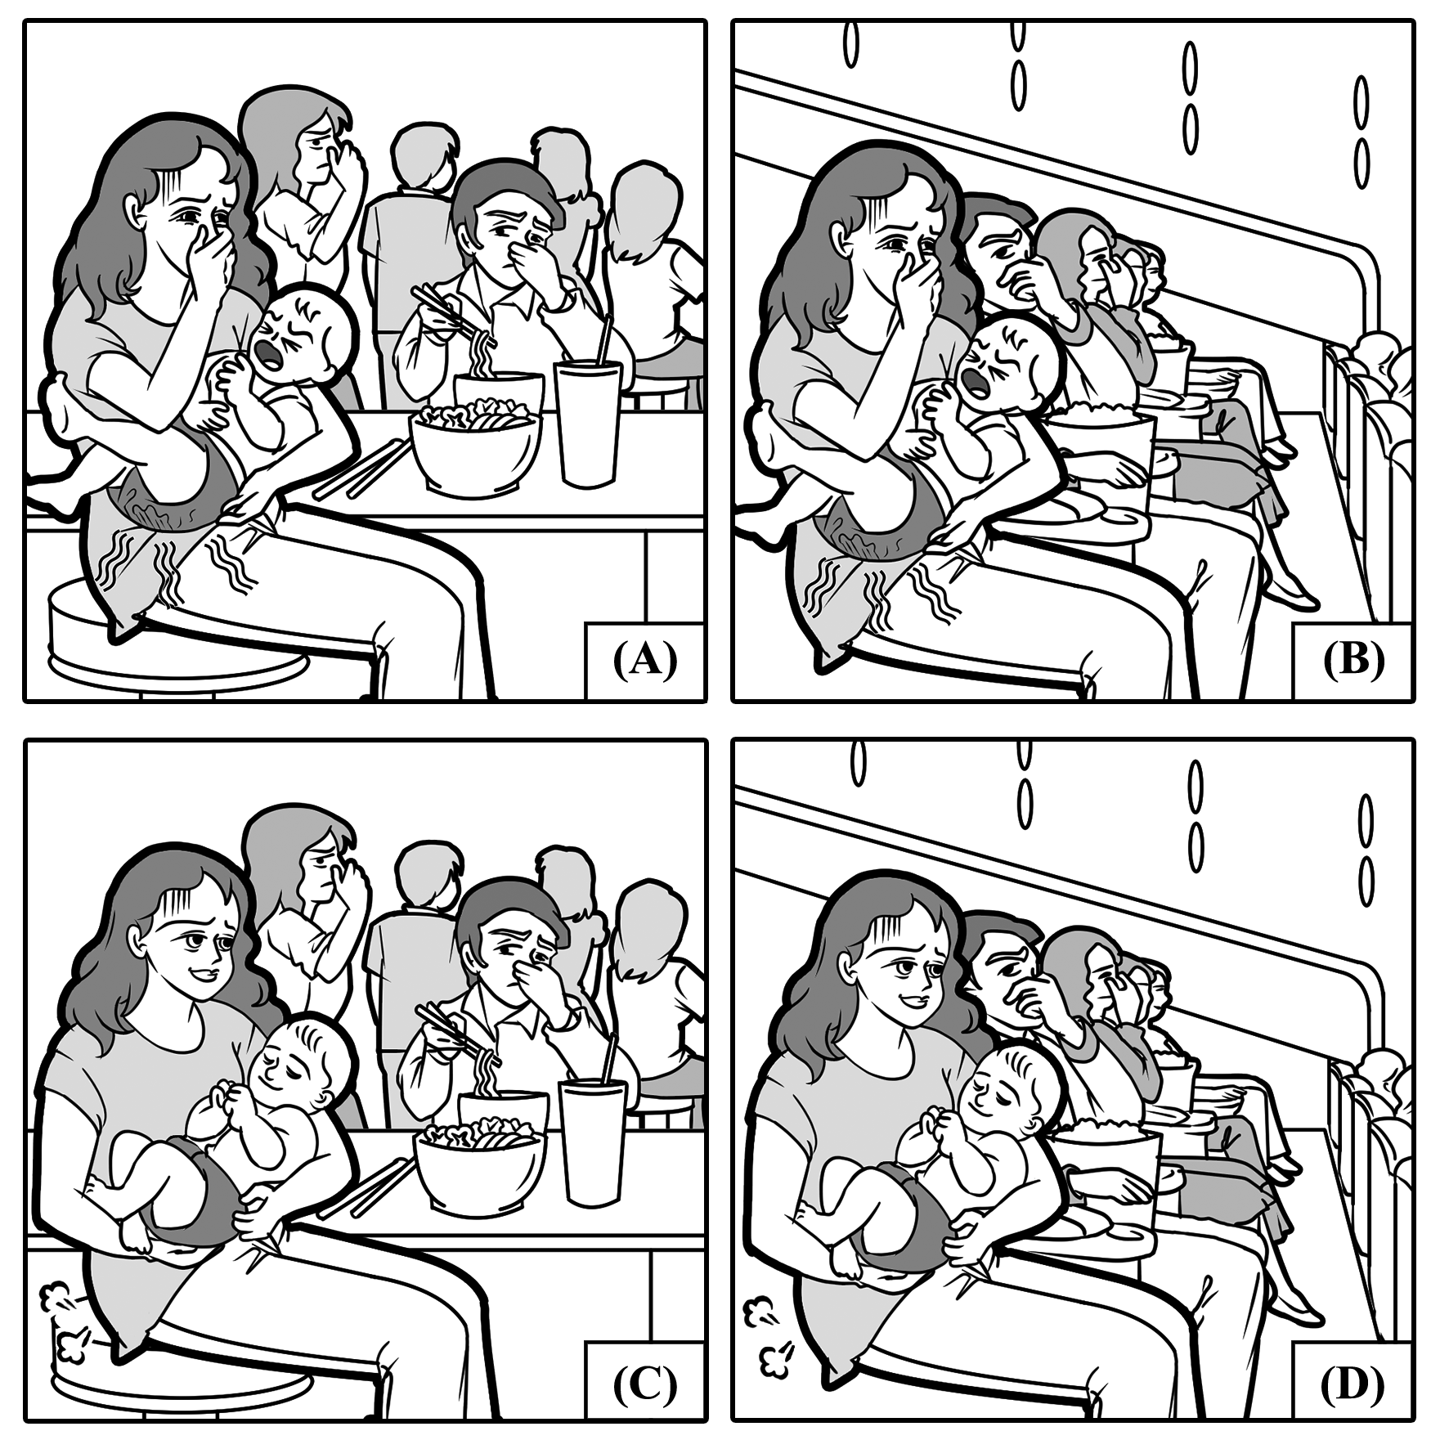

For question number 2, please look at the four pictures.
B Question number 2: The baby farted and people in the theater were covering their noses.

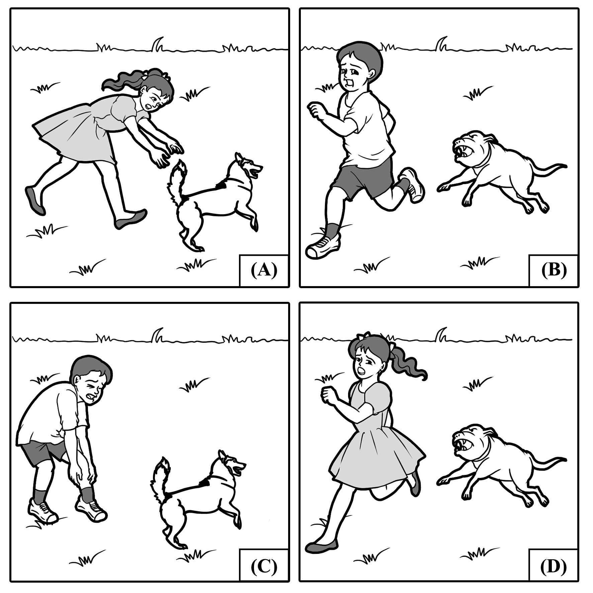

For question number 3, please look at the four pictures.
A Question number 3: The child in a dress is chasing after a dog.
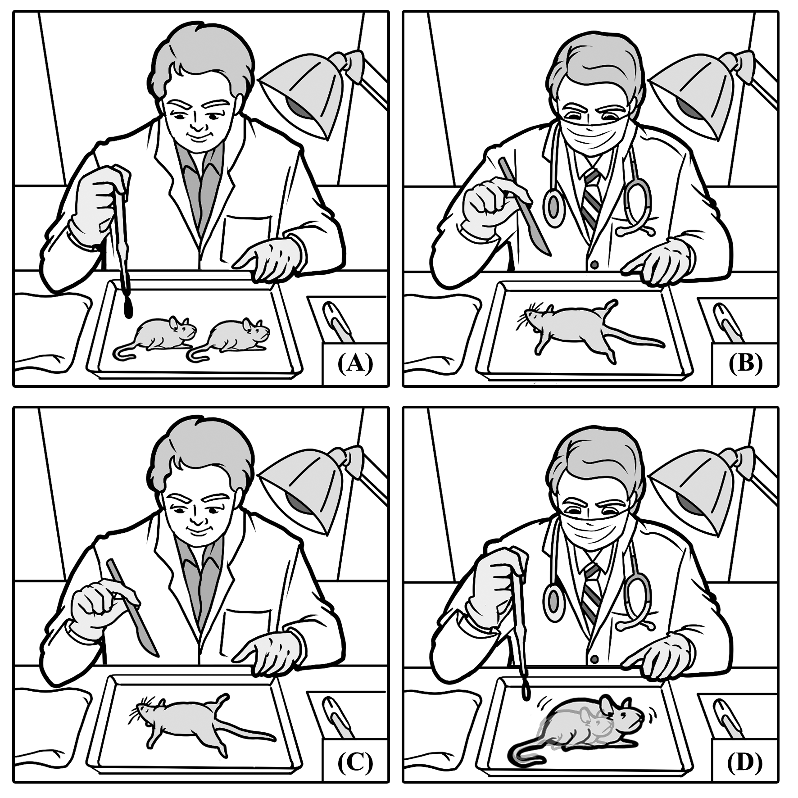

For question number 4, please look at the four pictures.
D Question number 4: The scientist put a droplet of chemicals ont the rat that made it grow bigger.

Part B (%)
In Part B, you will see two pictures on your test paper. For each picture, you will be asked three questions. For each question, you will hear four possible answers. Choose the best two answers according to what you see in the picture.

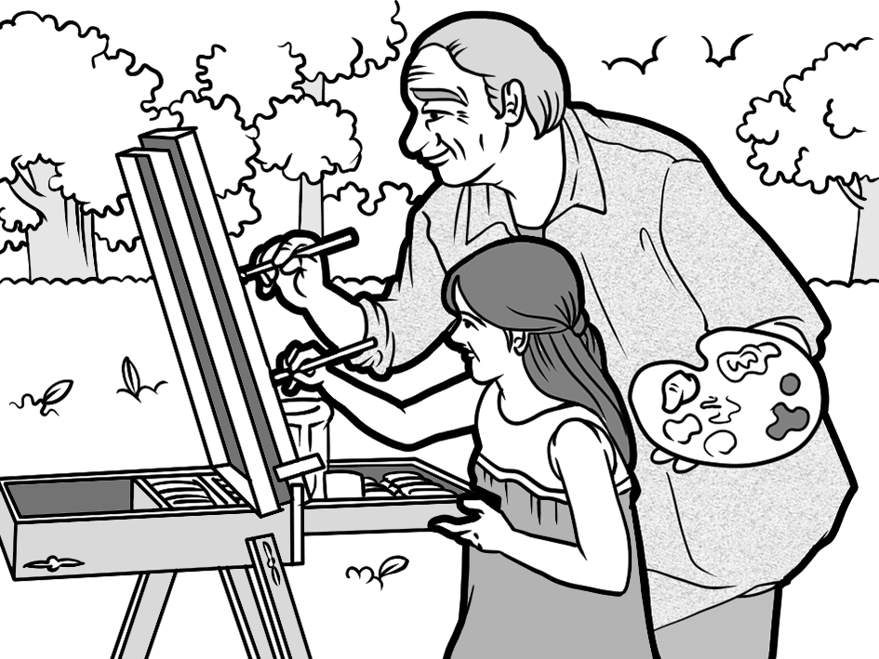
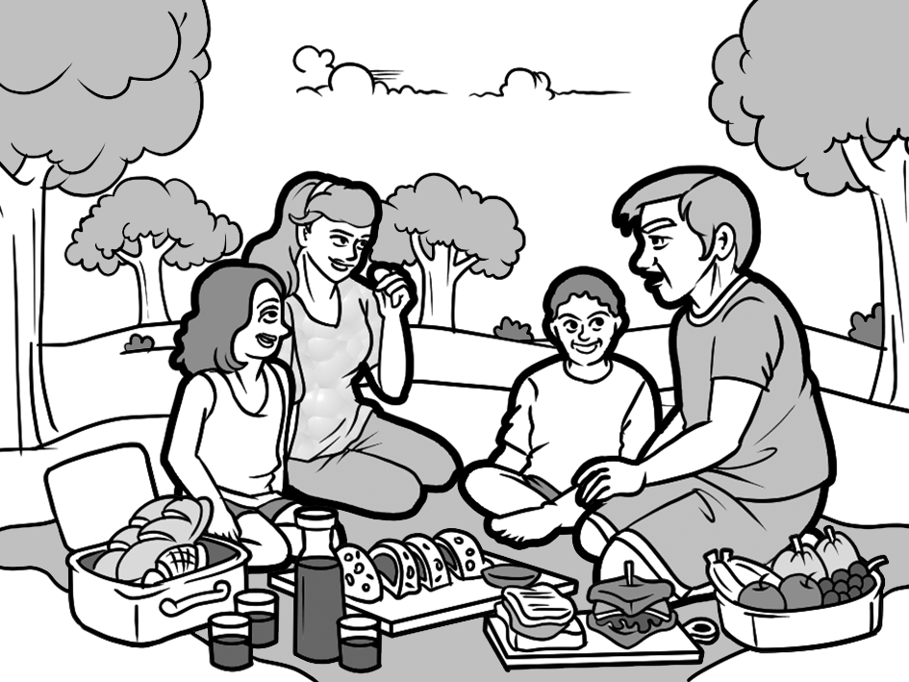
A
B

For questions number 5-7, please look at picture A.
Question number 5: What is true about the picture?
AD (A) The people just settled down in their destination.
(B) They are about to pack up and leave their hotel rooms.
(C) The people are preparing to go to a fancy restaurant.
(D) They are planning on staying for a while longer.

Question number 6: Where are these people?
BC (A) On a cold, snowy mountain.
(B) In a spacious park.
(C) On an open meadow.
(D) At a food court.

Question number 7: What are they doing?
AD (A) They are having a nice picnic on the weekend.
(B) The mother is showing their children how to cook.
(C) The kids are running around the grass field.
(D) They are enjoying the bright sunshine and fresh air.

For questions number 8-10, please look at picture B.
Question number 8: Who is the man to the girl?
AC (A) Her grandfather.
(B) Her boss at the company.
(C) Her art teacher.
(D) Her music instructor.

Question number 9: What is taking place?
BC (A) The man is taking his granddaughter out for ice cream.
(B) They are painting on a canvas together.
(C) The man is showing her how to create a picture.
(D) They are sculpting an animal out of wood.

Question number 10: What is a phrase that can be heard?
AB (A) "This is how you hold the brush to paint a tree."
(B) "You should use these colors for the sky."
(C) "When did you have time to plan a surprise party for me?"
(D) "Make a wish when you see a shooting star!"

Part C (%)
In Part C, you will hear 10 questions or statements. After you hear a question or statement, read the four possible answers on your test paper and decide which one is the best answer to the question or statement you have heard.

D 11. James found it difficult to cope with his parents' high expectations. (10/17)
(A) I think he deserves a high pay in his new company.
(B) The train is expected to arrive in Taipei at 8 p.m.
(C) Teaching the elderly how to use smartphones is never easy.
(D) He should talk to them about what he wants instead of bearing it.

D 12. I originally wanted to finish reading this book yesterday, but I got distracted. (10/20)
(A) What kind of book are you writing? I want to read it.
(B) Stop being sidetracked and finish your work on time.
(C) Once you finish buying the book, let's go get dinner.
(D) Don't worry. You may return it to me at any time.

B 13. How did you get into the habit of waking up at 5:00 a.m. every day? (10/22)
(A) My grandma wakes up early every morning.
(B) It took hard work to change my habit, and many alarms.
(C) Yes, I did get into trouble in my early days.
(D) I usually pick up my children from school at 5 p.m. on weekdays.

C 14. Hi, this booklet said there would be free food here today. Is it still happening? (10/23)
(A) Yes, if you book the hotel room earlier, you'll get a ten percent discount.
(B) No, the class will no longer run until further notice.
(C) I'm sorry; the pamphlets had the wrong information. It's tomorrow.
(D) Sir, it doesn't appear that you are on the guest list.

A 15. I can't go into that library because it isn't wheelchair accessible. (10/24)
(A) I'm sorry; I didn't realize it didn't have any ramps or elevators.
(B) I think that library has a lot of nice scenery, too.
(C) Yes, I did borrow that book before. Isn't it great?
(D) My grandpa uses a powered wheelchair to get around.

B 16. When will you reveal the secret behind your magic tricks? (11/1)
(A) I can't believe he pulled out a rabbit out of thin air.
(B) Never! A true magician will never expose his secrets.
(C) I will host a cooking show over the next few days.
(D) My fantasy novel will be published soon.

C 17. Can you please refrain from laughing loudly in the library? (11/6)
(A) Yes, you can bring in a bottle of water.
(B) Please meet me at the library later.
(C) Sorry, I'll stop. I thought we were alone.
(D) No, I don't have a frame for that picture.

B 18. My mom encouraged me to pursue my dream of being a musician. (11/9)
(A) I don't listen to that type of music, sorry.
(B) You are lucky to have such a supportive person in your life.
(C) I was thinking about buying that purse, too.
(D) You are too young to get married.

D 19. Great job, Craig. The whole theater was roaring with laughter during your performance.
(11/11)
(A) Which theater are we seeing the movie in?
(B) Here's the set of china you asked for.
(C) I agree. It's not easy to find a decent job nowadays.
(D) Thanks. My job as a comedian is to make people laugh.

C 20. When do you think we'll get electricity back in the apartment? (11/12)
(A) I think the album will be released next year.
(B) I have no idea why the landlord agreed to sell his apartment.
(C) News reports say we'll get power back tonight.
(D) Sometime over the next hours, I'll give you a call.

Part D (%)
In Part D, you will hear eight conversations between a man and a woman. After each conversation, you will hear one to two questions about the conversation. After you hear the question, read the four possible answers on your test paper and choose the best answer to the question you have heard.

B 21. M: Hi, I'm here for the job interview. (10/17)
W: Your résumé says you've applied here before.
M: Yes, that was a few years ago before I had any experience.
W: All right, let's get you into the conference room then.
Q: What does the woman mean?
(A) She needs him to hold a conference.
(B) The man has submitted a job application before.
(C) She doesn't think he has enough experience.
(D) She wonders how he got an interview with the celebrity.

A 22. W: Hi, Hank? Why didn't you pick up my calls before? (11/10)
M: Maria, I was trying to sleep in on my day off.
W: Oh, I'm sorry, but you promised we would see a movie together.
M: Can we wait until later? I'm tired.
W: All right, fine. Let me know when you wake up.
M: Thanks. I'll talk to you later.
Q: Why did the man not pick up the woman's phone calls?
(A) He was attempting to sleep later than usual.
(B) He didn't want to disturb her while she was sleeping.
(C) He wanted to wait to tell her the news in person.
(D) He didn't want to see a movie with her.

A 23. M: All right, girl. Here's the ball, now fetch! (11/11)
W: Hm, your dog doesn't seem to like this game.
M: No, I don't know how to teach her.
W: You should try to look up how to train her. It's doable.
Q: What game does the man's dog not like?
(A) Bringing the ball back to him.
(B) Catching a Frisbee.
(C) Playing tug-of-war with him.
(D) Playing hide-and-seek.

B 24. M: Oh, no. We're stuck in here. (11/12)
W: This is one of my worst fears ever. Getting stuck in this metal box.
M: Well, at least the light is still on in this elevator.
W: Please just hit the emergency button and call for help.
Q: What is the woman afraid of?
(A) Staying in a dark room.
(B) Being trapped in an elevator.
(C) Listening to heavy metal music.
(D) Getting stuck in a traffic jam.

C 25. W: Did you look outside yet, Arthur? (11/13)
M: Nope. Is it finally snowing?
W: Yeah, it is. Everything is already covered in snow. Are you ready for the severe
snowstorm?
M: Yes, we have enough supplies to last for a few days.
W: Lucky us! Also, I'm glad you got all this firewood. I'm a little chilly.
Q: Why was the man asked if he had looked outside yet?
(A) The snow was starting to melt.
(B) A huge wildfire was happening outside.
(C) The snowstorm already blanketed everything.
(D) The roads were clear enough to drive on.

A 26. M: Kristy, why did you invite Troy to the party? (11/14)
W: Why not? He's one of my childhood friends.
M: He's notorious for being a thief. He stole our friend's favorite necklace!
W: Really? No wonder I thought his wife's necklace looked so familiar.
M: We should call the police.
W: No, let's confront him first. Give him a second chance.
M: All right, but if it happens again, we're calling the police.
Q: Why is the man talking about calling the police?
(A) Kristy's friend Troy has been known to steal things.
(B) He saw a burglar outside of their home.
(C) Kristy's friend Troy was kidnapped.
(D) He saw the thief who stole a necklace from the store.

Questions 27-28 are based on the following conversation.
W: Are you making dumplings at the cooking competition? (10/24)
M: Yeah, I got a good family recipe. Why?
W: Your dumplings will be no match for mine. I've won the last two years.
M: We'll see. I have a good feeling that I'll win this time.
C 27. Q: Why is the woman asking the man about dumplings?
(A) She thinks making dumplings is a stupid idea.
(B) She wants to know his cake recipe.
(C) She noticed he will be making the same food as her.
(D) She lost the racing tournament to him.

D 28. Q: What is the woman saying to the man?
(A) Her recipe for a successful life worked.
(B) She wants to challenge him to a tennis match.
(C) She hopes she could have a family someday.
(D) His food won't be as good as hers.

Questions 29-30 are based on the following conversation.
W: Thank you for letting me walk under your umbrella. (10/30)
M: You're welcome! It's pouring out there. Well, I should get going.
W: Actually, are you busy now? Would you like to grab a cup of coffee with me?
M: I've got some plans, but I could meet up with you later. My name is James.
A 29. Q: What did James do for the woman?
(A) He offered her to walk beneath his umbrella.
(B) He gave her his jacket when it was cold.
(C) He gave her a ride home in his car.
(D) He paid for their second lunch together.

B 30. Q: What does the woman say to James?
(A) She needs to borrow his umbrella after lunch.
(B) She asks him if he wants to have coffee together.
(C) She has plans but she'll give him a call.
(D) She works at a café and wants him to visit.

Part E (%)
In Part E, you will hear four short passages. After the passage, you will hear two to three questions about the passage. After you hear the question, read the four possible answers on your test paper and choose the best answer to the question you have heard.

I.
It is expected that 135.5 million people will be diagnosed with dementia by 2050. At the present, Alzheimer's disease accounts for 60 to 70 percent of dementia cases. Until a cure is found, the only thing you can do is to learn to cope with it. Sha Yao is a woman whose grandmother suffered and died from Alzheimer's, so she was inspired to help dementia patients to maintain their dignity. In 2014, Yao won the top prize from the first annual design contest held by the Stanford Center on Longevity for her submission. It was Eatwell, a tableware set geared to people with cognitive impairment. Because of her hard work, Yao will help alleviate the burden of caregivers and help people with dementia eat their food better. (10/17)

D 31. What is expected by 2050?
(A) 13 billion people will be living on the planet.
(B) The minimum wage will be set at US$13.50 an hour.
(C) Scientists will find a cure for dementia.
(D) Over 135 million people will suffer from dementia.

B 32. Why is Sha Yao mentioned in the passage?
(A) She was the youngest person to have Alzheimer's.
(B) She won the top prize at Stanford Center on Longevity's contest.
(C) Her grandmother was the first person to be cured of dementia.
(D) She made a robot that would replace caregivers.

II.
"Is the glass half empty or half full?" is a question asked by many to test a person's personality. If you choose half full, it means you are a person who focuses on the positive things in their lives. "Half full" people are optimistic and have an outlook on life that makes them happier, more successful, and suffer from fewer diseases. If you choose half empty, then you look at life in a negative way. This may mean you notice what is missing in your life rather than what you already have. "Half empty" people tend to be unhealthier and less successful. Thankfully, people can change their outlook if they think of it as a habit. Therefore, you should get into the habit of being happy with what you already have, not dwelling on things that you're missing. (10/22)

C 33. Why is there a question at the start of the passage?
(A) It is important to drink eight glasses of water per day.
(B) It checks how many things you have in your life.
(C) It is a test to see what people's personalities are like.
(D) It is a question of half lies and half truths.

D 34. What is true about "half full" people?
(A) They suffer from more diseases.
(B) They notice what is missing in their lives.
(C) They have a less positive outlook on life.
(D) They are happier than "half empty" people are.

III.
Starting in 2016, units of the egg-shaped environmentally living space, Ecocapsule, will be shipped out for the first time. Its compact size and space may seem small, but two people can comfortably live in it. Developed by a Slovakian firm called Nice Architects, the Ecocapsule has many luxuries of a hotel room, and it uses sustainable energy. Running water, hot showers, a wind turbine, solar panels, a folding bed, a storeroom, and more are all geared to allow its inhabitants to have a comfortable stay. Instead of camping in a disappointing tent, you can take in the great outdoors without sacrificing anything. It is thought that a person could stay in the Ecocapsule for a year without having to recharge or resupply. (11/2)

D 35. What is true about the size of the Ecocapsule?
(A) It is large and hard to transport.
(B) It is small enough for just one person.
(C) It is big enough for a family of five.
(D) It is small but two people can live inside.

A 36. Why is the Ecocapsule considered comfortable?
(A) It has the luxuries of a hotel room.
(B) It has enough space for a couch.
(C) It can be expanded.
(D) It is equipped with an air filter.

C 37. How long can a person stay in the Ecocapsule for?
(A) For two years.
(B) Beginning in 2016.
(C) For about a year.
(D) For four years.

IV.
Because I am a morning person, I prefer to study and do my homework bright and early. I used to be a night owl, but I found that getting into the habit of waking up early was rather easy. I have fewer distractions in the morning and focus much better on my studies. For instance, the TV shows I watch usually compete for my attention at night. While it is better to review the materials covered in class earlier in the day at night, I am usually too exhausted to focus my attention on them. It would take me much longer to do my homework at night than in the morning. Therefore, studying early is the better option for me. (11/10)

C 38. According to the passage, what could be said about night owls?
(A) Night owls tend to get a lot done.
(B) They study better at night.
(C) They have many distractions..
(D) Night owls don't get enough sleep.

D 39. Why does the speaker like waking up early?
(A) To watch the early morning cartoons.
(B) To have more time for exercise.
(C) To take time to enjoy their breakfast.
(D) To focus on their studies.

C 40. What is an example of a distraction mentioned in the passage?
(A) Eating a large dinner.
(B) Playing video games.
(C) Watching a TV program.
(D) Training at a sports practice.

