國立臺東高中
104學年度第一學期高二A組第二次期中考英文聽力測驗 (適用班級201.202.205.206.209)

英聽代碼:18

Listening Test
I. Pictures看圖辨義
Listen to the questions. Then choose the best answer according to each picture.

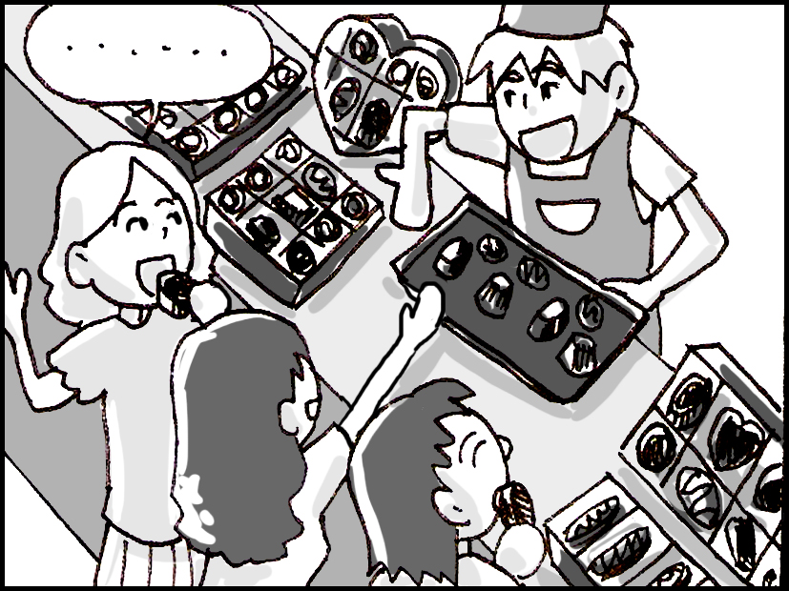

- _____

- _____

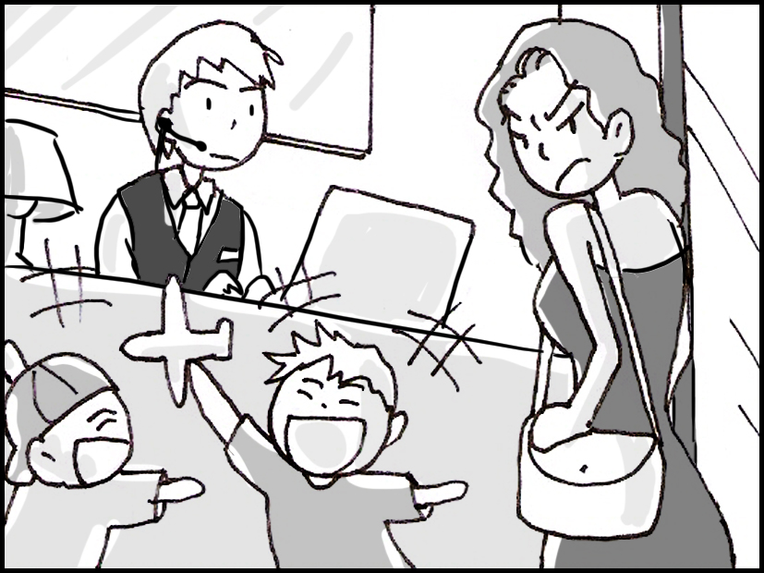

- _____

- _____

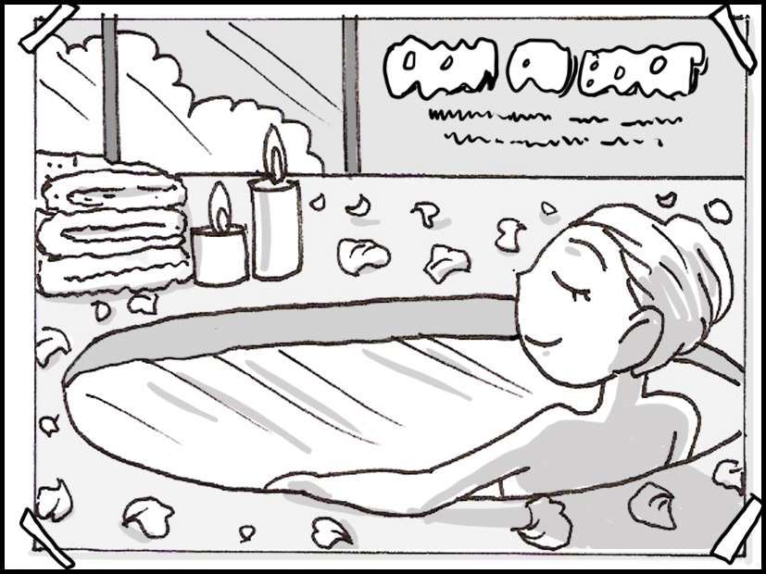

- _____

- _____


D.

- _____

- _____

E.
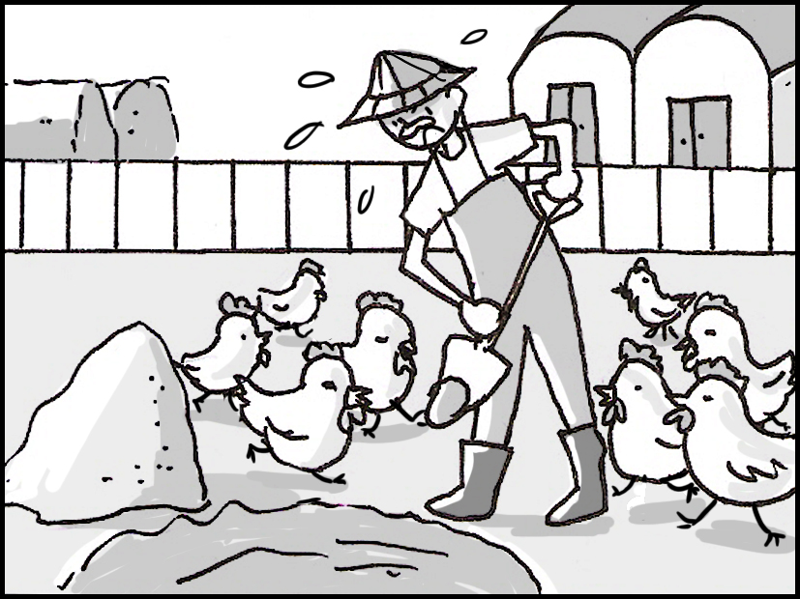

- _____

- _____

II. Best Response 最佳回應句
Choose the best response to each question or statement.

____11.
A. She let me borrow her cellphone to make a call.
B. She let me into the museum on a student discount.
C. I know. I arrived at the museum on time and had a wonderful time.
D. I know. I got lost and had to ask a police officer where I was.

____12.
A. His voice is always easy to recognize.
B. Yeah. I had to turn up the volume of the radio.
C. We will turn off the speakers during the exam.
D. Yeah. He’s been acting weird since he failed his mid-term test.

____13.
A. I’m not sure. I don’t really like basketball.
B. I’m sorry. I can’t. I have a concert to go to with my classmates.
C. We’re out of stock. I’ll call you when we get some more in the store.
D. I’m not sure. You’ll have to check with the coach to see if practice is on this afternoon.

____14.
A. You should get your ankle X-rayed.
B. Go get it checked by a doctor.
C. I got sunburned in yesterday’s sun, too.
D. Yeah, he clinched first place with that serve.

____15.
A. No one was hurt in the earthquake.
B. Everyone in the company got a flu shot.
C. Several people were injured mountain biking.
D. We have been increasing our profits every year.

____16.
A. OK. Can I just sit on your sofa for a while?
B. Thanks for helping me with my workload.
C. I’ll try. Can I get a parking space in this building?
D. Thanks. I’m trying to eat food with fewer chemicals in it.

____17.
A. I know. She bought some online yesterday.
B. Yes, she’s wanted to travel to Korea for a long time.
C. Yes, she is very fashionable.
D. I know. She gets bored when no one is talking to her.

____18.
A. These coins are from the local museum.
B. They’re beautiful rings for Tom’s sisters.
C. I’m sorry. We don’t have any more in the store.
D. Gordon is a very charming person and his students love him.

____19.
A. She’s been one of the best soldiers in her unit.
B. I heard that. She said she wants to travel around the world.
C. Taking a break is a good idea. She could go on vacation for a few weeks.
D. Well she just started her degree, so I think it’s OK for her to change courses.

____20.
A. Why does she like reading there?
B. Do you know what paint she used?
C. I suppose that by relaxing there, she is closer to the food.
D. I know. She has to make dinner for twenty people.

III. Short Conversations 簡短會話
Listen to the conversations. Then answer the questions.

____21.
A. She is very happy with her old car.
B. She is very keen about cars.
C. She loves driving to work.
D. She loves buying fancy cars.

____22.
A. He wants to go to somewhere with pleasant weather.
B. He wants to go walking along a beach near the ocean.
C. He wants to stay at home.
D. He wants to go read a book in a hotel on an island.

____23.
A. She works in the clothing industry.
B. She is a housewife.
C. She supervises people.
D. She works as a secretary.

____24.
A. The man has damaged the boxes he moved earlier.
B. The man’s back hurts because he was sitting down too long.
C. The man has hurt his back.
D. The man has been exercising too much.

____25.
A. He made the woman’s favorite dessert.
B. He surprised her with a canary.
C. He bought a chocolate bar for the woman.
D. He called the woman to ask her to get off work.

____26.
A. The woman is not ready for the test.
B. The woman thinks studying is very difficult.
C. She told him that he doesn’t need to study at all.
D. She told him that he needs to study to get a good grade.

____27.
A. The boy said that he felt bad for the teacher.
B. He said that he would cheat again.
C. He said that the teacher cheated on the test.
D. The boy said that he felt bad for cheating.

____28.
A. Just after they found out about the chicken curry.
B. Just after they had got married.
C. Before they got married.
D. Before the woman learned to swim.

____29.
A. She said that he should try his best at all things.
B. She said that he should work hard but exercise less.
C. She said that he should work less but exercise more.
D. She said that he should have a successful plan.

____30.
A. He doesn’t want to get fit.
B. He is worried about getting hit again.
C. He is worried about making big decisions.
D. He doesn’t want to leave the game.

IV. Short Talk 短文
Listen to the talk. Then choose the best answer to each question.

Part A

____31.
A. To tell people about an event at a restaurant.
B. To explain how often people should eat pizza.
C. To inform people about the benefits of eating pizza.
D. To warn people about the dangers of trying new things.

____32.
A. Paul’s Pizzeria is very expensive.
B. Paul’s Pizzeria is giving away kangaroos.
C. Paul’s Pizzeria is selling unique flavors of pizza.
D. Paul’s Pizzeria is closing at the end of the month.

Part B

____33.
A. To help couples plan their wedding dinner.
B. To sell special clothing at a lower price.
C. To inform people about weddings in other countries.
D. To assist Brittany with raising money for her wedding.

____34.
A. They want to stand out during the dinner.
B. They want to look pure on their wedding day.
C. They want to follow Indian wedding customs.
D. They want to move to East Asia after the wedding.

Part C

____35.
A. To promote a store that sells healthy chickens.
B. To promote a company that makes healthy foods.
C. To tell people about the dangers of eating fresh food.
D. To tell people about the importance of eating food as a family.

____36.
A. Food Family is an expensive store.
B. Food Family does not sell chickens.
C. Food Family makes a variety of products.
D. Food Family makes products with many chemicals.

Part D

____37.
A. Someone who is allergic to dairy.
B. Someone who makes handmade soap.
C. Someone who enjoys special foods.
D. Someone who likes to keep a diary.

____38.
A. Learn how to make cheese.
B. Taste different kinds of cheese.
C. Wear clothes made from cheese.
D. Attend several talks about cheese.

Part E

____39.
A. Someone staying at an affordable hotel.
B. Someone living with their family members and pets.
C. Someone staying with their friends from college.
D. Someone staying at a private and expensive location.
____40.
A. It is far away from the ocean.
B. It used to be a rich person’s home.
C. It shares the beach with another resort.
D. It is difficult to relax there because of the noise.

