
Name:
Class:
No:
台東高中
104學年度第一學期高二第二次英文聽力測驗
For Teacher’s Use Only

Listening Test

I. Pictures看圖辨義
Listen to the questions. Then choose the best answer according to each picture.

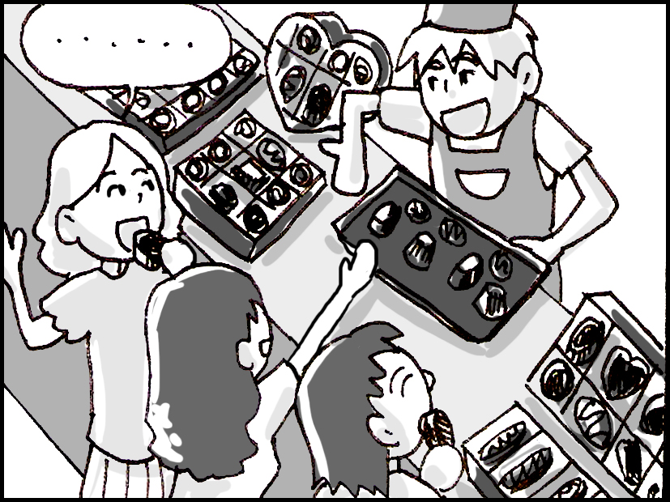
- (10/30,31)

For questions number 1 and 2, please look at picture A.
1. What are these people doing?
A. Learning some tricks of the trade.
B. Listening for sound vibrations.
C. Sampling a culinary creation.
D. Studying their cultural heritage.

2. What might the woman say?
A. I adore tropical plants!
B. I am a chocoholic.
C. He’s a great travel blogger.
D. He must be a beloved actor.

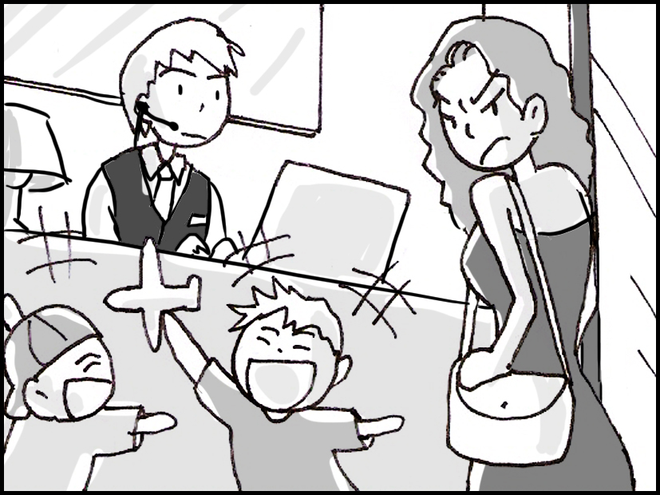
- (10/7,8)

For questions number 3 and 4, please look at picture B.
3. Where are these people?
A. Near a front desk.
B. On a hotel balcony.
C. On a tropical island.
D. In a fragrant garden.

4. How does the woman feel?
A. She is panicking because she’s late.
B. She’s sighing in relief to finally be at her destination.
C. She’s embarrassed to be singing in the wrong key.
D. She is annoyed because the children are yelling.

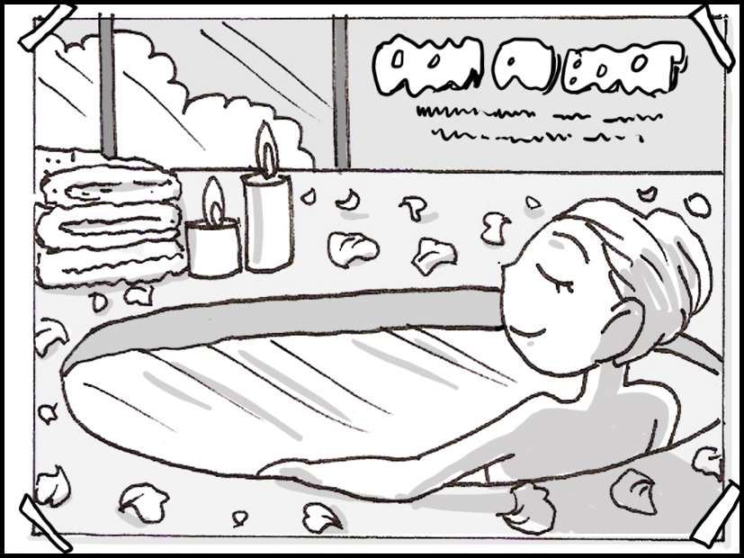
- (10/20-22)

For questions number 5 and 6, please look at picture C.
5. What can you see in the picture?
A. A woman soaking in a tub.
B. A couple on their honeymoon.
C. A group of relatives taking a photo.
D. A delicious bowl of goat curry.

6. What might the words on the picture say?
A. Mild Weather Predicted.
B. Plunge into the Ocean Now!
C. Learn Some Local Dialects!
D. Relax in Our Crystal-Clear Waters.

D. (10/14,15)


For questions number 7 and 8, please look at picture D.
7. What can you see in this picture?
A. A recipe for making pizza.
B. Various flavors of pizza.
C. The sign at a pizza restaurant.
D. Locations of pizza shops around the globe.

8. What is true of pizza #1?
A. It has a lot of vegetables.
B. It has kangaroo meat on it.
C. It is covered in seafood.
D. It shows a single slice.

E. (10/9,10)
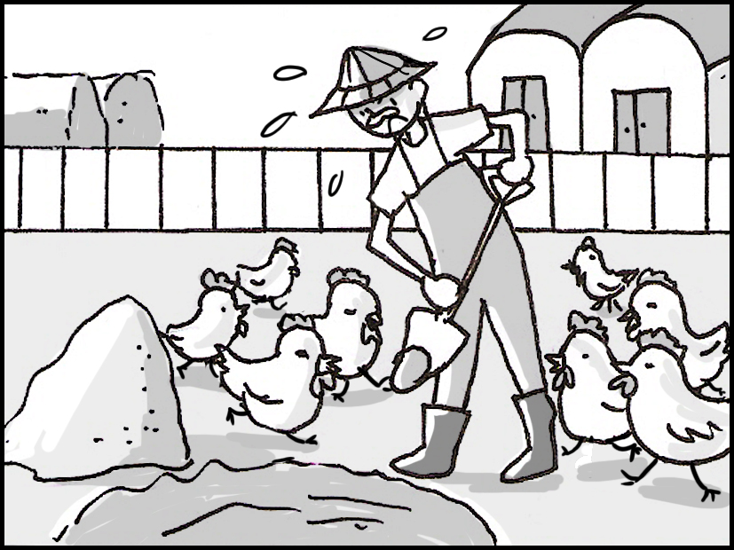

For questions number 9 and 10, please look at picture E.

9. What can you see in the picture?
A. An animal doctor giving antibiotics.
B. Members of a household taking a photo.
C. Chickens roaming around a yard.
D. A farmer spraying pesticides on his crop.

10. What is true of the man?
A. He is laboring in his garden.
B. He is reading about a scandal.
C. He is eating some glutinous rice.
D. He is striving to catch an animal.

II. Best Response 最佳回應句
Choose the best response to each question or statement.

11. The woman’s directions to the museum were confusing. (10/3)
A. She let me borrow her cellphone to make a call.
B. She let me into the museum on a student discount.
C. I know. I arrived at the museum on time and had a wonderful time.
D. I know. I got lost and had to ask a police officer where I was.

12. I heard Jason’s distinctive voice echo through the hall. (10/1,2)
A. His voice is always easy to recognize.
B. Yeah. I had to turn up the volume of the radio.
C. We will turn off the speakers during the exam.
D. Yeah. He’s been acting weird since he failed his mid-term test.

13. Can you come to my hockey game this coming Saturday afternoon? (10/5,6)
A. I’m not sure. I don’t really like basketball.
B. I’m sorry. I can’t. I have a concert to go to with my classmates.
C. We’re out of stock. I’ll call you when we get some more in the store.
D. I’m not sure. You’ll have to check with the coach to see if practice is on this afternoon.

14. I think I have a pinched nerve in my arm. (10/12,13)
A. You should get your ankle X-rayed.
B. Go get it checked by a doctor.
C. I got sunburned in yesterday’s sun, too.
D. Yeah, he clinched first place with that serve.

15. How has your company recovered since the recession took place? (10/16,17)
A. No one was hurt in the earthquake.
B. Everyone in the company got a flu shot.
C. Several people were injured mountain biking.
D. We have been increasing our profits every year.

16. Try to rest and that should reduce your heart rate. (10/23,24)
A. OK. Can I just sit on your sofa for a while?
B. Thanks for helping me with my workload.
C. I’ll try. Can I get a parking space in this building?
D. Thanks. I’m trying to eat food with fewer chemicals in it.

17. Sally has a fascination with cartoon characters from Japan. (10/19)
A. I know. She bought some online yesterday.
B. Yes, she’s wanted to travel to Korea for a long time.
C. Yes, she is very fashionable.
D. I know. She gets bored when no one is talking to her.

18. I’d like to buy five of these gold charms. (10/26,27)
A. These coins are from the local museum.
B. They’re beautiful rings for Tom’s sisters.
C. I’m sorry. We don’t have any more in the store.
D. Gordon is a very charming person and his students love him.

19. Erica is thinking of retiring from teaching after thirty years. (10/28,29)
A. She’s been one of the best soldiers in her unit.
B. I heard that. She said she wants to travel around the world.
C. Taking a break is a good idea. She could go on vacation for a few weeks.
D. Well she just started her degree, so I think it’s OK for her to change courses.

20. Kelly has been laboring in the kitchen the whole afternoon. (10/9,10)
A. Why does she like reading there?
B. Do you know what paint she used?
C. I suppose that by relaxing there, she is closer to the food.
D. I know. She has to make dinner for twenty people.

III. Short Conversations 簡短會話
Listen to the conversations. Then answer the questions.

21. (10/1,2)
W: I’m bored with driving the same car for five years.
M: Why don't you buy a new one?
W: I would like to buy something distinctive, but fancy cars are really expensive.
M: I didn’t know that you were so enthusiastic about cars.
W: Well, I am. I love driving.
Q: What did the woman say about cars?
A. She is very happy with her old car.
B. She is very keen about cars.
C. She loves driving to work.
D. She loves buying fancy cars.

22. (10/7,8)
W: Where are you going on holiday this year?
M: I don’t know yet, but I want to go to a tropical island.
W: What do you want to do there?
M: I want to go swimming in the ocean.
Q: What does the man want to do?
A. He wants to go to somewhere with pleasant weather.
B. He wants to go walking along a beach near the ocean.
C. He wants to stay at home.
D. He wants to go read a book in a hotel on an island.

23. (10/16,17)
W: The worldwide recession has really hit the clothing industry in Taiwan.
M: Yes, lucky I’m not the only breadwinner in the house as my wife also works.
W: What does she do?
M: She is a manager in an electronics company.
W: Well I’m glad both of you are still doing well.
M: Thank you.
Q: What does the man’s wife do?
A. She works in the clothing industry.
B. She is a housewife.
C. She supervises people.
D. She works as a secretary.

24. (10/12,13)
W: What’s wrong?
M: My back has been hurting me all day long.
W: Do you think you’ve strained it?
M: Yes, I was moving some boxes around the office earlier today.
W: I hope you haven’t damaged your spine.
Q: What has happened?
A. The man has damaged the boxes he moved earlier.
B. The man’s back hurts because he was sitting down too long.
C. The man has hurt his back.
D. The man has been exercising too much.

25. (10/30,31)
M: Are you ready for a culinary surprise tonight?
W: Did you make me dinner?
M: Yes, and I made your beloved chocolate cake as well.
W: Thank you. What time is dinner?
M: What time do you get off work?
W: I don’t know. I’ll phone you as soon as I get off.
Q: What did the man do?
A. He made the woman’s favorite dessert.
B. He surprised her with a canary.
C. He bought a chocolate bar for the woman.
D. He called the woman to ask her to get off work.

26. (10/28,29)
B: Do I need to study for tomorrow’s test?
W: You don’t necessarily need to study for the test, but do you think you’ll do well if you don’t?
B: Probably not.
W: That’s right. It’s always best to be prepared.
B: Studying is very troublesome.
Q: What did the woman tell the boy?
A. The woman is not ready for the test.
B. The woman thinks studying is very difficult.
C. She told him that he doesn’t need to study at all.
D. She told him that he needs to study to get a good grade.

27. (10/3)
B: I feel guilty about cheating on the test.
W: You should feel guilty. I should tell your teacher.
B: Please don’t! I feel bad enough already.
W: If I don’t, you will only cheat next time as well.
Q: What did the boy say?
A. The boy said that he felt bad for the teacher.
B. He said that he would cheat again.
C. He said that the teacher cheated on the test.
D. The boy said that he felt bad for cheating.

28. (10/20-22)
W: My husband and I went to Jamaica last year for our honeymoon.
M: What did you think about Jamaica?
W: They have great food there.
M: What was your favorite local food?
W: I loved the chicken curry.
Q: When did the woman and her husband go to Jamaica?
A. Just after they found out about the chicken curry.
B. Just after they had got married.
C. Before they got married.
D. Before the woman learned to swim.

29. (10/23,24)
M: What is your strategy for success in life?
W: I think you should work hard and play hard.
M: That’s a great plan.
W: That’s how I live my life.
Q: What did the woman tell the man?
A. She said that he should try his best at all things.
B. She said that he should work hard but exercise less.
C. She said that he should work less but exercise more.
D. She said that he should have a successful plan.

30. (10/5,6) (
W: Have you ever played hockey?
M: I tried it one time, but I wouldn’t play again.
W: Why not?
M: I had a big collision with another player.
W: Did you get hurt?
M: Yes, I had to leave the game.
Q: Why doesn’t the man want to play hockey again?
A. He doesn’t want to get fit.
B. He is worried about getting hit again.
C. He is worried about making big decisions.
D. He doesn’t want to leave the game.

IV. Short Talk 短文
Listen to the talk. Then choose the best answer to each question.

Part A (10/14,15)
Pizza is a delightful dish enjoyed all over the world. And this month is National Pizza Month! To celebrate, Paul’s Pizzeria is having specials every day. On Mondays, you can try Greek and Roman inspired pizza. This is a flat, round bread with various toppings. On Tuesdays, celebrate the dish perfected by Italians by getting a “pie” with tomatoes. Italians spread their pizza style by sharing their recipes when they moved to other countries. If you are feeling brave on Wednesdays, you can sample an Australian pizza topped with kangaroo meat. Be sure to stop by to see what other specials they have during the rest of the week!

31. Why is this talk being given?
A. To tell people about an event at a restaurant.
B. To explain how often people should eat pizza.
C. To inform people about the benefits of eating pizza.
D. To warn people about the dangers of trying new things.

32. According to the talk, what is true?
A. Paul’s Pizzeria is very expensive.
B. Paul’s Pizzeria is giving away kangaroos.
C. Paul’s Pizzeria is selling unique flavors of pizza.
D. Paul’s Pizzeria is closing at the end of the month.

Part B (10/26,27)
Brittany’s Bridal is having its annual sale for the next two weeks! Brides and grooms looking for the perfect dress and suit will love the choices and prices. White dresses are the most popular because the color white represents purity. Brittany’s Bridal also offers dresses in other colors and styles for couples interested in having a traditional wedding from another culture. In India, brides traditionally wear red, the color of celebration. And brides throughout East Asia often change into several different dresses on their wedding day. During the annual sale, brides can find great discounts on many different styles of wedding dresses.

33. What is the main purpose of this event?
A. To help couples plan their wedding dinner.
B. To sell special clothing at a lower price.
C. To inform people about weddings in other countries.
D. To assist Brittany with raising money for her wedding.

34. Why might someone want to buy a red dress?
A. They want to stand out during the dinner.
B. They want to look pure on their wedding day.
C. They want to follow Indian wedding customs.
D. They want to move to East Asia after the wedding.

Part C (10/9,10)
Shopping for food can be quite a challenge these days. Food safety issues have become a real concern for many people. But don’t worry! There are people laboring to make healthy foods free of chemicals. Customers at our store love the products from Food Family. Through much trial and error, they have developed a delicious soy sauce that doesn’t contain any unnatural ingredients. Their goal of creating tasty food from organic ingredients is admirable. Food Family also has a great line of chicken products. Their chickens are raised in a free-roaming environment and are never given hormones or antibiotics. So the next time you go shopping, look for the healthy choices offered by Food Family.

35. What is the main purpose of this talk?
A. To promote a store that sells healthy chickens.
B. To promote a company that makes healthy foods.
C. To tell people about the dangers of eating fresh food.
D. To tell people about the importance of eating food as a family.

36. According to the article, what is true?
A. Food Family is an expensive store.
B. Food Family does not sell chickens.
C. Food Family makes a variety of products.
D. Food Family makes products with many chemicals.

Part D (10/30,31)
People around the world adore cheese. There are a wide range of styles and flavors, many of which are part of its region’s heritage. To provide people with the opportunity to celebrate this beloved food, there will be a cheese fair for the next two months. Culinary experts from across the globe will come to show off and sample the world’s finest cheese. Flavors abound, with everything from creamy Parmesan to salty Cheddar. Cheese bloggers have also been invited to cover the event and enjoy the culinary experience. For more information, please visit our official website or stop by the information counter at the front entrance.

37. Who would be interested in this talk?
A. Someone who is allergic to dairy.
B. Someone who makes handmade soap.
C. Someone who enjoys special foods.
D. Someone who likes to keep a diary.

38. What can people do at this event?
A. Learn how to make cheese.
B. Taste different kinds of cheese.
C. Wear clothes made from cheese.
D. Attend several talks about cheese.

Part E (10/20-22)
Welcome to Rick’s Resort on the beautiful island of Jamaica! During your stay, we hope you enjoy the rhythm and rhyme of the island. Life here is more relaxed, which makes it the perfect place for you and your relatives to soak in some sun. The resort’s location was originally a huge mansion. The main house and its grounds have been converted into the beautiful beach houses you see today. If you walk out of the main gates of the resort, you will find a private, white-sand beach. The crystal-clear water is the perfect place for you to cool off and relax after enjoying some of the exciting activities found nearby.

39. Who is probably listening to this talk?
A. Someone staying at an affordable hotel.
B. Someone living with their family members and pets.
C. Someone staying with their friends from college.
D. Someone staying at a private and expensive location.

40. What is true of Rick’s Resort?
A. It is far away from the ocean.
B. It used to be a rich person’s home.
C. It shares the beach with another resort.
D. It is difficult to relax there because of the noise.

