國立臺東高級中學 105學年度第二學期期末考
高二原藝班與體育班
Class:_______ No._______ Name:____________
（5%為口試成績，所以本卷共95%）
一、Matching健身中英文配對 (1% x 15 = 15%)(將以下英文填入對應的中文旁，須寫出完整英文不然不給分)
training | waist | fitness center
sit-ups | run a marathon | swimming pool
push-ups | work out | do weights
gym | cycling | boxing
stomach | thighs | triathlon
作重訓： | 鐵人三項： | 健身房、體育館：
跑馬拉松： | 仰臥起坐： | 健身中心：
伏地挺身： | 騎自行車： | 游泳池：
健身： | 訓練： | 拳擊：
胃： | 大腿： | 腰：
二、問路英文克漏字Cloze (12%)
Visitor: Excuse me. I’m not sure if I’m on the right ___1___.
Woman: ___2___ are you heading to?
Visitor: I want to go downtown, to the Central Market. I followed the signs, but then I got a little ___3____.
Across（橫的）:
1. 標誌
4. 月台
5. 機器
7. (火車)站：train ___?___
8. 市中心
9. 出口
10. 打擾
Woman: Yeah, you’re on the wrong platform. You need to go to Platform B. Just go ___4___ those stairs, and turn right.
1. | ( ) | (A) platform | (B) display | (C) terminal | (D) line
2. | ( ) | (A) What | (B) When | (C) Where | (D) How
3. | ( ) | (A) confusing | (B) confused | (C) confusion | (D) confusedly
4. | ( ) | (A) straight | (B) along | (C) on | (D) up
5. 這位迷路的觀光客要去______________，指路的女子跟他說要去______月台搭車。(2%)
Down（直的）:
1. 地下鐵
2. 街區
3. 入口
4. 乘客、旅客
6. 單程票：one way ____?____
Visitor: Hi. I’m sorry to bother you, but I’m totally lost. Where is this?
Woman: _____ is Woodlands Park.
Visitor: Oh no! I wanted to ______ Woodbury Park. Do you know ______ I can get there from here?
Woman: You need to get back on the southbound train, and then transfer to the Green Line.
6. | ( ) | (A) That | (B) This | (C) These | (D) Those
7. | ( ) | (A) get to | (B) pass by | (C) figure out | (D) carry on  第ㄧ頁，共兩頁
8. | ( ) | (A) which | (B) where | (C) how | (D) that
9. 這位迷路的觀光客要去________________，好心指路的女子跟他說他得再回去搭往（東/西/南/北）向的列車(←圈選1個答案)，然後轉搭________線。(3%)
三、中翻英 Translation (18%)
1. 我想要縮小我的啤酒肚。(3%)
__________________________________________________________.
2. 我想要讓我的贅肉瘦下來。(3%)
__________________________________________________________.
3. 我想要讓我的六塊肌變結實。(3%)
__________________________________________________________.

- 請翻譯底下框起來的句子：
觀光客：不好意思。可以請教一個問題嗎？(3%)
- ____________________________________________________
男子：好啊，你想知道什麼？(2%)
- ____________________________________________________
觀光客：我在找有到帝國大廈的地鐵線。
男子：首先，直走，然後右轉。你會看到入口。(4%)
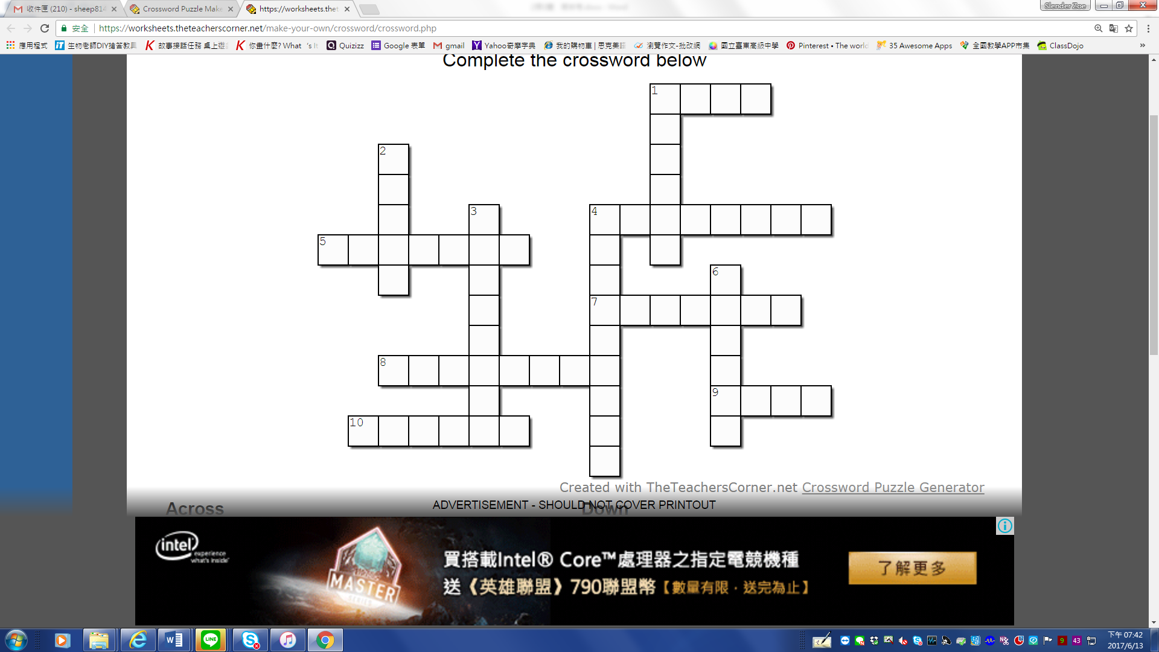
- ____________________________________________________
四、問路Crossword Puzzle (1% x 12 = 12%)

五、填空題 Blank Filling （對照中文，從以下單字中選適當的填入空格）(1% x 10 = 10%)
cell phone | turbulence | cabin | remain | sign
seat | get up | Fahrenheit | landed | captain
Attention. This is your ¹___________ speaking. We are experiencing some ²____________, so please ³___________ seated with your seatbelts fastened until the seatbelt ⁴___________ is turned off.
請注意，這是機長廣播。我們現在正遇上亂流，所以請您留在座位上，繫好安全帶，直到安全帶指示燈熄滅為止。

You are now free to ⁵___________ and move around the ⁶____________ as necessary. However, please keep your seatbelt fastened while you’re in your ⁷___________ in case we encounter any unexpected situation.
如有必要，您現在可以在機艙內起身走動。但是坐在座位上時請繼續繫好安全帶，以免遇上突發狀況。

We have now ⁸____________ in Chicago. The local time is 3:32 p.m., and the temperature is 56 degrees ⁹____________. You may use your ¹⁰_______________ now. 我們現在已降落在芝加哥，當地時間為下午3:32，氣溫為華氏56度。您現在可以使用手機了。

六、機場英文—英翻中 Chinese-English Translation (12%)
1. Excuse me, I’m a little cold. Could I have a blanket? (2%)
→ __________________________________________________________
2. Would you like a hot beverage as well? (2%)
→ __________________________________________________________
3. We have hot coffee and tea. (2%)
__________________________________________________________
4. Later on, we’ll also be serving soft drinks and alcoholic beverages with a light snack.
→ ________________________________________________________(3%)
5. I’ll also buy a carton of these cigarettes, and a bottle of this perfume, too. (3%)
→ __________________________________________________________
七、Best Response 機上對話之選擇題：(3%)
( ) 1. Ground Staff (地勤人員): Are you checking any bags today?
Customer (顧客): Yeah. _________
(A) I don’t have any luggage to check in. (B) I have one bag to check.
(C) I’ll take the chicken meal. (D) I’ll pay with my Visa card.
( ) 2. Ground Staff (地勤人員): There’s a 20$ charge for your bag. _________
Customer (顧客): I’ll pay with my Visa card.
(A) What’s the weight limit?
(B) Can I take this as a carry-on?
第二頁，共兩頁
(C) How much is the extra baggage fee?
(D) Would you like to pay by credit card or cash?
( ) 3. Attendant (空姐): Any duty-free, sir?
Customer (顧客): Yes. _________
(A) I’d like to buy a bottle of perfume. (B) Here’s my credit card.
(C) I am sorry. I don’t. (D) Do you have vegetarian options?
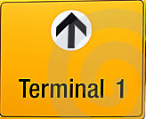
八、請寫出機場常見標示的中文意義 (一格0.5% x 10 = 5%)
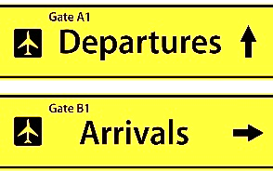
1. ___________ 2. ___________

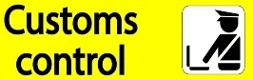
3. ___________ 4. ___________

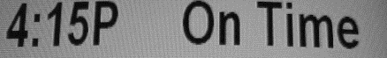
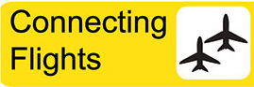
5. ___________ 6. ___________

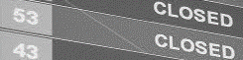
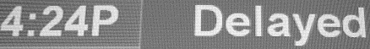
7. ___________ 8. ___________

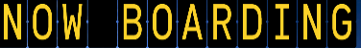
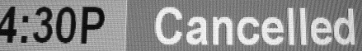
9. ___________ 10. __________
九、下面是一張登機證，請問上面的英文是什麼意思？寫出中文註解。(8%)
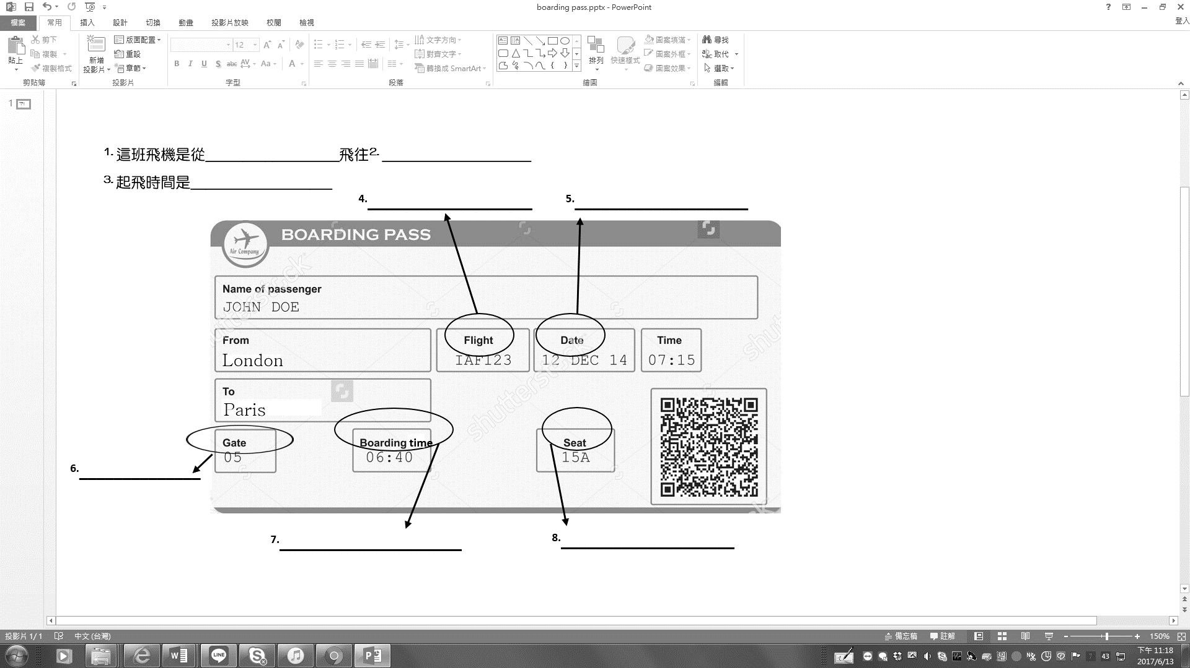
十、加分題 Bonus (5%)
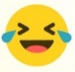
各位即將邁入高三，又是另外一個階段的開始，請想一想並寫下關於自己的夢想，可以是夢想的大學、科系、工作或想發展的興趣，也可以是對自己的期許或對未來的想像。中英文書寫皆可，英文寫錯不扣分。
______________________________________________________________________________________________________________________________________________________________________________________________________
--By Stephen Curry

