國立臺東高級中學 | 105學年度  第二學期 | 第一次期中考 | 高三英文科試卷 | 卷別：社B卷
適用班級：3-7、3-8 【答案卡＋答案卷】
三年 班 號 姓名：

第壹部份：單選題 (占60分)
一、詞彙（占30分）
說明：第1題至第15題，每題有4個選項，其中只有一個是正確或最適當的選項，請畫記在答案卡之「選擇題答案區」。各題答對者，得2分。

1. Brian appeared impatient and kept on glancing at his watch. I couldn’t help but _____ about what he was going to do next.
(A) awaken (B) meditate (C) deem (D) speculate
2. Having grown up in a bustling city, Helen found it hard to get _____ to living in a quiet rural area.
(A) miraculous (B) upright (C) accustomed (D) minimum
3. Lisa’s trip to India was a _____ experience for her. She attended some special events and met several interesting local people there.
(A) taxing (B) thrilling (C) trifling (D) toiling
4. Sean _____ the secret of the magic trick the first time he saw it performed. He is very clever indeed.
(A) penetrated (B) consoled (C) flickered (D) glimpsed
5. During the Chinese New Year, the sight of the homeless sleeping on the streets is even more _____.
(A) literal (B) unfavorable (C) worthy (D) pathetic
6. Sarah Brightman was _____ to be an accomplished singer because she was born with such a beautiful voice.
(A) worthy (B) destined (C) serene (D) outer
7. _____ at public universities in Taiwan is low compared with that in some other countries.
(A) Enterprise (B) Inequality (C) Tuition (D) Tax
8. After months of drought, the rainy season finally came and brought lots of water. It was considered to be
a real _____ for the locals.
(A) symmetry (B) blessing (C) strain (D) veterinarian
9. Though Serena apologized to Tony for revealing his secrets, it was little _____ to him. He was still upset that she had betrayed his trust.
(A) consolation (B) perseverance (C) perfume (D) miracle
10. Due to _____ weather conditions, our flight was delayed for three hours.
(A) serene (B) thrilling (C) unfavorable (D) worthy
11. Memorizing more than 30 new words a day is beyond the _____ of my memory.
(A) architects (B) canvases (C) hints (D) boundaries
12. Long after the police started to _____ the murder case, they finally identify the prime suspect.
(A) outline (B) investigate (C) glimpse (D) grant

13. Gloria _____ the opportunity to represent her school at the national speech contest, and she spent weeks
practicing.
(A) awakened (B) strained (C) relished (D) gazed
14. Since the current interest rates in blanks are rather low, most people have no _____ to deposit their money there.
(A) adulthood (B) consolation (C) inequality (D) incentive
15. The French phrase “C’est la vie!” _____ means “That’s life!” in English.
(A) literally (B) serenely (C) miraculously (D) thrillingly

二、文法選擇（占10分）
說明：第16題至第25題，每題一個空格，請依文意在文章後所提供的 (A) 到 (D) 選項中分別選出最適當者，並將其英文字母代號標示在答案卡之「選擇題答案區」。各題答對者，得1分。

16. Henry can’t afford a secondhand bike, ________ a sports car.
(A) regardless of (B) based on (C) speaking of (D) let alone
17. This scientist has contributed much to the advancement of nanotechnology. Her achievements are
________.
(A) worth to our respect (B) worthy of our respect
(C) worthy respecting (D) worth of our respect
18. It seemed that Thomas ________ well the night before because he kept dozing off in class.
(A) doesn’t sleep (B) hasn’t slept (C) hadn’t slept (D) won’t sleep
19. For his deeds in the past, Mr. Hsieh isn’t accepted by his daughter. He seems to ________ chances to
make up their relationship.
(A) be missing (B) be missed (C) missing (D) have missed
20. The High Speed Rail runs at over ________ of regular trains.
(A) twice the speed (B) the speed of twice
(C) two of the speed (D) the twice speed
21. The water in the bottle is ________ that in the cup.
(A) the number of three times (B) three times number for
(C) the three amount as (D) three times the amount of
22. Dave decided to quit smoking ________ live a healthier life.
(A) in order that he couldn’t (B) so that he can
(C) in order not to (D) so as to
23. Mary made up her mind to pull herself together ________ her parents _________ be worried about her.
(A) for fear of..….will (B) in order that….won’t
(C) so that….........wouldn’t (D) so as to……….would
24. Had it not rained yesterday, we ________ on a picnic.
(A) had gone (B) would have gone (C) will go (D) might go
25. ________ an iPhone 7 Plus, I could have enough money to pay the rent.
(A) If I were to buy (B) If I didn’t buy (C) Were I bought (D) Had I not bought
三、文意選填（占10分）
說明：第26題至第35題，每題一個空格，請依文意在文章後所提供的 (A) 到 (BC) 選項中分別選出最適當者，並將其英文字母代號標示在答案卡之「選擇題答案區」。各題答對者，得1分。
請忽略字首大小寫。

Helen Keller was born a healthy baby in 1880. However, she 26 a disease that caused her to lose her sight and hearing at nineteen months old. She was raised almost like a caged beast with no 27 or education because no one could communicate with her. When Helen was six, her parents hired Anne Sullivan, a twenty-year-old teacher who had been blind herself, to teach Helen.
Miss Sullivan used a 28 language that Helen could feel through her hands. At first Helen 29 the signs, but did not know that they had meaning. When she finally 30 that these signs could finally form meaningful words, Helen became a(n) 31 learner. Soon, she and Miss Sullivan could “talk” to each other quite easily.
32 Helen’s disabilities, she insisted on leading a 33 life. She went to college with the help of Miss Sullivan, who translated books and lectures into sign language for her. Finally, Helen got a 34 degree from a highly prestigious university. While in college, Helen wrote her autobiography The Story of My Life. Helen realized that she could help and inspire many people by writing. Therefore she wrote about disabilities, social issues, and women’s rights. She was so influential and 35 that she received many honorary degrees from universities around the world.
- eager (B) accomplished (C) bachelor’s (D) imitated (E) despite
(AB) realized (AC) productive (AD) sign (AE) contracted (BC) discipline

四、電影情節問答題（占10分）
說明：第36題至第40題，每題請分別根據各篇文章選出最適當的一個選項，標示在答案卡之「選擇題答案區」。各題答對者，得2分。


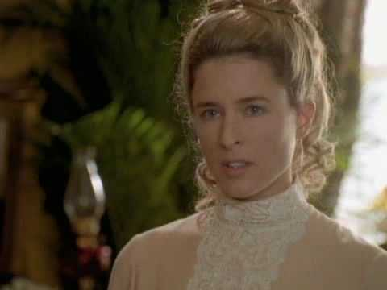


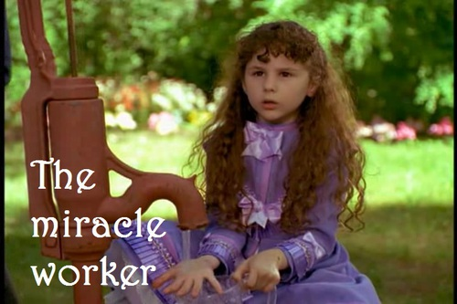
Katy Keller
Anne Sullivan
Arthur Keller
James Keller
Helen Keller
Katy Keller

36.

36. Who is “the miracle worker” that the movie title refers to?
(A) Helen Keller (B) Katy Keller (C) Anne Sullivan (D) Arthur Keller
37. Who often has quarrels over Helen’s problems with others, but in fact feels sorry for himself?
(A) Anne Sullivan (B) James Keller (C) Arthur Keller (D) Katy Keller
38. According to the movie, what can we know about Ms. Anne Sullivan?
(A) She is a teacher from The Perkins Institute.
(B) She still lives with her younger brother Jimmy.
(C) She has high expectations of Helen.
(D) She wears glasses because she is currently blind.
39. Which of the following is NOT true about Ms. Sullivan’s techniques for helping Helen on the right track?
(A) She separated Helen from her overprotective parents for self-independence and discipline.
(B) She spelled words into the palm of Helen’s hand with her fingers for communication.
(C) She always stayed indoors with Helen to teach her about the system of sign language.
(D) She put much effort into teaching Helen about table manners at the very beginning.
40. How does Helen realize the meaning of words and there is a system of language for communication?
(A) When Ms. Sullivan put her hands on the dog’s fur and spelled the word “dog” in her palm.
(B) When Ms. Sullivan pumped the water that runs over her hand and spelled the word “water.”
(C) When Ms. Sullivan gave her a doll as a present with the letters “d-o-l-l” spelled in her hand.
(D) When Ms. Sullivan put one of her hands in the river and spelled the word “water” into the other.

第貳部分：非選擇題 (占40分)
一、課文字串英翻中（占20分）
說明：1. 依據各題英文字串提示，寫出完整的中文翻譯在「答案卷」上。
2. 請依序作答。每題2分，共20分。

However, among all of the children featured in these films, it is a boy named Sandeep Shahani that impresses me the most. Sandeep is from India, and he is about twelve years old. In the Indian language, his family name literally means “boatman.” When asked about his future, Sandeep replies that the only thing he intends to do is to (1) follow in his father’s footsteps and become a boatman. Sandeep (2) works around the clock, rowing passengers across the river for trifling sums. To me, it seems that he lives a miserable life. Even if he makes twenty trips every day, his total earnings are still quite small. His income for the entire day is roughly half the amount of (3) the statutory minimum hourly wage in Taiwan. Since he makes so little money, he is likely to stay in his hometown all his life and will probably never get the chance to see the world.
Later, I learned that the caste system may be the main reason why Sandeep (4) doesn’t hold out much hope that he can work in another occupation. This caste system classifies each person into a group based on the family they are born into, and it has existed for centuries. Sandeep may find some consolation in the fact that he is not a member of the lowest class, the socalled “untouchables,” in which people are destined for an even harsher life full of inequality and mistreatment. Life is so despicable for those people that (5) they cannot imagine ever being treated fairly, let alone in a respectable way.
Watching these films and seeing how Sandeep and other children around the world live made me feel fortunate to own so much. Living lives of such difficulty, these children do not seem to stand a chance of dreaming big. For them, doing so would be nothing more than (6) building castles in the air. (7) Their dreams, in fact, would probably be deemed ordinary or insignificant by some people. Nevertheless, these children have (8) made repeated attempts to make their dreams come true. I couldn’t help but (9) admire these children’s perseverance. The fact that they work hard and try their best even under unfavorable circumstances serves as an incentive for me to follow through with my own dreams. I have come to realize that it doesn’t matter whether our dreams are big or small, as long as (10) we don’t set any boundaries or limits on ourselves. No matter what, there is always the possibility of achieving our dreams.

二、句子合併或改寫（占8分）
說明：1. 依各題提示改寫或合併句子，並將答案寫在「答案卷」上。
2. 請依序作答。每題2分，共8分。

- The player is three times heavier than his wife.
  - 用 S₁ + be/V + half/twice/three times/ . . . + the N of + S₂ 的句型改寫句子

- It seemed that the actress had undergone plastic surgery before.
  - 用 S + seem/seemed + to be/V/have p.p. . . . 的句型改寫句子

- Helen was eager to learn. / Helen became successful.
  - 用Had + S₁+ been/p.p.₁ . . . , S₂ + would/could/might/should + have + been/p.p.₂ . . .” 的句型改寫句子
  - 請翻出語意：如果Helen沒有渴望學習的話，她就不會成功了。

- I put on a raincoat. / I don’t want to get drenched in the heavy rain.
  - 用“S₁ + V₁+ so that/in order that + S₂ + aux. + V₂的句型改寫句子

三、看圖寫作中譯英 （占12分）
說明：1. 請將以下四個中文字串/句子譯成正確、通順、達意的英文，書寫時請注意句子時態，
並將答案寫在「答案卷」上。
2. 請依序作答，並標明題號。每題3分，共12分。

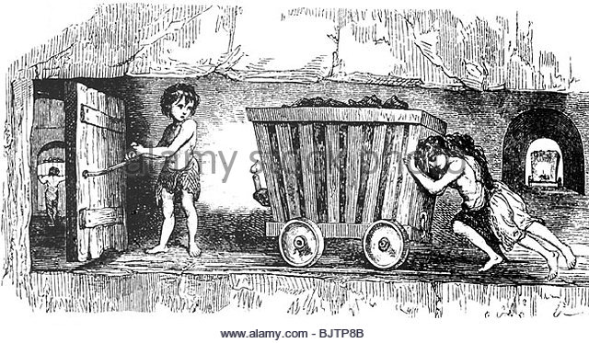

Pedro is a 12-year-old boy. (1) 他住在位於海拔4200公尺高度的玻利維亞 (Bolivia)。 He works as a coal miner when he was nine years old. (2) 因為他父親幾乎眼盲，母親生病，Pedro必須自己賺錢。
Pedro has to work eight hours in one day in the mine. Every day, when he comes out of the mine, it is almost dark. (3) Pedro工作非常認真，為的是賺取他的學費。 Pedro worries very much about his brother. He drew his brother very often because he misses him so much. (4) Pedro希望有一天他們可以全家團圓。

國立臺東高級中學 | 105學年度  第二學期 | 第一次期中考 | 高三英文科試卷 | 卷別：社B卷
適用班級：3-7、3-8 【答案卡＋答案卷】

第壹部份：單選題 (占60分)
一、詞彙 二、文法選擇 三、文意選填 四、電影情節問答題
01-05 DCBAD 16-20 DBCDA 26-30 (AE) (BC) (AD) D (AB) 36-40 CBCCB
06-10 BCBAC 21-25 DDCBD 31-35 A E (AC) C B
11-15 DBCDA

第貳部分：非選擇題 (占40分)
一、課文字串英翻中（占20分，每題2分） * 語意接近可給分。
1. 繼承父親的衣缽 (跟隨他父親的腳步)
2. 日以繼夜地工作
3. 法定最低時薪
4. 對….不抱希望
5. 他們無法想像被公平對待，更遑論受人尊敬了
6. 癡人說夢 (作白日夢)
7. 他們的夢想也許被認為是平淡無奇或無關緊要
8. 鍥而不捨地完成他們的夢想
9. 讚嘆這些孩子的堅毅
10. 我們不對自我設限

二、句子合併或改寫（占8分，每題2分）
1. The player is three times / the weight of / his wife. (粗體部分一錯扣1分，其餘一錯扣0.5分)
2. The actress / seems to have undergone / plastic surgery before. (粗體部分一錯扣1分，其餘一錯扣0.5分)
3. Had Helen not been eager to learn, she would not have become successful. (一錯扣0.5分)
4. I put on a raincoat so that I / won’t get / drenched in the heavy rain. (粗體部分一錯扣1分，其餘一錯扣0.5分)

三、看圖寫作中譯英（占12分，每題3分） * 一錯扣0.5分，扣到該字串1分為止。
1. He lives in Bolivia, / where it is located / at the height of 4200 meters.
He lives in Bolivia, / which is located / at the height of 4200 meters.
2. Because his father is almost blind / and his mother is sick, / Pedro has to earn money by himself.
3. Pedro works / very hard to / pay his tuition.
4. Pedro hopes that / someday they can have / a family reunion.

