國立臺東高級中學 105學年度第一學期第二次期中考

高二原藝班與體育班

Class:_______ No._______ Name:____________

（**答案直接寫在本張考卷上，交卷時，請將整份考卷交回，共1張**）

（20%為口試成績，所以本卷共80%）

Don’t care too much about your scores, but do care about your attitude.

After all, **attitude decides your altitude.**

分數什麼的都是身外之物，唯有態度會陪你走到天荒地老！！

老師不在乎分數，只要你肯努力、用力、盡力地寫好寫滿一次！

1.　請問：**”Attitude decides your altitude.”** 這句俗諺的中文意思是（開學第一堂就告訴你這句話要一直放心底了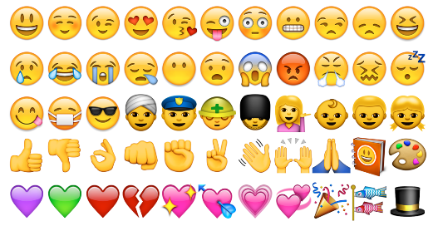）：_______________________________________(1%)

一、中英文連連看　Matching (1% x 5 = 5%)

|  |  |  |
| --- | --- | --- |
| 1. 擁抱　 • |  | * + understanding |
| 1. 分享 • |  | * + kindness |
| 1. 了解 • |  | * + sharing |
| 1. 歡笑 • |  | * + hugs |
| 1. 體貼 • |  | * + 「stephen curry」的圖片搜尋結果laughter |

二、克漏字Cloze　 (1% x 11 = 11%)

Some have called Stephen Curry the best ___1___ in NBA history. His team, the Golden State Warriors, has ___2___ the NBA Championship, and he has been named the NBA’s Most ___3___ Player (MVP). Without doubt, Stephen Curry is a superstar.

____4___, just a few years ago, his rise to greatness was thought by many people to be a long shot. Born in Ohio, Curry came from a(n) ___5___ family. His father was an NBA player, too, while his mother used to play college volleyball. However, Curry was short and ___6___. In fact, he was usually one of the smallest players ___7___ his school teams. ___8___ he worked hard and played well, he was not recruited by any major universities.

In 2012, Curry set—and then ___9___—his own record for the number of three-point shots. He sometimes even shoots from half-court, and he makes an amazing 48 percent of these shots! He ___10___ 1000 shots every week. Curry may not be the tallest or fastest NBA player. However, ___11__ his dedication, he has become one of the best players in NBA history.

|  |  |  |  |  |  |
| --- | --- | --- | --- | --- | --- |
| 1. | ( ) | (A) cooker | (B) rookie | (C) hunter | (D) shooter |
| 2. | ( ) | (A) won | (B) win | (C) winning | (D) been winning |
| 3. | ( ) | (A) Virtual | (B) Valuable | (C) Voluptuous | (D) Vegetarian |
| 4. | ( ) | (A) Amazingly | (B) Overall | (C) However | (D) After all |
| 5. | ( ) | (A) athletic | (B) major | (C) flat | (D) lean |
| 6. | ( ) | (A) obese | (B) muscular | (C) strong | (D) skinny |
| 7. | ( ) | (A) among | (B) on | (C) within | (D) to |
| 8. | ( ) | (A) Despite | (B) Because | (C) Though | (D) If |
| 9. | ( ) | (A) drafted | (B) scored | (C) shot | (D) broke |
| 10. | ( ) | (A) jumped | (B) lifted | (C) mixed | (D) practiced |
| 11. | ( ) | (A) thanks to | (B) according to | (C) Taking to | (D) returning to |

三、中翻英 Chinese-English Translation (5% x 4 = 20%)

1. 我想要的聖誕節禮物就是你。(All I …. is ….)

→ _________________________________________________________.

2. 我現在想吃的就是炸雞和珍珠奶茶！！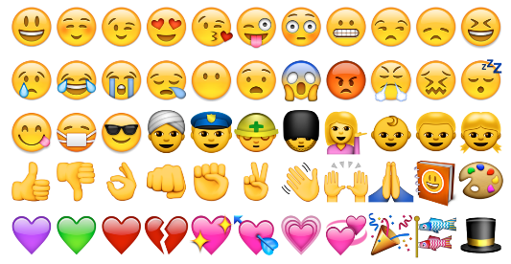 (What I … is …)

→ ________________________________________________________.

3. 毫無疑問地，Curry是個超級巨星。他也是最棒的射手。

→ _________________________________________________________.

4. 運球，然後傳球給我！「basketball」的圖片搜尋結果

→ _________________________________________________________.

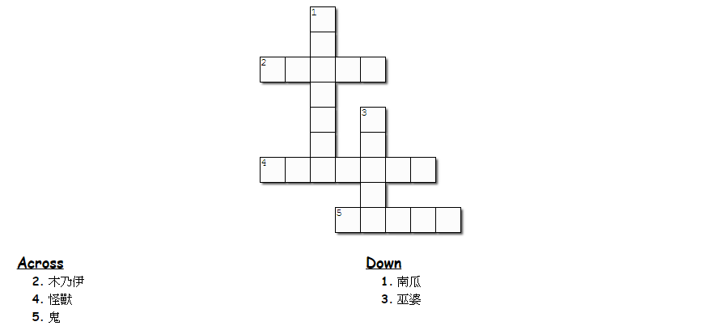四、萬聖節特輯Crossword Puzzle: Halloween Vocabulary!　 (1% x 5 = 5%)

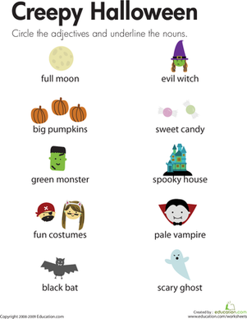





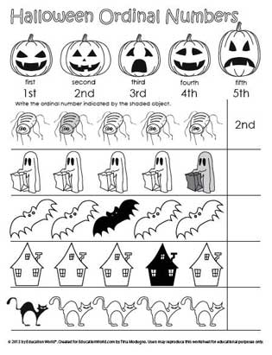

第ㄧ頁，共兩頁

五、句子填填空Sentence Making（自己有自己的答案，但要文法正確）(3%)

To me, friends are those who _________________________________. (2%)

（對我來說，朋友就是_________________________________________) (1%)

六、籃球英文 Basketball English (請從右下方框中選擇英文單字填入左下空格內) (1% x 10 = 10%)

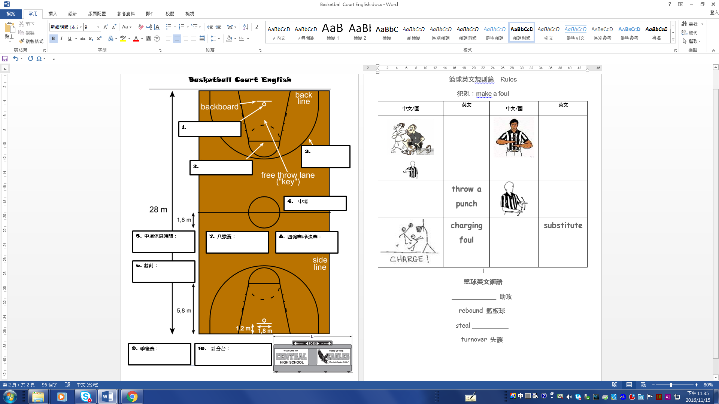

referee

halftime

semi final

quarter final

free throw line

playoff

first period

scoring table

three-point shot

crossover

mid court

basket

七、Bruno Mars’ *Count on me*歌詞選擇題 Multiple Choice (1% x 5 = 5%)

1. ( ) If you ever find yourself lost in the _____ and you can't see, I'll be the light to guide you.

|  |  |  |  |
| --- | --- | --- | --- |
| (A) basket | (B) dark | (C) vampire | (D) court |

2. ( ) I ______ when I need help I can count on you, and you'll be there because that's what friends are supposed to do, oh yeah.

|  |  |  |  |
| --- | --- | --- | --- |
| (A) know | (B) throw | (C) add | (D) sail |

3. ( ) If you're tossing and you're turning in the night, and you just can't fall _____, I'll sing a song beside you.

|  |  |  |  |
| --- | --- | --- | --- |
| (A) sleep | (B) sleepy | (C) sleepily | (D) asleep |

4. ( ) Oh, you'll always have my ______ to lean on whenever you cry or feel sad.

第二頁，共兩頁

|  |  |  |  |
| --- | --- | --- | --- |
| (A) V-line abs | (B) bingo wings | (C) shoulders | (D) butts |

5. ( ) You are my best friend forever. I'll never _______. Never say goodbye.

|  |  |  |  |
| --- | --- | --- | --- |
| (A) let go | (B) set apart | (C) count down | (D) go out |

八、英翻中 Chinese-English Translation（健身相關）　(5% x 4 = 20%)

1. Coco is the envy of everybody because she has such perfect beach body.

→ __________________________________________________________

2. Look at her flat tummy and lean legs!

→ __________________________________________________________

3. How long have you been working out?

→ __________________________________________________________

4. I do 100 squats to lift my butt and 50 push-ups to lose arm fat.

→ __________________________________________________________

九、加分題　Bonus

1. 請問：你衣服上的東中”**NTSH**”是哪4個英文字的縮寫：(4%)

______________ _______________ _______________ _____________

**【以下兩大題只能選1題答】**

2. 請教會瘦容幾句你知道的族語！！（不可為為髒話或色情的**句子**，是句子不是單字！）

1句1分，最多5句，族語跟中文皆要有才給分(0~5%)：我是___________族(也可寫別族族語～)

(1)__________________________________________________________

(2)__________________________________________________________

(3)__________________________________________________________

(4)__________________________________________________________

(5)__________________________________________________________

3. 英文自我介紹，1句1分，1句不得少於4個英文字 (0~5%)：

____________________________________________________________

____________________________________________________________

____________________________________________________________

考試結束！End of the test. (後面是想要告訴你們的小祕密) 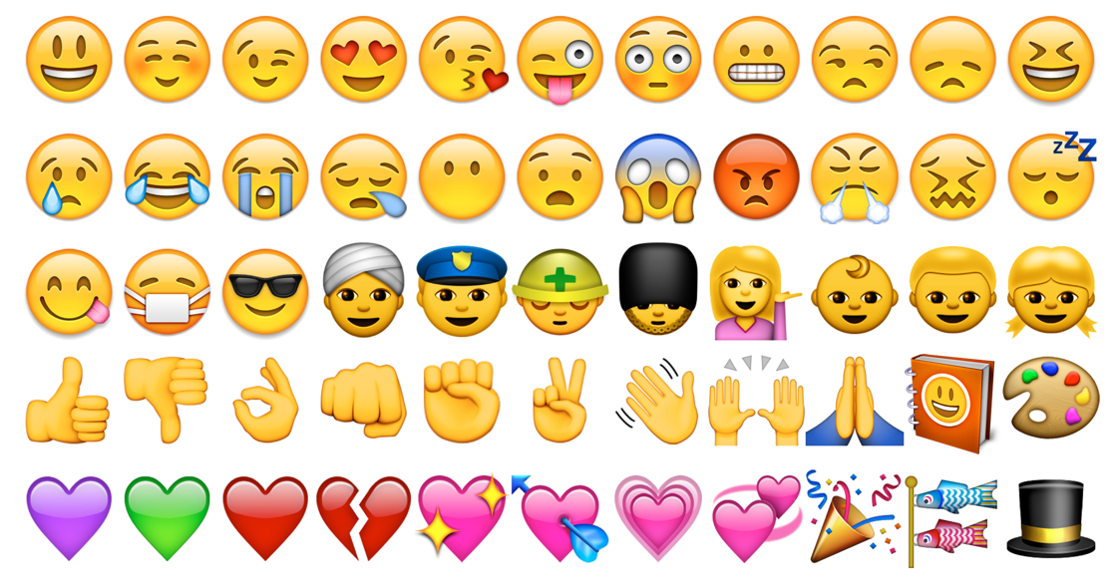

Thank you, my students, for making every of my day so meaningful and amazingly enjoyable. You guys have brought me so much laughter and joy. Love you guys.

Yours Truly,

Slender Zoe　瘦容

--By Stephen Curry