國立臺東高級中學 105學年度第二學期第二次期中考

高二原藝班與體育班

Class:_______ No._______ Name:____________

（10%為口試成績，所以本卷共90%）

一、Weird Job Matching特種工作中英文配對(1% x 10 = 10%)(須寫出完整英文不然不給分)(12選10)

|  |  |
| --- | --- |
| 熊貓保姆： | 冰淇淋試味員： |
| 推人上火車員： | 聲優/配音員： |
| 巧克力試味員： | 私人購物員： |
| 滑水道測試員： | 嘗狗食人員： |
| 吹氣球員： | 聞腋青年： |

二、餐廳點餐克漏字Cloze (14%)

Waiter: May I ___1___ your order now, sir?

Customer: I’m having trouble ___2___. What’s good here?

Waiter: Personally, I like the sirloin steak.

Customer: Hmm. Ok, I’ll try that.

Waiter: ___3___ would you like your steak?

Customer: I like my meat still mooing. Rare, please.

Waiter: OK. And do you want some sauce ___4___ that?

Customer: ___5___ some Black Pepper Sauce on the side?

|  |  |  |  |  |  |
| --- | --- | --- | --- | --- | --- |
| 1. | ( ) | (A) bring | (B) make | (C) carry | (D) take |
| 2. | ( ) | (A) decide | (B) deciding | (C) decided | (D) be deciding |
| 3. | ( ) | (A) How | (B) What | (C) Who | (D) When |
| 4. | ( ) | (A) above | (B) on | (C) with | (D) from |
| 5. | ( ) | (A) What if | (B) As if | (C) How about | (D) How come |

6. 此顧客點了____________牛排、____________分熟。(2%)

Waiter: Soup or salad? We have chicken noodle and vegetable soup tonight.

Customer: I’ll take the salad.

第ㄧ頁，共兩頁

Waiter: And which ___7___ would you like?

Customer: I’ll have the baked potato with chives.

Waiter: I’m sorry, we’re ___8___ steak.

Customer: Shoot. Well, how’s the seafood here?

|  |  |  |
| --- | --- | --- |
| **Balloon blower** | **Water Slide Tester** | **Pet Masseuse** |
| **people-onto-train pusher** | **Underarm odor assessor** | **Ice Cream Tester** |
| **Personal Shopper** | **Panda Nanny** | **Chocolate Taster** |
| **Sex Toy Tester** | **Voice Actor** | **Dog food taster** |

Waiter: Oh, it’s excellent. We actually have a shrimp special tonight.

Customer: OK, ___9___. I’ll get that.

|  |  |  |  |  |  |
| --- | --- | --- | --- | --- | --- |
| 7. | ( ) | (A) beef | (B) sauce | (C) topping | (D) side |
| 8. | ( ) | (A) out of | (B) far from | (C) rich in | (D) taken aback |
| 9. | ( ) | (A) too bad | (B) sounds good | (C) it’s a pity | (D) good job |

10. 此顧客點了　湯 / 沙拉 ，和香蔥__________作為配菜。(2%)

11. 由於餐廳的__________賣完了，所以顧客只好點今晚的__________特餐。(2%)

三、餐廳點餐中翻英 Translation (17%)

1. 我可以追蹤你臉書和Instagram嗎？(2%)

🡪 __________________________________________________________.

2. 讓我們玩個遊戲！(2%)

🡪 __________________________________________________________.

3. 我可以和你拍張照嗎？(2%)

🡪 __________________________________________________________.

Customer: I’m so 4_________. 5_________ me. 6________ 7_______

8________ the dessert 9_________?

Waiter: 10________ 11________, sir. 12________ you go.

Customer: Hmm, everything looks 13_________. Could you recommend something?

　　　　　Nothing too 14_________.

Waiter: Personally, I like the brownie. It’s a nice choice! (1格1分)

顧客：我好飽了。不好意思，我可以看一下甜點菜單嗎？

服務生：當然可以，先生，這給你。

顧客：恩…每樣東西看起來都好好吃，有什麼可以推薦一下嗎？不要太甜的。

服務生：我個人喜歡布朗尼，它會是好選擇！

四、問答題：（以完整句子回答，句首大寫、句尾句點）(2% x 4 = 8%)

1. What do you want to do in the future? ______________________________
2. (去牛排店用餐)How would you like your steak? _____________________________
3. (去冰淇淋店)What flavor of ice cream would you like? ________________________
4. (去冰淇淋店)What kind of sauce/topping would you like? _____________________

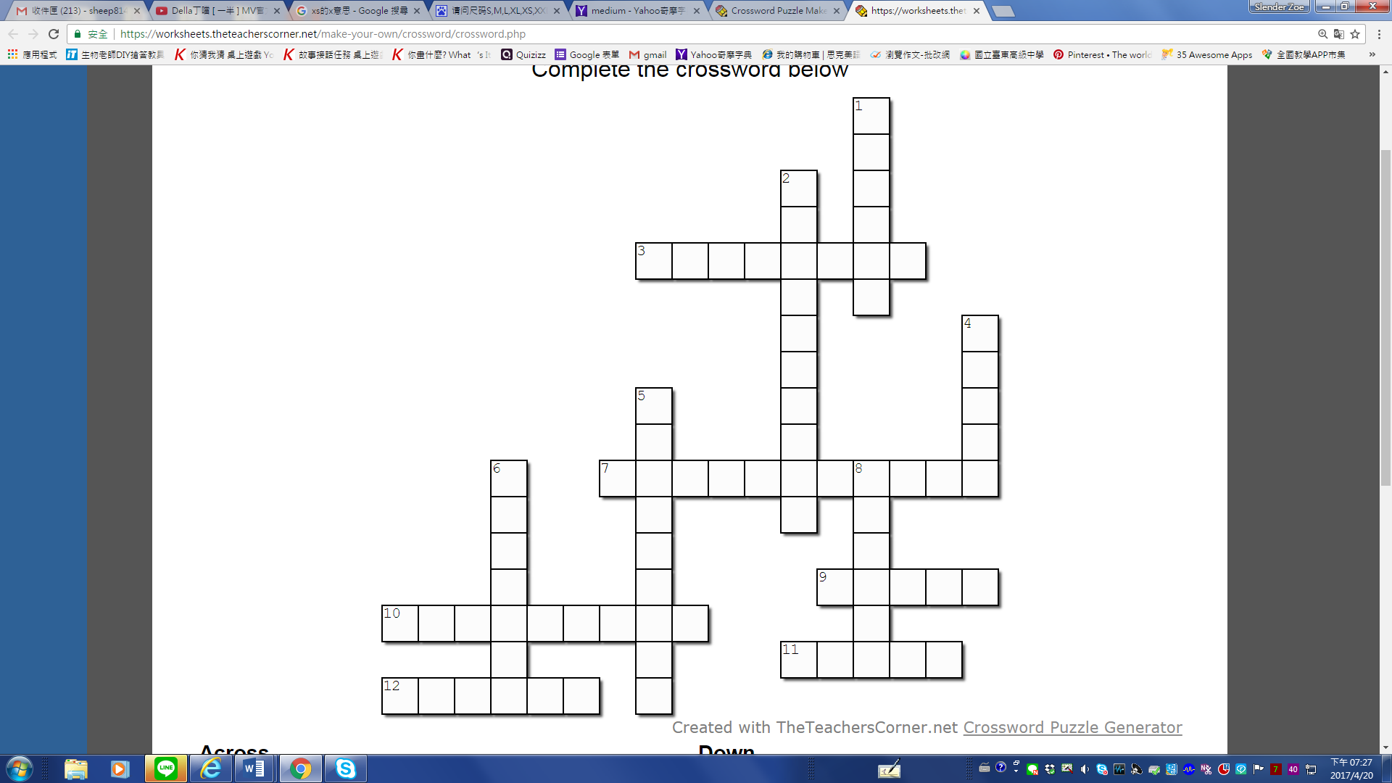五、Crossword Puzzle　 (1% x 12 = 12%)

**Across（橫的）:**

3. 記者

7. 舒服的

9. 很緊的、緊身的

10. 警察

11. （男）演員

12.　服務生

**Down（直的）:**

1. 苦的

2. 草莓

4. 護士

5. 巧克力

6. 牙醫

8. 藝術家

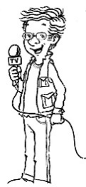



六、填空題 Blank Filling （對照中文，從15個單字中選13個適當的填入空格）(1% x 13 = 13%)

|  |  |  |  |  |
| --- | --- | --- | --- | --- |
| **fortune** | **salary** | **heart** | **humor** | **encouraging** |
| **job** | **schedule** | **writing** | **thousands** | **doctor** |
| **and so on** | **messages** | **luck** | **interesting** | **sick** |

Are you a creative and inspiring person who always enjoys 1__________ down 2__________ words in your notebook? If “yes,” you are the perfect 3__________ cookie writer-to-be.

Fortune-cookie writers create something 4__________ on just a small piece of paper inside a cookie, so they have to convey their 5__________ in just a few words. To do this 6__________ well, they need excellent writing skills and a sense of 7__________.

Fortune-cookie writers often receive high 8__________, health insurance, 9__________ leave, holiday pay, 10__________. They can create their own 11__________ and decide when to work. Fortune-cookie writers enjoy the benefit of reaching 12__________ of people’s 13__________ with inspiring or humorous words.

你是個既有創意又具有啟發性，且總是喜歡在你的筆記本上寫下振奮人心的話語的人嗎？如果答案是Yes，那你絕對是幸運餅乾作家的不二人選。

幸運餅乾作家只在餅乾中的一小片紙張上創作並寫下一些有趣的東西，所以，他們必須言簡意賅。想要勝任這份工作，他們得具備精湛的寫作技巧，還要有幽默感。

幸運餅乾作家常常有高薪，還享有健保、病假、有薪假期，等等。他們能夠決定自己的行程，還有決定何時工作。幸運餅乾作家享受用幽默的珠璣字句觸動人心。

七、英翻中 Chinese-English Translation　(3% x 3 = 9%)

1. Would you like your Frappuccino with whipped cream?

第二頁，共兩頁

→ __________________________________________________________

2. Would you like coffee with your dessert?

→ __________________________________________________________

3. Instead of the cheesecake, I prefer an ice cream sundae.

→ __________________________________________________________

八、Best Response 買衣服對話之選擇題：(7%)

( ) 1. Clerk: How do those slacks fit? Customer: _______________

(A) Do you have this in blue? (B) Hold on a second. I’ll be right back.

(C) Not until next week. (D) They’re a little tight and not long enough.

( ) 2. Customer: Do you have this shirt in blue? Clerk: _______________

(A) Let me check in the back. (B) Let me bring you a larger size.

(C) The sleeves on this shirt are long. (D) They’re tight and not long enough.

( ) 3. Customer: When will you be getting new stock in? Clerk: _______

(A) Not until next week. (B) Let me call another store.

(C) No, I am sorry. We don’t. (D) If so, I can have one sent over here.

( ) 4. Customer: What would you recommend? Clerk: _______________

(A) Oops, they match my outfit! (B) I’ll be back to measure your size.

(C) We have some new arrivals here. (D) I’m looking for a pair of heels.

( ) 5. Clerk: What’s your price range? Customer: _______________

(A) The shoes are comfortable to walk in.

(B) I’d like to spend under a hundred dollars.

(C) I’m going to wear this dress to an event tonight.

(D) I think one of the classic styles over here will do.

( ) 6. How do you say “我能為你效勞嗎？” in English?

(A) May I help you? (B) Can I try them on?

(C) What would you recommend? (D) Could you bring me a smaller size?

( ) 7. How do you say “沒有特別要買的，我只是逛逛” in Chinese?

(A) Nothing special. I can’t find what I want.

(B) Nothing particular. I am just browsing.

(C) No, I am going to wear this dress tonight.

(D) No, I am looking for a pair of shoes.

九、加分題　Bonus

1. ［猜謎］什麼椅子最舒服？（猜一英文單字）：_______________(1%)
2. 寫出c開頭的英文單字，2個字1分，最少2字，最多5分：

_________________________________________________________

1. Draw a picture. If it makes me laugh or it is fun, you get 3 points. It it’s mean, you get -3 points! Be creative! 畫一個會讓人笑出來的圖（或有趣的圖），越有創意越好！(1-3%) 如果內容涉及色情暴力，扣3分。

--By Stephen Curry