**國立臺東高中104學年第一學期高三第二次段考英聽測驗**

Part A (%) 適用班級301-311 英聽代碼:18

In Part A, you will hear four statements. For each statement, you will see four pictures. Choose the best picture for what you hear.

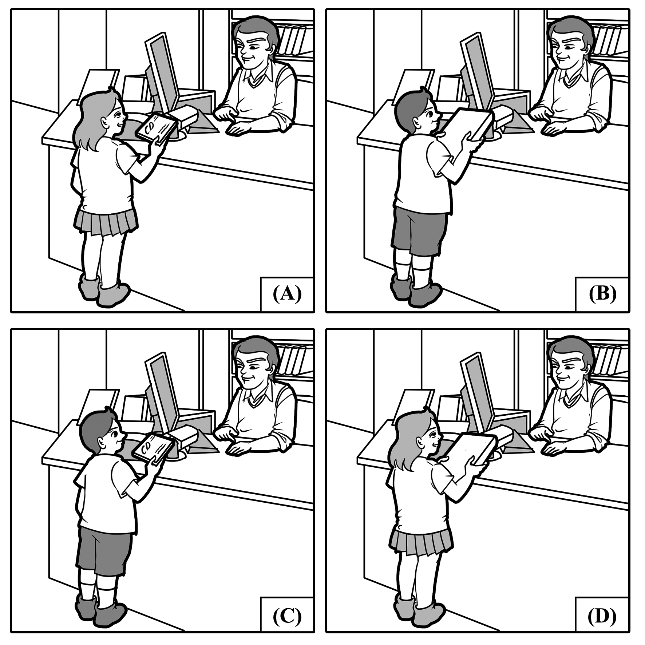

1. (　　)

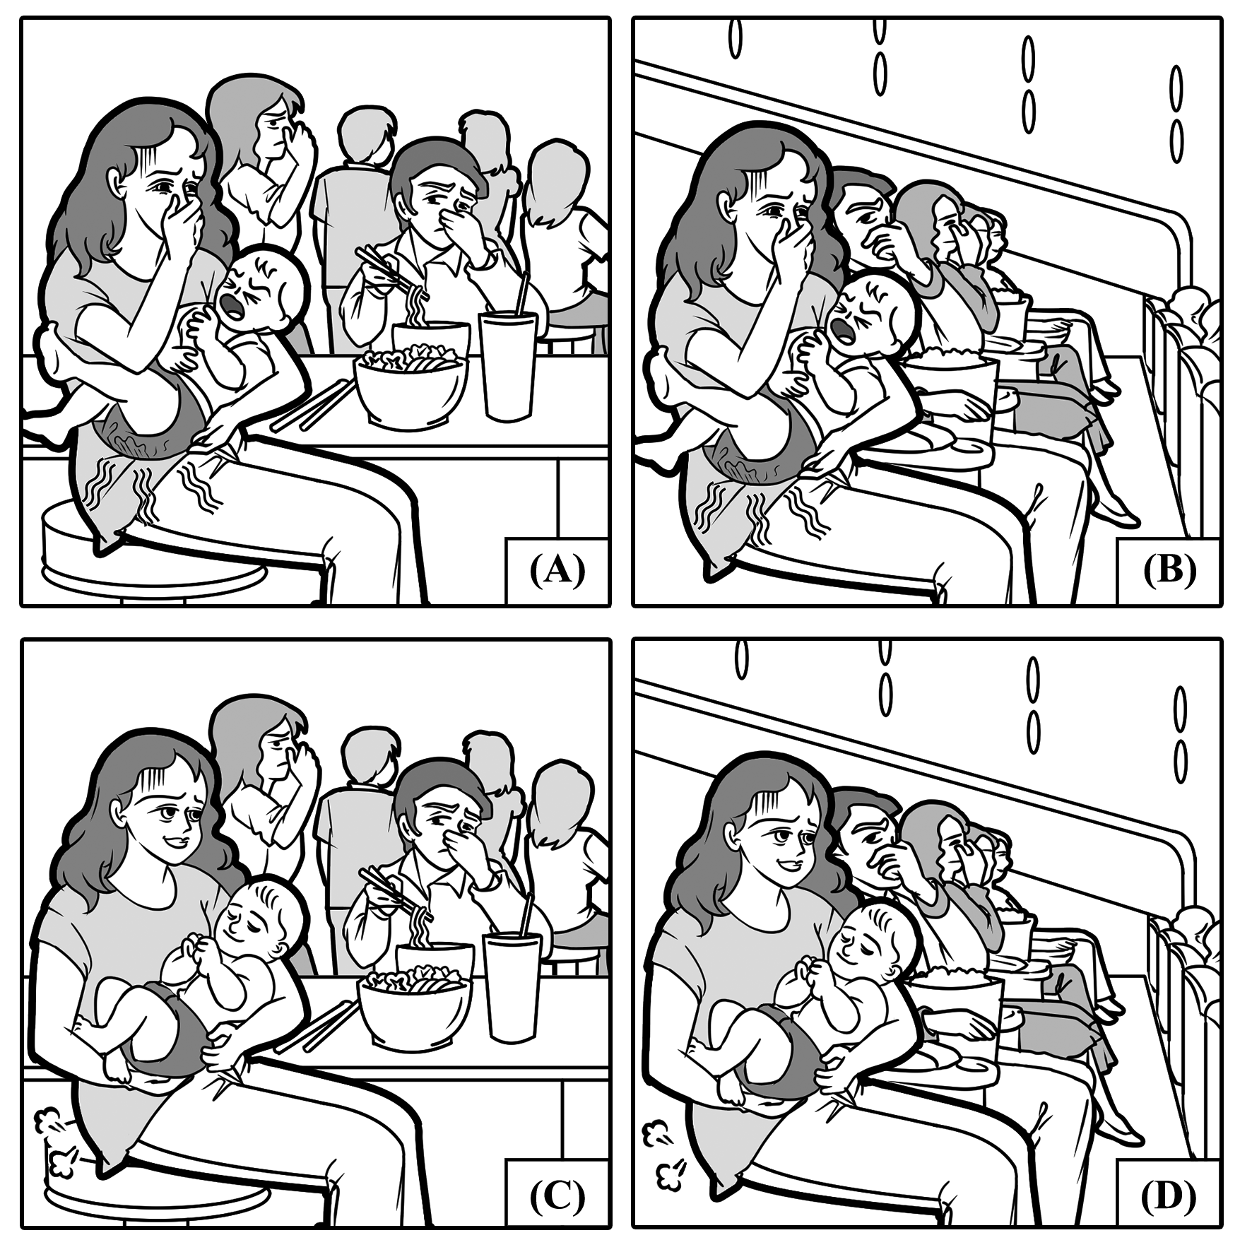

2. (　　)

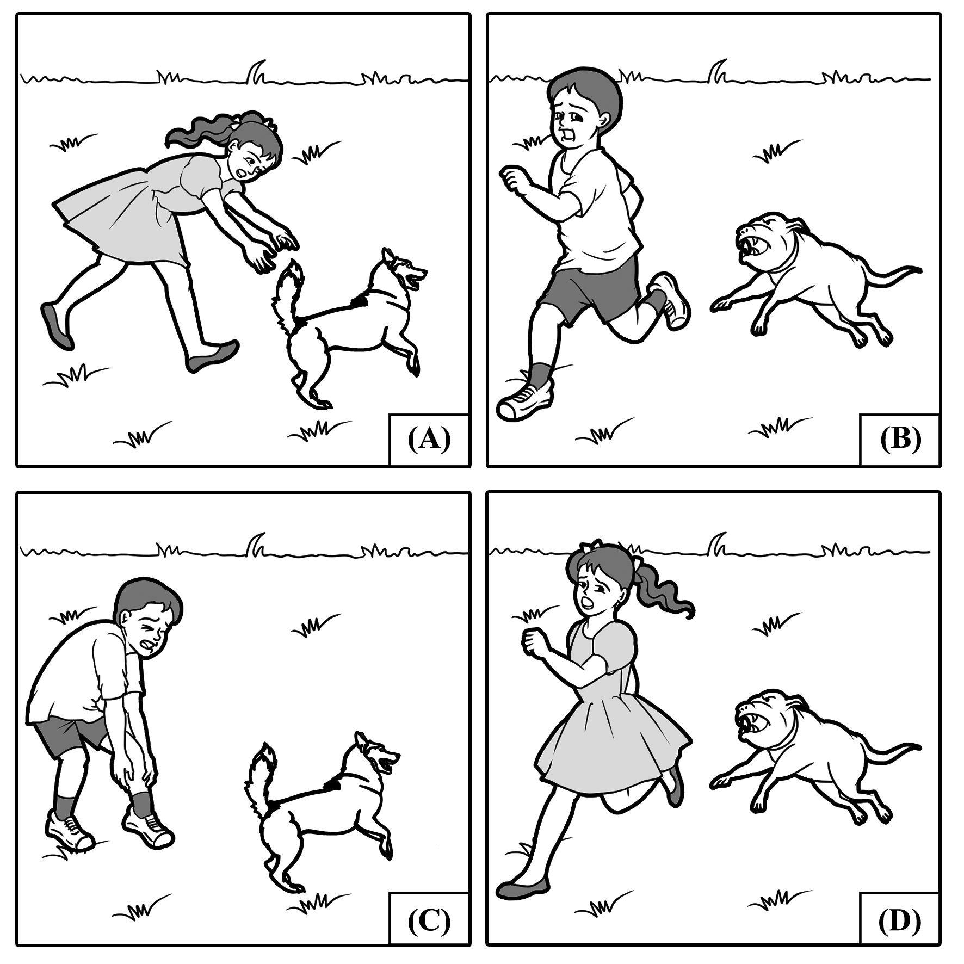

3. (　　)

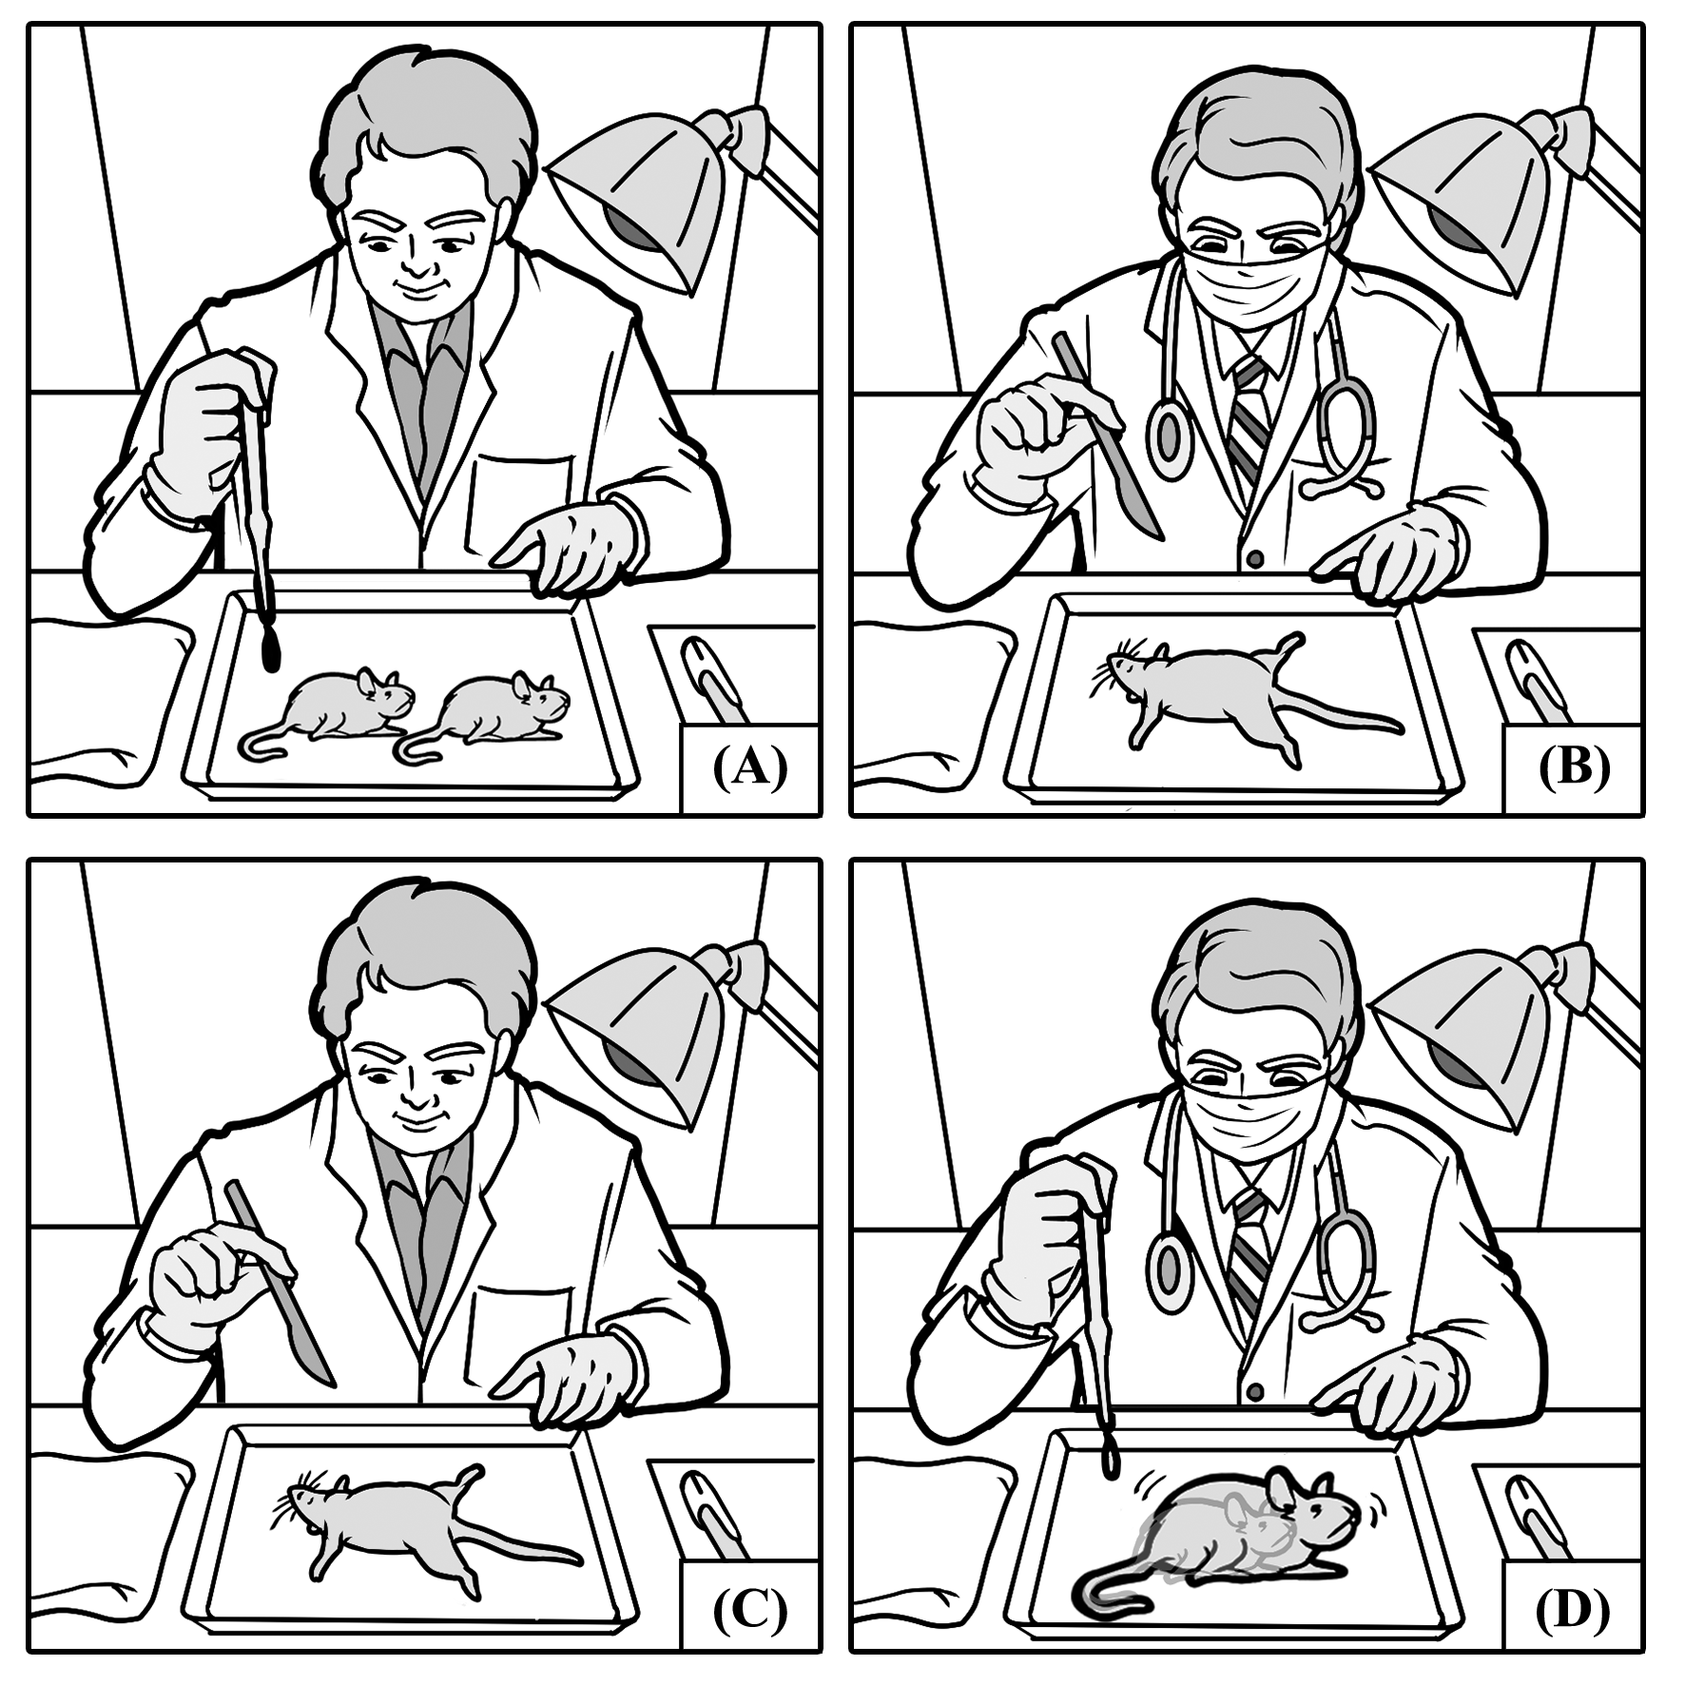

4. (　　)

Part B (%)

In Part B, you will see two pictures on your test paper. For each picture, you will be asked three questions. For each question, you will hear four possible answers. Choose the best two answers according to what you see in the picture.

**B**

**A**

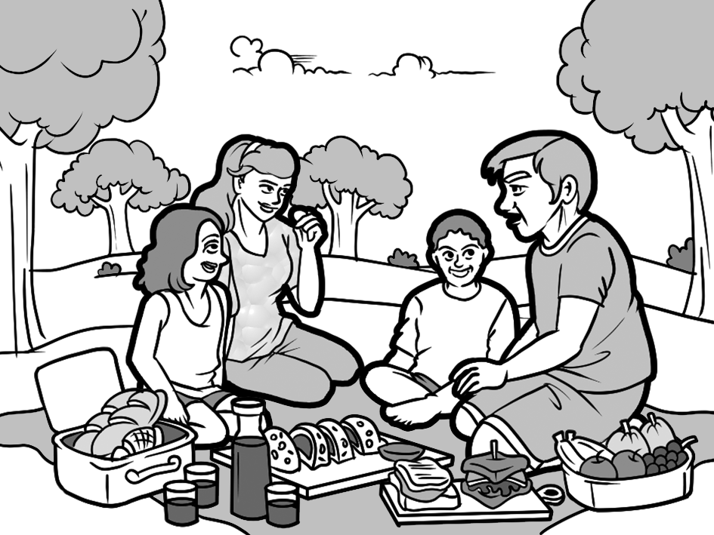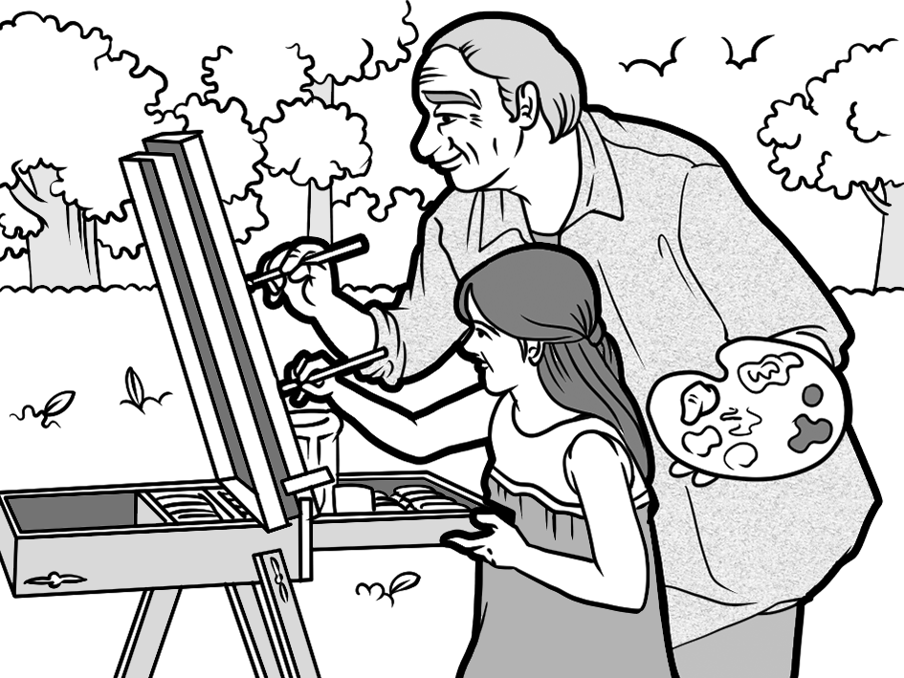

5. (　　) (　　) 6. (　　) (　　) 7. (　　) (　　) 8. (　　) (　　) 9. (　　) (　　)

10. (　　) (　　)  
Part C (%)

In Part C, you will hear 10 questions or statements. After you hear a question or statement, read the four possible answers on your test paper and decide which one is the best answer to the question or statement you have heard.

11. (A) I think he deserves a high pay in his new company.

(B) The train is expected to arrive in Taipei at 8 p.m.

(C) Teaching the elderly how to use smartphones is never easy.

(D) He should talk to them about what he wants instead of bearing it.

12. (A) What kind of book are you writing? I want to read it.

(B) Stop being sidetracked and finish your work on time.

(C) Once you finish buying the book, let's go get dinner.

(D) Don't worry. You may return it to me at any time.

13. (A) My grandma wakes up early every morning.

(B) It took hard work to change my habit, and many alarms.

(C) Yes, I did get into trouble in my early days.

(D) I usually pick up my children from school at 5 p.m. on weekdays.

14. (A) Yes, if you book the hotel room earlier, you'll get a ten percent discount.

(B) No, the class will no longer run until further notice.

(C) I'm sorry; the pamphlets had the wrong information. It's tomorrow.

(D) Sir, it doesn't appear that you are on the guest list.

15. (A) I'm sorry; I didn't realize it didn't have any ramps or elevators.

(B) I think that library has a lot of nice scenery, too.

(C) Yes, I did borrow that book before. Isn't it great?

(D) My grandpa uses a powered wheelchair to get around.

16. (A) I can't believe he pulled out a rabbit out of thin air.

(B) Never! A true magician will never expose his secrets.

(C) I will host a cooking show over the next few days.

(D) My fantasy novel will be published soon.

17. (A) Yes, you can bring in a bottle of water.

(B) Please meet me at the library later.

(C) Sorry, I'll stop. I thought we were alone.

(D) No, I don't have a frame for that picture.

18. (A) I don't listen to that type of music, sorry.

(B) You are lucky to have such a supportive person in your life.

(C) I was thinking about buying that purse, too.

(D) You are too young to get married.

19. (A) Which theater are we seeing the movie in?

(B) Here's the set of china you asked for.

(C) I agree. It's not easy to find a decent job nowadays.

(D) Thanks. My job as a comedian is to make people laugh.

20. (A) I think the album will be released next year.

(B) I have no idea why the landlord agreed to sell his apartment.

(C) News reports say we'll get power back tonight.

(D) Sometime over the next hours, I'll give you a call.

Part D (%)

In Part D, you will hear eight conversations between a man and a woman. After each conversation, you will hear one to two questions about the conversation. After you hear the question, read the four possible answers on your test paper and choose the best answer to the question you have heard.

21. (A) She needs him to hold a conference.

(B) The man has submitted a job application before.

(C) She doesn't think he has enough experience.

(D) She wonders how he got an interview with the celebrity.

22. (A) He was attempting to sleep later than usual.

(B) He didn't want to disturb her while she was sleeping.

(C) He wanted to wait to tell her the news in person.

(D) He didn't want to see a movie with her.

23. (A) Bringing the ball back to him.

(B) Catching a Frisbee.

(C) Playing tug-of-war with him.

(D) Playing hide-and-seek.

24. (A) Staying in a dark room.

(B) Being trapped in an elevator.

(C) Listening to heavy metal music.

(D) Getting stuck in a traffic jam.

25. (A) The snow was starting to melt.

(B) A huge wildfire was happening outside.

(C) The snowstorm already blanketed everything.

(D) The roads were clear enough to drive on.

26. (A) Kristy's friend Troy has been known to steal things.

(B) He saw a burglar outside of their home.

(C) Kristy's friend Troy was kidnapped.

(D) He saw the thief who stole a necklace from the store.

**Questions 27-28 are based on the following conversation.**

27. (A) She thinks making dumplings is a stupid idea.

(B) She wants to know his cake recipe.

(C) She noticed he will be making the same food as her.

(D) She lost the racing tournament to him.

28. (A) Her recipe for a successful life worked.

(B) She wants to challenge him to a tennis match.

(C) She hopes she could have a family someday.

(D) His food won't be as good as hers.

**Questions 29-30 are based on the following conversation.**

29. (A) He offered her to walk beneath his umbrella.

(B) He gave her his jacket when it was cold.

(C) He gave her a ride home in his car.

(D) He paid for their second lunch together.

30. (A) She needs to borrow his umbrella after lunch.

(B) She asks him if he wants to have coffee together.

(C) She has plans but she'll give him a call.

(D) She works at a café and wants him to visit.

Part E (%)

In Part E, you will hear four short passages. After the passage, you will hear two to three questions about the passage. After you hear the question, read the four possible answers on your test paper and choose the best answer to the question you have heard.

I.

31. (A) 13 billion people will be living on the planet.

(B) The minimum wage will be set at US$13.50 an hour.

(C) Scientists will find a cure for dementia.

(D) Over 135 million people will suffer from dementia.

32. (A) She was the youngest person to have Alzheimer's.

(B) She won the top prize at Stanford Center on Longevity's contest.

(C) Her grandmother was the first person to be cured of dementia.

(D) She made a robot that would replace caregivers.

II.

33. (A) It is important to drink eight glasses of water per day.

(B) It checks how many things you have in your life.

(C) It is a test to see what people's personalities are like.

(D) It is a question of half lies and half truths.

34. (A) They suffer from more diseases.

(B) They notice what is missing in their lives.

(C) They have a less positive outlook on life.

(D) They are happier than "half empty" people are.

III.

35. (A) It is large and hard to transport.

(B) It is small enough for just one person.

(C) It is big enough for a family of five.

(D) It is small but two people can live inside.

36. (A) It has the luxuries of a hotel room.

(B) It has enough space for a couch.

(C) It can be expanded.

(D) It is equipped with an air filter.

37. (A) For two years.

(B) Beginning in 2016.

(C) For about a year.

(D) For four years.

IV.

38. (A) Night owls tend to get a lot done.

(B) They study better at night.

(C) They have many distractions..

(D) Night owls don't get enough sleep.

39. (A) To watch the early morning cartoons.

(B) To have more time for exercise.

(C) To take time to enjoy their breakfast.

(D) To focus on their studies.

40. (A) Eating a large dinner.

(B) Playing video games.

(C) Watching a TV program.

(D) Training at a sports practice.